Greenhouse Effect on Trends of F2-layer Ionosphere

Liying Qian, Stanley C. Solomon, Alan G. Burns, Raymond G. Roble

Abstract

Greenhouse effects on trends of h_{m}F₂ and N_{m}F₂ are investigated using a coupled thermosphere and ionosphere general circulation model. Model simulations indicate that greenhouse cooling not only causes contraction of the upper atmosphere, but also changes dynamics and electrodynamics in the thermosphere/ionosphere. Consequently, trends of h_{m}F₂ and N_{m}F₂ are influenced by cooling and contraction of the upper atmosphere as well as trends of plasma transport as the thermosphere/ionosphere adjusts to a new equilibrium. Percentage changes of N_{m}F₂ are comparable to percentage changes of neutral composition, indicating that photochemical processes determine the basic magnitude of the trends of N_{m}F₂. However, changes in plasma transport can significantly modify these trends of N_{m}F₂ as well. Neutral wind plasma transport plays a major role in this dynamical influence and such transport is stronger under solar minimum conditions due to larger changes in neutral winds at solar minimum. Trends of h_{m}F₂ and N_{m}F₂ show significant variations with geographic location, local time, season, and solar activity. Under the greenhouse effect, trends of N_{m}F₂ are negative with magnitude from 0 to ~ -40% for doubled CO₂, depending on location, local time, season, and solar activity. The corresponding trends of h_{m}F₂ are mostly negative with a magnitude from 0 ~ -40km, but can be positive with a magnitude from 0 to ~ 10 km at night, with maximum positive trends occurring after mid-night under solar minimum conditions. These positive trends of h_{m}F₂ are mainly caused by the equatorward trend of the meridional winds that transport plasma upward thus increasing h_{m}F₂. Trends of h_{m}F₂ and N_{m}F₂ are larger under solar minimum than solar maximum conditions. Solar cycle variations of trends of N_{m}F₂ are mainly caused by solar cycle variations of trends of neutral wind plasma transport; whereas solar cycle variations of trends of h_{m}F₂ are caused by stronger cooling, and thus greater descending of pressure surfaces, as well as larger trends of neutral wind plasma transport under solar minimum conditions.

1. Introduction

Long-term changes in the upper atmosphere and ionosphere have been of great interest since Roble and Dickinson [1989] suggested that global cooling will occur in the upper atmosphere in conjunction with global warming in the troposphere due to long-term increase of greenhouse gas concentrations. In addition to its practical importance such as its effect on satellite drag, determination of long-term changes in the upper atmosphere and ionosphere has important scientific interest. It can facilitate understanding of global change in the lower atmosphere since global change in the lower atmosphere and upper atmosphere/ionosphere are closely linked, and it can be easier to detect global changes in the upper atmosphere and ionosphere due to larger signal to noise ratio. Significant progress has been made after nearly two decades of observational and modeling studies [e.g., Akmaev and Fomichev, 1998, 2000; Akmaev et al., 2006; Beig, et al., 2003; Bremer et al., 2004; Clilverd et al, 2003; Danilov and Mikhailov, 1999; Emmert at al., 2004; Gruzdev and Brasseur, 2005; Keating, 2000; Laštovička and Bremer, 2004; Laštovička, 2005; Laštovička et al., 2008; Marcos et al., 2005; Mikhailov and Marin, 2000, 2001; Qian et al., 2006, 2008; Rishbeth, 1990, 1997; Rishbeth and Roble, 1992; Xu et al. 2004]. Consistent results have been obtained regarding long-term trends of mesospheric temperature, electron density in the lower ionosphere and F₁-region, hmE and NmE, and thermospheric neutral density [Laštovička et al., 2006a; Laštovička et al., 2008]. These results support the hypothesis of cooling and contraction of the upper atmosphere as a result of increased greenhouse gas concentrations.
However, controversies and discrepancies remain for detection of trends of F₂ peak parameters (h_{m}F₂ and N_{m}F₂), regarding methods of data analysis, the magnitudes of the trends, and interpretation of the causes of the trends. Since these trends of h_{m}F₂ and N_{m}F₂ are relatively weak compared to the strong natural variability due to solar and geomagnetic activity, different analysis methods resulted in discrepancies of more than one order of magnitude [Laštovička et al., 2006b]. There are two interpretations of the cause of these trends of h_{m}F₂ and N_{m}F₂: geomagnetic origin and greenhouse effect. Mikhailov et al. [2002] found a small negative residual trend of foF₂ with a natural origin related to long-term variations in solar and geomagnetic activity, but no indication of any manmade effects. Mikhailov [2006] further indicated that thermosphere cooling due to the greenhouse effect is not noticeable in the foF₂ trends due to the weak dependence of N_{m}F₂ on neutral temperature and, therefore, foF₂ trends are completely controlled by long-term variations of geomagnetic activity. On the other hand, Bremer [1992] found a negative trend in h_{m}F₂ for a mid-latitude station over time; this supports global cooling of the thermosphere due to greenhouse effect. Danilov [2002] developed a method of determining of long-term trends of non-geomagnetic origin, and found a negative trend in foF₂ for the period 1958-1995, that is substantially larger than that for the period of 1948-1985, which supports its anthropogenic origin. Attempts were also made to reconcile the greenhouse effect and geomagnetic activity causes of these trends. It was suggested that there is simultaneous greenhouse control of the trend in h_{m}F₂ and geomagnetic control of the trend in foF₂ [e.g., Mikhailov, 2006].
In addition, trends of F₂ peak parameters exhibit variations with geographic location, local time, season, and solar activity. Controversies exist regarding these variations. Bremer [1998, 2001] obtained h_{m}F₂ and foF₂ trends of different signs for 31 European stations, with negative trends west of 30ºE but positive trends east of 30ºE. He suggested that trends of F₂ parameters cannot be explained by the increasing greenhouse effect alone and that dynamical effects seem to play an important role. Danilov and Mikhailov [1998; 1999a, b] found negative trends for all individual stations they selected, and detected a strong and well pronounced dependence of the foF₂ trends on geomagnetic latitude but no longitudinal dependence, which is contrary to Bremer’s finding [1998, 2001]. Mikhailov and Marin [2000] found diurnal variations of foF₂, with foF₂ having its minimum trend at local noon and its maximum at night. Danilov [2008] found clear seasonal and diurnal variations of foF₂ and evoked long-term variations of thermospheric meridional wind to explain these variations. Furthermore, variability in trends of F₂ peak parameters has also been used as evidence of the origin of these trends. Mikhailov et al. [2000, 2001, 2002] argued that trends of foF₂ due to greenhouse gas cooling should be positive and should not have complex latitudinal, longitudinal, and diurnal variations, and that latitudinal and diurnal variations of foF₂ are evidence of geomagnetic control of the foF₂ trend.
So what are the signs and magnitudes of trends of the F₂ peak parameters and what has been causing their long-term trends? It is likely that both natural trends of solar and geomagnetic activity and anthropogenic trends through the greenhouse effect have contributed to long-term trends of the F₂ peak parameters. It is important to understand how the trends of the F₂ peak parameters are influenced by each forcing process in order to determine contributions from each forcing type and identify the driving mechanisms of these trends. In data analysis, it is difficult to separate contributions from forcing of natural origin and the greenhouse effect. For example, it is difficult to explain the origin of complex features of trend dependence on geographic location, local time, season, and solar activity. Modeling studies can be a great tool to separate contributions from the two forcing types and to understand the distribution of trends with location and variations with local time, season, and solar activity. Furthermore, possible dynamic influences on trends of F₂ peak parameters has been speculated about and used to explain the observed features of trend variations [e.g., Bremer, 1998; Danilov, 2008]. In this paper we will use a three dimensional general circulation model to examine dynamic influences on these trends.
Qian et al [2008] used a one dimensional model to investigate trends in the global mean ionosphere. In this paper, we will use a 3-dimensional upper atmospheric general circulation model to investigate how the three dimensional ionosphere, particularly foF₂ and h_{m}F₂, responds to increased CO₂ concentrations in the atmosphere. Specifically, the model will be used to examine the geographic pattern of these trends, their diurnal and seasonal variations, and the dependence of these trends on solar activity. The model will also be used to determine dynamical influences on trends and their variability. Section 2 describes the 3-dimensional upper atmosphere general circulation model; Section 3 shows model simulation results; section 4 provides some discussion; and section 5 concludes the study.

2. Model Description

The model used for this study is the National Center for Atmospheric Research (NCAR) Thermosphere-Ionosphere-Electrodynamic General Circulation Model (TIEGCM). The TIEGCM is a first-principles numerical model that solves the Eulerian continuity, momentum, and energy equations for the coupled thermosphere/ionosphere system [Dickinson et al., 1981; Dickinson et al., 1984; Roble and Ridley, 1987; Roble et al., 1988; Richmond et al., 1992; Richmond, 1995]. It utilizes a spherical coordinate system fixed with respect to the rotating Earth, with latitude and longitude as the horizontal coordinates and pressure surfaces as the vertical coordinate. The pressure interfaces are defined as z=ln(P₀/P), where P₀ is a reference pressure of $5×{\text{10}}^{−4}μb$. The vertical range of these pressure surfaces is from -7 to 7, and thus covers an altitude range of about 97–600 km, depending on solar activity. The vertical resolution is 2 model grids per pressure scale height; the horizontal resolution is 5º latitude by 5º longitude, and the model time step is about 3 minutes. Output of the model are neutral, electron, and ion temperatures; neutral winds; concentrations of major species O, O₂, and N₂; concentrations of minor species N(⁴S), N(²D), NO; concentrations of ions O⁺,O₂⁺, N₂⁺, N⁺, NO⁺; electron density; and geopotential heights of pressure interfaces.
The external forcing of the TIE-GCM are solar irradiance, mainly in the extreme ultraviolet (EUV) and ultraviolet (UV) regions; geomagnetic energy input in the form of auroral energetic particle precipitation and ionospheric convection driven by the magnetosphere-ionosphere current system; perturbation at the lower boundary of the model by waves representing the interaction between the thermosphere/ionosphere system and lower atmosphere processes; and a specified upward or downward plasma flux at the upper boundary representing the interaction of the system with the plasmasphere. In this study, the EUVAC solar proxy model [Richards et al., 1994] was used as solar input. Ionospheric convection driven by the magnetosphere-ionosphere current system is specified by the empirical model of Heelis et al. [1982]. Auroral particle precipitation and its ionization and dissociation are calculated by an analytical auroral model described by Roble and Ridley [1987]. The migrating semi-diurnal and diurnal tides are specified at the lower boundary using the Global Scale Wave Model (GSWM) [Hagan and Forbes, 2002, 2003]. The effect of gravity wave breaking in the mesosphere-lower-thermosphere (MLT) region is included by specifying eddy diffusivity at the lower boundary that declines with altitude. Effects of planetary waves and non-migrating tides are not considered.
Since the goal of this paper is to examine and separate contribution of the greenhouse effect on the global distribution of ionospheric trends, we conducted all model runs under geomagnetic quiet conditions. Since CO₂ is the main cooler of the upper atmosphere, we consider the effect of changes of CO₂ concentrations. Changes of other radiatively active gases, such as stratospheric ozone depletion and possible stratospheric and mesospheric water vapor increases, may also slightly affect long-term changes of the ionosphere since Akmaev et al. [2006] have demonstrated the effects of ozone depletion and water vapor increase on lower thermospheric temperature and density. However, this secondary effect is not treated here. The model was run with base (365 ppmv) and doubled CO₂ concentrations (730 ppmv), for both solar minimum and solar maximum, near the June solstice. The 365 ppmv characterizes present-day CO₂ concentration while 730 ppmv represents a projection of CO₂ concentration for year 2100 by the Intergovernmental Panel on Climate Change (IPCC) [2007] emission scenario A1B, a medium emission scenario. These CO₂ concentrations were applied at the model lower boundary. Above the lower boundary, CO₂ concentrations decrease exponentially with pressure scale height.

3. Results

Ionosonde data analysis indicated that trends of foF₂ and h_{m}F₂ vary with geographic location, local time, and season [e.g. Bremer, 1998; Mikhailov and Marin, 2000; Xu et al., 2004; Danilov, 2008]. In addition, solar activity influence on ionospheric trend detection is evident [Clilverd et al, 2003]. The TIEGCM model was run with base and doubled CO₂ concentrations, for both solar minimum and solar maximum, under geomagnetic quiet condition, and near June solstice to include these possible variations. These model runs were designed to investigate the geographic distribution of ionospheric trends, diurnal and seasonal variations of possible trends, and the effect of solar activity on trends, under the greenhouse effect. Changes of h_{m}F₂ and N_{m}F₂ due to increased CO₂ concentrations were calculated and shown for different local times (longitude as the X-axis and latitude as the Y-axis), for both solar minimum and solar maximum conditions. Since the model uses pressure surfaces as the vertical coordinate and thus solves the continuity, momentum, and energy equations on pressure surfaces, least square second degree polynomial fitting was performed to the model simulated vertical electron density profiles to obtain h_{m}F₂ and N_{m}F₂. Figure 1 and figure 2 are results for local time 12:00 noon and 3:00 am, respectively, which show the dependence of F₂ peak trends on geographic location, local time, season, and solar activity. Changes of h_{m}F₂ and N_{m}F₂ shown in figure 1 and 2 are absolute changes and percentage changes, respectively. Trends of N_{m}F₂ are investigated in this paper, but the relationship between N_{m}F₂ and foF₂ is: $N_{m}F_{2}=1\text{.}\text{24}×{\text{10}}^{\text{10}}(f_{o}F_{2})^{2}$, where N_{m}F₂ is in m⁻³ and foF₂ is in MHZ. We will first observe the overall patterns of h_{m}F₂ and N_{m}F₂ variations with geographic location, local time, season, and solar activity. We will then examine how photochemical processes and plasma transport control these patterns. Finally, we will briefly look at the vertical distribution of ionospheric trends due to the greenhouse effect.

3.1 Overall Trends of h_{m}F₂ and N_{m}F₂

Geographic location (latitude and longitude): Trends of h_{m}F₂ and N_{m}F₂ exhibit large latitudinal and longitudinal variations in both daytime (figure 1) and night time (figure 2). Both latitudinal and longitudinal distributions of these trends show strong correlation with the geomagnetic dip equator, indicating the effects of electrodynamics on these trends.
Local time: Figure 1 and figure 2 show that trends of h_{m}F₂ and N_{m}F₂ have strong local time dependence, and that this local time dependence varies at different geographic locations. Some locations have larger trends during night time while other locations have their largest trends during the day. In addition, trends of N_{m}F₂ are negative over the globe during both the day (figure 1) and the night (figure 2), whereas trends of h_{m}F₂ are all negative during the day (figure 1), but can be positive at some locations at night (figure 2); On average, the trend of N_{m}F₂ at 3:00 am (figure 2) is larger than that at 12:00 noon (figure 1), for both solar minimum and solar maximum conditions; Positive h_{m}F₂ trends at night correspond to where the maximum trend of N_{m}F₂ occurs, which is in the winter hemisphere.
Season: Trends of F₂ peak parameters show different patterns in the winter and summer hemispheres. Particularly, trends of N_{m}F_{2,} are larger in the winter hemisphere than those in the summer hemisphere overall, for both solar minimum and solar maximum conditions.
Solar activity: On a globally average basis, trends of both h_{m}F₂ and N_{m}F₂ are larger under solar minimum conditions than under solar maximum conditions, and the global distribution of trends tends to be more structured under solar minimum conditions.

3.2 Analysis of Trends of h_{m}F₂ and N_{m}F₂

The F₂ peak is the place where the effects of plasma transport processes become comparable to the effects of photochemical processes [Rishbeth, 1998]. Below the F₂ peak altitude, photochemical processes control electron density whereas above the F₂ peak, plasma transport controls electron density. Model simulations show that trends of F₂ peak parameters have a distinct global distribution and exhibit variations with local time, season, and solar activity. It is important to understand the roles of photochemical processes and plasma transport in determining trends of F₂ parameters and variability of these trends; and how photochemical processes and plasma transport contribute to the trends and trend variability.
In order to understand the underlying physics of trends and the associated trend features, we need to examine the governing processes that determine electron density and its altitude profile. The ionosphere is approximately under charge neutrality in the E- and F- regions, i.e., the electron number density is approximately equal to the sum of the number densities of ions. The TIEGCM obtains electron number density by calculating ion number densities. The major ion at the F₂ peak is O⁺. The model solves the following O⁺ continuity equation:
$$\frac{∂n}{∂t}=Q−\text{Ln}+\text{transport}$$
where n is O⁺ number density, Q is total production of O⁺ through ionization by photons and photoelectrons, dissociative ionization by photon and photoelectrons, and chemical reactions; L is the total loss of O⁺ through charge exchange and chemical reactions of O⁺ with neutrals. The transport term includes plasma transport by ambipolar diffusion, neutral wind, and $\vec{E}×\vec{B}$ drift. $\vec{E}$ is electric field which is mainly of magnetospheric-origin at high latitudes, but is largely generated by the neutral wind dynamo at low latitudes; $\vec{B}$is the Earth’s magnetic field.
At the F₂ peak, the main photochemical production of O⁺ is photoionization of O ($O+hν→O^{+}+e$). The main photochemical loss is a two-step process, with transfer of $O^{+}$ to the molecular ions${\text{NO}}^{+}$and$O_{2^{+}}$through atom-ion interchange reactions ($O^{+}+N_{2}→{\text{NO}}^{+}+N,O^{+}+O_{2}→O_{2^{+}}+O)$ followed by dissociative recombination of the two molecular ions. The atom-ion interchange reaction rates are much slower than the dissociative recombination rates. If the F₂ peak is under photochemical equilibrium, then electron density will be approximately determined by the balance between the photoionization rate of O and atom-ion interchange reaction rates, therefore, electron density would be proportional to O/N₂ through balance of these photochemical production and loss processes considering N₂ is the main molecular species at the F₂ peak. However, unlike in the E and F₁ regions, the possible photochemical equilibrium in the F₂ peak is, in practice, modified by plasma transport. Nevertheless, O/N₂ is still an indicative parameter for N_{m}F₂ as we will see in the following analysis.
Figure 3 and 4 relate trends of h_{m}F₂ and N_{m}F₂ to the governing photochemical and transport processes, for solar minimum and solar maximum conditions, respectively. The figures show trends of N_{m}F₂ and h_{m}F₂; changes of O/N₂ ratio, and trends of the three plasma transport terms at UT 12:00 near June solstice, under a doubling of CO₂. Since the TIEGCM assumes hydrostatic equilibrium and solves the thermospheric and ionospheric continuity, momentum, and energy equations on pressure surfaces, these changes were calculated on the pressure surfaces where F₂ peak lies.
Trends of N_{m}F₂ due to the greenhouse effect are negative all over the globe under both solar minimum and solar maximum conditions (figure 3a; figure 4a). Patterns of N_{m}F₂ trend resemble patterns of O/N₂ changes, especially under solar maximum conditions (figure 4a, figure 4c). This indicates the important role of O/N₂ in determining N_{m}F₂. However, even though the changes of O/N₂, both in magnitude and pattern, are similar under solar minimum and solar maximum (figure 3c; figure 4c), the magnitude and pattern of trends of N_{m}F₂ have a strong dependence on solar activity (figure 3a; figure 4a). Trends of N_{m}F₂ at solar minimum are more structured and show significant departures from the pattern of change of O/N₂ (figure 3a, figure 3c). This departure is caused by trends in plasma transport. Figure 3d-3f and figure 4d-4f show trends of the three transport terms: plasma transport by neutral wind, ambipolar diffusion, and $\vec{E}×\vec{B}$. Under solar minimum conditions, significant modification of photochemical equilibrium by transport processes is clearly seen, and the main contribution is from trends of neutral wind plasma transport (figure 3a, figure 3d). While pattern and magnitude of trends of N_{m}F₂ trends are controlled by trends of O/N₂ under solar maximum conditions, they are significantly modified and controlled by trends of plasma transport processes under solar minimum conditions.
Plasma transport by neutral wind is determined by the meridional neutral winds and vertical gradients of electron density. In order to understand solar cycle variability of the trends of neutral wind plasma transport due to the greenhouse effect, we need to look into the solar cycle variability of trends of neutral wind and the vertical gradient of electron density. Figure 5 shows changes of the meridional winds between the CO₂ doubling case and the base case under solar minimum and solar maximum conditions. Patterns of changes of meridional wind are similar at solar minimum and solar maximum, but the magnitude of the change is much larger under solar minimum conditions. In addition, changes of vertical gradients of electron density should also be larger under solar minimum conditions, due to stronger cooling and thus stronger contraction. The greater changes in both meridional wind and the vertical gradient of electron density under solar minimum conditions result in a greater effect of neutral wind plasma transport on N_{m}F₂ trends. Consequently, neutral wind plasma transport plays a more important role in determining trends of N_{m}F₂ under solar minimum conditions. Therefore, solar cycle variations of the N_{m}F₂ trends are mainly caused by solar cycle variations of the response of neutral wind plasma transport to the greenhouse effect at the F₂ peak, due to stronger changes of the meridional winds and vertical gradients of electron density under solar minimum conditions.
Figure 3a and figure 4a also show that the amplitude of diurnal variations of N_{m}F₂ trends is generally larger at solar minimum than at solar maximum, and the geographic distribution of N_{m}F₂ trends is more complex at solar minimum than at solar maximum. These are also caused by the stronger response of neutral wind plasma transport to the greenhouse effect at solar minimum. Changes of neutral wind transport show a larger the diurnal amplitude than that of O/N₂, since the trends of N_{m}F₂ are more modified by the neutral wind transport effect at solar minimum, diurnal variations of the N_{m}F₂ trend are also more prominent at solar minimum. Since changes of neutral wind transport exhibit a complex geographic structure, the stronger effect of neutral wind transport on N_{m}F₂ trends increases the complexity of geographic structure of N_{m}F₂ trends under solar minimum conditions. However, even though changes of O/N₂ show large hemisphere asymmetry under both solar minimum and solar maximum conditions (figure 3c, figure 4c, e.g., changes of O/N₂ are much stronger in the winter hemisphere than the summer hemisphere), changes of neutral wind transport is largely symmetric in term of the total amount in either of the two hemispheres (figure 3d). Stronger effects of neutral wind transport on the trend of N_{m}F₂ neutralizes hemispheric asymmetry of N_{m}F₂ trends at solar minimum.
Trends of h_{m}F₂ are negative during the day, but can be positive at night, for both solar minimum and solar maximum conditions. Negative trends of h_{m}F₂ during the day are on average larger under solar minimum than solar maximum conditions. Rishbeth [1998] found that the F₂ peak tends to remain on the same pressure surfaces as temperature changes. This was verified by the TIEGCM model run that we made. When temperature decreases as a result of increased CO₂ concentration, the F₂ peak remains on the same pressure surface in most cases. Since there is more cooling under solar minimum conditions with the same increase of CO₂ [Emmert et al., 2004; Marcos et al., 2005; Qian et al., 2006], pressure surfaces descend more at solar minimum, and thus stronger negative trends of h_{m}F₂ occur at solar minimum. In addition, positive trends of h_{m}F₂ at night are also larger under solar minimum than solar maximum conditions. These positive trends of h_{m}F₂ are caused by trends of plasma transport. This transport effect can be demonstrated by examining the longitude sector between -180º and -90º in figure 3b, figure 4b, and figure 5. The local time for this longitude sector is from mid-night to 6:00am. Trends of meridional wind are equatorward in both hemispheres, at both solar minimum and solar maximum. This equatorward trend of the meridional wind has the effect of lifting the F₂ peak to higher pressure surfaces. When this effect of lifting is larger than the effect of cooling and contraction, trends of h_{m}F₂ at these locations become positive. Figure 3b and figure 4b show that this is especially true in the winter hemisphere. Furthermore, since the equatorward trends of the meridional wind are larger under solar minimum conditions, positive trends of h_{m}F₂ are also larger at solar minimum. Stronger negative trends of h_{m}F₂ during the day, and larger positive trends at night under solar minimum conditions, also mean that the diurnal amplitude of trends of h_{m}F₂ is larger under solar minimum conditions than solar maximum conditions.

3.3 Vertical Distribution of Trends in the Ionosphere

Previous sections have focused on trends of h_{m}F₂ and N_{m}F₂, their dependence on geographic location, local time, season, and solar activity, and analysis of these trends and trend variability. In this section, we will take a look at the vertical distribution of ionospheric trends in the E and F regions. We will choose one longitude from figure 1 to look at the vertical distribution of electron density with latitude. Figure 6a shows the altitude distribution of electron density changes between the CO₂ doubling case and the base case at longitude 0º and local time 12:00 noon. The dotted line in figure 6a represents F₂ peak altitude for the base case and the solid line is F₂ peak altitude for the CO₂ doubling case. F₂ peak altitude decreases are approximately in the range of 10-25 km, depending on latitude. Overall, when CO₂ is doubled, electron density increases in the E region and the F region up to near the F₂ peak, above which electron density decreases, with the greatest negative changes occurring above the F₂ peak. This is evident in figure 6b. Figure 6b gives electron density profiles of the base case in red and the CO₂ doubling case in blue for latitude 32ºN.

4. Discussion

In figure 3 and figure 4, changes of neutral composition (O/N₂) are plotted to represent its influence on trends of N_{m}F₂ caused by photochemical production and loss processes; Changes of plasma transport caused by neutral wind, ambipolar diffusion, and $\vec{E}×\vec{B}$ are shown to represent dynamical effects on trends of h_{m}F₂ and N_{m}F₂. Both changes of composition and changes of plasma transport show some interesting features.
Changes of O/N₂ exhibit hemispheric/seasonal asymmetry (figure 3c and figure 4c) with much larger O/N₂ changes in the winter hemisphere. Changes of O/N₂ referred to here are changes of O/N₂ on pressure surfaces. The lowering of constant pressure surfaces due to cooling and thus thermal contraction does not change the O/N₂ ratio [Rishbeth, 1998]. Since the changes of O/N₂ are negative in both of the hemispheres, the changes of O/N₂ shown in figure 3c and figure 4c are likely due to photochemical processes.
Figure 5 shows that cooling changes the large-scale circulation. Consequently, neutral wind plasma transport also changes due to cooling. Figure 3 and figure 4 show that plasma transport by ambipolar diffusion and $\vec{E}×\vec{B}$also change due to cooling, but the influence of these two forcing mechanisms on trends is secondary compared to neutral wind plasma transport effects. Model simulations indicate that dynamical influences are more significant at solar minimum than solar maximum. This dynamical modification to the cooling and contraction effect can be easily seen through the trends of h_{m}F₂. Cooling, and thus contraction of the atmosphere, causes lowering of the ionosphere. This is evident through the observed and modeled negative trends of h_{m}E and negative trends of h_{m}F₂ observed at many stations and the overall negative trends of h_{m}F₂ shown in figure 1, figure 2, and figure 6. However, figure 2 and figure 3 show that trends of h_{m}F₂ are positive at some locations after mid-night. Examination of transport terms in figure 3 and figure 4 indicate that the positive h_{m}F₂ trends are mainly caused by change of meridional wind at these locations and during these local times. Change of meridional wind is equatorward in both of the hemispheres. As a result, the F₂ peak is pushed up to a higher pressure surfaces. As we mentioned earlier, we used least square polynomial fitting to find the accurate height of h_{m}F₂. When this dynamical lift up of the F₂ peak overcompensates for the cooling and contraction effect, trends of h_{m}F₂ become positive.
These features of photochemical forcing and transport forcing are reflected in features of trends of h_{m}F₂ and N_{m}F₂. Figure 3 and figure 4 show that under the greenhouse effect, the percentage changes of N_{m}F₂ are comparable to percentage changes of neutral composition (O/N₂). This indicates that compositional changes determine the basic magnitudes of trends of N_{m}F₂. Since compositional changes show strong hemispheric/seasonal asymmetry (figure 3c and figure 4c), trends of N_{m}F₂ also have strong hemispheric/seasonal asymmetry. Trends of N_{m}F₂ are much larger in the winter hemisphere. This asymmetry is especially evident under solar maximum conditions (figure 4a), when the dynamical effect is weaker (figure 5). On the other hand, the dynamical effect, mainly neutral wind plasma transport, can significantly change trends of N_{m}F₂, and contribute to local time variations and solar cycle variations of trends of N_{m}F₂ (figure 3 and figure 4). This dynamical effect is stronger under solar minimum conditions due to larger changes of meridional wind at solar minimum (figure 5).
Trends of h_{m}F₂ are mostly caused by direct contraction of the thermosphere due to cooling, since h_{m}F₂ mostly remains on the same pressure surface when the temperature changes. However, similar to trends of N_{m}F₂, dynamical effects alter trends of h_{m}F₂ in the cases when the plasma transport effect moves h_{m}F₂ to a higher pressure surface. For example, the neutral wind transport effect at night lifts h_{m}F₂ to a higher pressure surface and causes positive h_{m}F₂ trends (figure 3b and figure 5a). Thus, dynamics play an important role in the local time and solar cycle variations of trends of both N_{m}F₂ and h_{m}F₂.
Both the trends of h_{m}F₂ and N_{m}F₂ show strong solar cycle variations. Trends of h_{m}F₂ and N_{m}F₂ are generally larger under solar minimum than under solar maximum conditions. Since thermospheric cooling due to the greenhouse effect is stronger under solar minimum than under solar maximum conditions [Qian et al, 2006], and trends of h_{m}F₂ involve the lowering of pressure surfaces in most cases, trends of h_{m}F₂ are larger under solar minimum conditions. In addition, changes of meridional winds, and thus changes that result from dynamical effects, are also stronger under solar minimum conditions. This contributes to additional solar cycle variations of trends of h_{m}F₂. As mentioned earlier, under the greenhouse effect, percentage changes of N_{m}F₂ are comparable to those of neutral composition (O/N₂). Figure 3c and figure 4c show that compositional changes do not have a significant solar cycle variation; the solar cycle variation of trends of N_{m}F₂ are mainly due to solar cycle variations of the neutral wind plasma transport effect. Stronger changes of meridional winds under solar minimum conditions contribute to this stronger dynamical effect. In addition, more cooling and contraction at solar minimum also causes more changes in the gradient of the electron density profiles, which can also contribute to the greater change of plasma transport that is caused by neutral winds.
In addition, latitudinal and longitudinal variations of trends of h_{m}F₂ and N_{m}F₂ show strong correlation with the geomagnetic dip equator. This is true for both the daytime (figure 1) and night time (figure 2). This correlation indicates the effect of the Earth’s geomagnetic field on these trends. The Earth’s geomagnetic field influences plasma transport as the plasma travels along geomagnetic field lines driven by neutral winds. It can also influence plasma transport through $\vec{E}×\vec{B}$ drifts. Therefore, a secular change in the Earth’s geomagnetic field can cause secular change in h_{m}F₂ and N_{m}F₂ [Cnossen and Richmond, 2008].

5. Conclusions

Model simulations were conducted to investigate the greenhouse effect on ionospheric long-term trends, with emphasize on trends of h_{m}F₂ and N_{m}F₂. These simulations indicate that greenhouse gas cooling causes contraction of the upper atmosphere and changes of neutral and ion composition in the thermosphere/ionosphere, as well as changes of plasma transport. These changes determine the altitude dependence of ionospheric trends and complex latitudinal, longitudinal, diurnal, seasonal, and solar cycle variations of trends of h_{m}F₂ and N_{m}F₂.
Trends of electron density are positive in the E- and F- regions up to slightly below the F₂ peak, above which trends of electron density become negative.
Percentage changes of N_{m}F₂ are comparable to percentage changes of neutral composition, indicating important contributions from neutral composition change. However, trends of N_{m}F₂ are also significantly modified by dynamical influences, mainly through changes of meridional wind and thus neutral wind plasma transport, especially under solar minimum conditions. As well as these general conclusions, the following specific conclusions are made:
- Under the greenhouse effect, trends of N_{m}F₂ are negative. Percentage changes of N_{m}F₂ range from 0 to ~ -40% with the doubling of CO₂ depending on location, local time, season, and solar activity. The corresponding trends of h_{m}F₂ are generally negative as well, with a magnitude from 0 to ~ -40 km, also depending on location, local time, season, and solar activity. However, trends of h_{m}F₂ can be positive, usually after midnight, with a maximum positive trend of ~10 km. These positive trends of h_{m}F₂ are due to the equatorward trend of meridional winds in both of the hemispheres at these local times, which dynamically increases h_{m}F₂.
- Trends of h_{m}F₂ and N_{m}F₂ exhibit large latitudinal and longitudinal variations. Both latitudinal and longitudinal distributions of these trends show strong correlations with the geomagnetic dip equator, indicating the effects of electrodynamics on these trends.
- Both trends of h_{m}F₂ and N_{m}F₂ show strong local time variations and this local time dependence varies with different geographic location. This trend is largest during day time at some locations while it is largest during night time at other locations. Trends of h_{m}F₂ are negative during day time but can be positive at night. In addition, the amplitude of diurnal variations of trends of h_{m}F₂ and N_{m}F₂ are larger under solar minimum than solar maximum conditions, due to stronger trends of plasma transport at solar minimum.
- There is a seasonal/hemispheric asymmetry of trends N_{m}F₂, with larger trends in the winter hemisphere, which is apparently related to the seasonal/hemispheric asymmetry of neutral composition changes. This hemispheric asymmetry is more evident under solar maximum conditions due to weaker dynamical contributions in this part of the solar cycle.
- On a global averaged basis, trends of both h_{m}F₂ and N_{m}F₂ are larger under solar minimum than solar maximum conditions; and the global distribution of trends tends to be more structured under solar minimum conditions due to the stronger influence of dynamical forcing in this part of the solar cycle. Neutral composition change does not show much solar cycle variation. Solar cycle variations of trends of N_{m}F₂ is mainly caused by solar cycle variations of trends of plasma transport, with most contributions coming from trends in neutral wind plasma transport, due to the larger trend of meridional winds and the larger change of vertical gradients of electron density under solar minimum conditions.
These conclusions apply to ionospheric trends due to greenhouse effects. Any secular changes in the upper atmosphere, whether anthropogenic or natural origin, that cause changes in neutral composition, temperature, dynamics, and electrodynamics, should influence ionospheric trends. For example, the ionosphere, especially the F₂ peak, is strongly influenced by geomagnetic storm effects since geomagnetic storms change temperature, composition, dynamics, and electrodynamics. Therefore, trends in geomagnetic activity should be expected to cause trends of h_{m}F₂ and N_{m}F₂; Secular changes in the geomagnetic poles and thus changes in geomagnetic field can also change electrodynamic coupling between the thermosphere and the ionosphere and thus contribute to ionospheric trends.

Reference

Akmaev, R. A., and V. I. Fomichev (1998), Cooling of the mesosphere and lower thermosphere due to doubling of CO₂, Ann. Geophys., 16, 1501-1512.

Akmaev, R. A., and V. I. Fomichev (2000), A model estimate of cooling in the mesosphere and lower thermosphere due to the CO₂ increase over the last 3-4 decades, Geophys. Res. Lett., 27, 2113-2116.

Akmaev, R. A., V. I. Fomichev, X. Zhu (2006), Impact of middle-atmospheric composition changes on greenhouse cooling in the upper atmosphere, J. Atmos. Terr. Phys., 68, 1879-1889.

Beig, G., P. Keckhut, R. P. Lowe, R. G. Roble, M. G. Mlynczak, J. Scheer, V. I. Fomichev, D. Offermann, W. J. R. French, M. G. Shepherd, A. I. Semenov, E. E. Remsberg, C. Y. She, F. J. Lübken, J. Bremer, B. R. Clemesha, J. Stegman, F. Sigernes, and S. Fadnavis (2003), Review of mesospheric temperature trends, Rev. Geophys., 41(4), 1015, doi:10.1029/2002RG000121

Bremer, J. (1992), Ionospheric trends in mid-latitudes as a possible indicator of the atmospheric greenhouse effect, Journal of Atmospheric and Terrestrial Physics, 54, pp. 1505-1511.

Bremer, J. (1998), Trends in the ionospheric E- and F-regions over Europe, Annales Geophysicae 16, pp. 986–996.

Bremer, J. (2001), Trends in the thermosphere derived from global ionosonde observations, Advances in Space Research 28, pp. 997–1006.

Bremer, J, L. Alfonsi, P. Bencze, J. Laštovička, A.V. Mikhailov and N. Rogers (2004), Long-term trends in the ionosphere and upper atmosphere parameters, Ann. Geophys. 47 (Supplement to nos. 2–3), pp. 1009–1029.

Clilverd, M. A., T. Ulich, and M. J. Jarvis (2003), Residual solar cycle influence on trends in ionospheric F2-layer peak height, J. Geophys. Res., 108(A12), 1450, doi:10.1029/2003JA009838.

Cnossen I and A. D. Richmond (2008), Modeling the effects of changes in the Earth’s magnetic field from 1957 to 1997 on the ionospheric hmF2 and foF2 parameters, Journal of Atmospheric and Terrestrial Physics, 70, pp. 1512-1524.

Danilov, A. D. and A.V. Mikhailov (1999), Spatial and seasonal variations of foF2 long-term trend, Annales Geophysicae 17, pp. 1239–1243.

Danilov, A. D. (2001), Do ionospheric trends indicate to the greenhouse effect? Advances in Space Research 28, pp. 987–996.

Danilov, A. D. (2002), The method of determination of long-term trends in F2-region independent of geomagnetic activity, Annales Geophysicae 20, 1-11.

Danilov, A. D. (2003), Long-term trends in foF2 independent of geomagnetic activity, Annales Geophysicae 21, pp. 1167–1176.

Danilov, A. D. (2008), Long-term trends in the relation between daytime and nighttime values of foF2, Annales Geophysicae 26, pp. 1199-1206.

Dickinson, R. E., E. C. Ridley, and R. G. Roble (1981), A three-dimensional general circulation model of the thermosphere, J. Geophys. Res., 86, 1499-1512.

Dickinson, R. E., E. C. Ridley, and R. G. Roble (1984), Thermospheric general circulation with coupled dynamics and composition, J. Atmos. Sci., 41, 205-219.

Emmert, J. T., J. M. Picone, J. L. Lean, and S. H. Knowles (2004), Global change in the thermosphere: Compelling evidence of a secular decrease in density, J. Geophys. Res., 109, A02301, doi:10.1029/2003JA010176.

Foppiano, A. J., Cid, L., Jara, V. (1999), Ionospheric long-term trends for South American mid-latitudes, J. Atmos. Terr. Phys. 61, pp. 717-723.

Gruzdev A. N. and G. P. Brasseur (2005), Long-term changes in the mesosphere calculated by a two-dimensional model, J. Geophys. Res., 110, D03304, doi:10.1029/2003JD004410.

Keating, G. M., R. H. Tolson, and M. S. Bradford (2000), Evidence of long-term global decline in the Earth’s thermospheric densities apparently related to anthropogenic effects, Geophys. Res. Lett., 27, 1523-1526.

Hagan, M. E. and J. M. Forbes (2002), Migrating and nonmigrating diurnal tides in the middle and upper atmosphere excited by tropospheric latent heat release, J. Geophys. Res., 107(D24), 4754, doi: 10.1029/2001JD001236.

Hagan, M. E. and J. M. Forbes (2003), Migrating and nonmigrating semidiurnal tides in the upper atmosphere excited by tropospheric latent heat release, J. Geophys. Res., 108(A2), 1062, doi:10.1029/2002JA009466.

Heelis, R. A., J. K. Lowell, and R. W. Spiro (1982), A model of the high-latitude ionospheric convection pattern, J. Geophys. Res., 87, 6339-6345.

IPCC AR4 WG1 report (2007), Climate Change 2007: The Physical Science Basis.

Laštovička, J., and J. Bremer (2004), An overview of long-term trends in the lower ionosphere below 120 km, Surveys in Geophysics 25, pp. 69–99.

Laštovička, J. (2005), On the role of solar and geomagnetic activity in long-term trends in the atmosphere-ionosphere system, J. Atmos. Terr. Phys. 67, pp. 83–92.

Laštovička, J., R. A. Akmaev, G. Beig, J. Bremer, and J. T. Emmert (2006a), Global change in the upper atmosphere, Science, 314, pp. 1253 – 1254.

Laštovička, J., A. V. Mikhailov, T. Ulich, J. Bremer, A. G. Elias, N. Ortiz de Adler, V. Jara, R. Abarca del Rio, A. J. Foppiano, E. Ovalle, A. D. Danilov (2006b), Long-term trends in foF2: A comparison of various methods, J. Atmos. Terr. Phys. 68, pp. 1854-1870.

Laštovička, J., R. A. Akmaev, G, Beig, J. Bremer, J. T. Emmert, C. Jacobi, M. J. Jarvis, G. Nedoluha, Y. I. Portnyagin, and T. Ulich (2008), Emerging pattern of global change in the upper atmosphere and ionosphere, Ann. Geophys. 26, pp. 1255-1268.

Marcos, F. A., J. O. Wise, M. J. Kendra, N. J. Grossbard, and B. R. Bowman (2005), Detection of a long-term decrease in thermospheric neutral density, Geophys. Res. Lett., 32, L04103, doi:10.1029/2004GL021269.

Marin, D., A. V. Mikhailov, B. A. de la Morena, and M. Herraiz (2001), Long-term hmF2 trends in the Eurasian longitudinal sector on the ground-based ionosonde observations, Annales Geophysicae 19, pp. 761-772.

Mikhailov A. V. and D. Marin (2000), Geomagnetic control of the foF2 long-term trends, Annales Geophysicae 18, pp. 653–665.

Mikhailov A. V. and D. Marin (2001), An interpretation of the foF2 and hmF2 long-term trends in the framework of the geomagnetic control concept, Annales Geophysicae 19, pp. 733–748.

Mikhailov A. V. (2006), Ionospheric long-term trends: can the geomagnetic control and the greenhouse hypotheses be reconciled? Annales Geophysicae 24, pp. 2533-2541.

Qian, L., S. C. Solomon, R. G. Roble, and T. J. Kane (2008), Model simulations of global change in the ionosphere, Geophys. Res. Lett., 35, L07811, doi:10.1029/2007GL033156.

Richards, P. G., J. A. Fennelly, and D. G. Torr (1994), EUVAC: A solar EUV flux model for aeronomic calculations, J. Geophys. Res., 99, 8981 – 8992.

Richmond, A. D., E. C. Ridley, and R. G. Roble (1992), A thermosphere/ionosphere general circulation model with coupled electrodynamics, Geophys. Res. Lett., 19, 601.

Richmond, A. D. (1995), Ionospheric electrodynamics using magnetic apex coordinates, J. Geomagn. Geoelectr., Vol 47, 191-212.

Rishbeth, H. (1990), A greenhouse effect in the ionosphere? Planet. Space Sci. 38, 945-948.

Rishbeth, H., and R. G. Roble (1992), Cooling of the upper atmosphere by enhanced greenhouse gases: Modeling of thermospheric and ionospheric effects, Planet. Space Sci., 40, 1011-1026.

Rishbeth, H. (1997), Long-term changes in the ionosphere, Adv. Space Res. 20(11), 2149-2155.

Rishbeth, H. (1998), How the thermospheric circulation affects the ionospheric F2-layer, J. Atmos. Terr. Phys. 60, pp. 1385-1402.

Roble, R. G., and E. C. Ridley (1987), An auroral model for the NCAR thermosphere general circulation model (TGCM), Annales. Geophysicae, 5A, (6), 369-382.

Roble, R. G., E. C. Ridley, A. D. Richmond, R. E. Dickinson (1988), A coupled thermosphere/ionosphere general circulation model, Geophys. Res. Lett., 15, 1325.

Xu, Z.-W., J. Wu, K. Igarashi, H. Kato and Z.-S. Wu (2004), Long-term ionospheric trends based on ground-based ionosonde observations at Kokubunji, Japan, Journal of Geophysical Research 109, p. A09307.

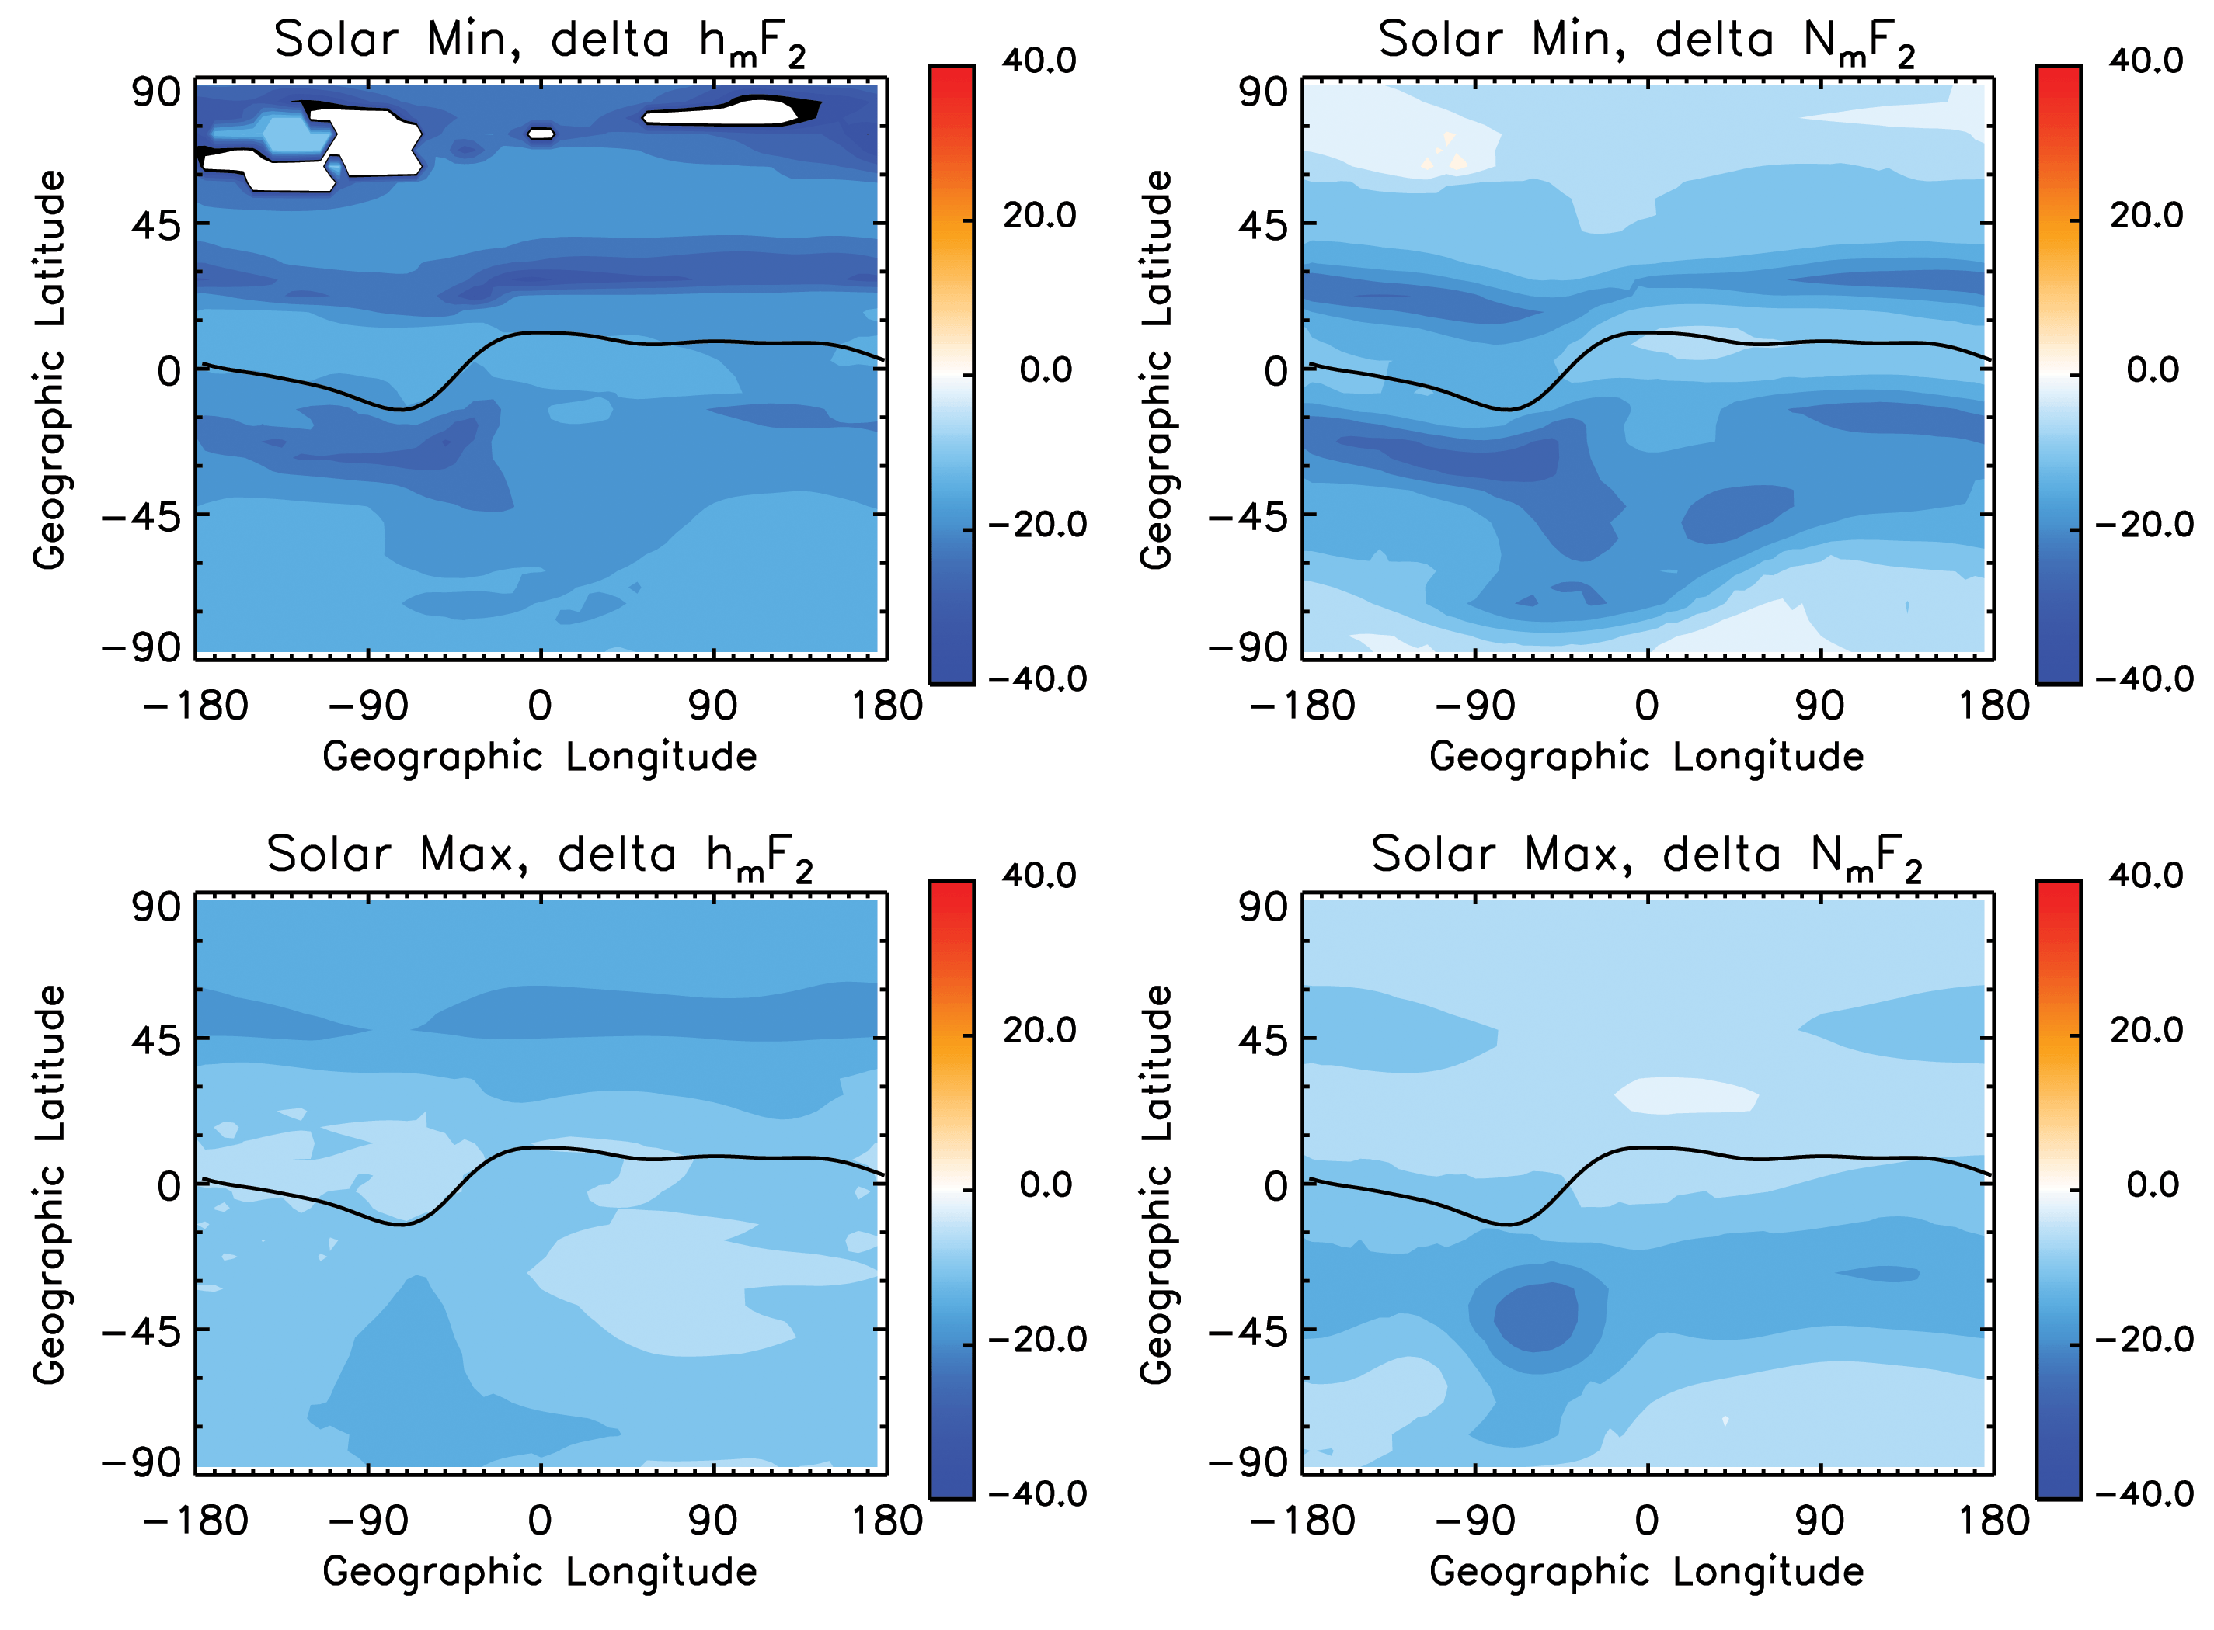
Figure 1: Changes of h_{m}F₂ and N_{m}F₂ (double CO₂ – base CO₂) at local noon for solar minimum (upper panels) and solar maximum (lower panel) conditions. Changes of h_{m}F₂ are absolution changes in km while changes of N_{m}F₂ are percentage changes. Solar minimum: $F_{\text{10}\text{.}7}=\overline{F_{\text{10}\text{.}7}}=\text{70}$; Solar maximum: $F_{\text{10}\text{.}7}=\overline{F_{\text{10}\text{.}7}}=\text{200}$. Geomagnetic K_{p} index is 1, i.e., under geomagnetic quiet condition. The black line in each figure is geomagnetic dip equator.

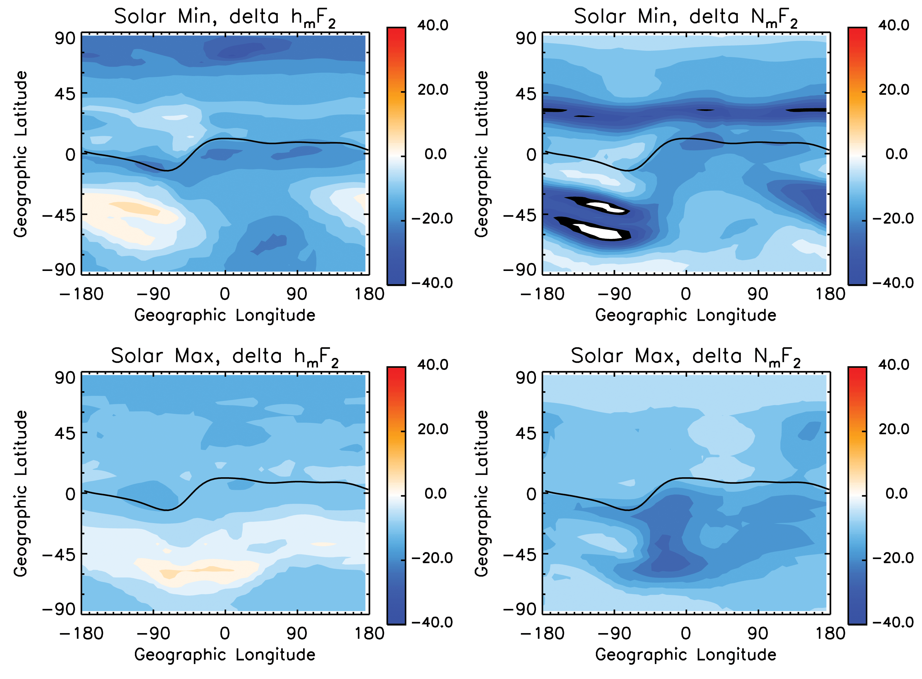
Figure 2: Changes of h_{m}F₂ and N_{m}F₂ (double CO₂ – base CO₂) at 3:00am for solar minimum (upper panels) and solar maximum (lower panel) conditions. Changes of h_{m}F₂ are absolution changes in km while changes of N_{m}F₂ are percentage changes. Solar minimum: $F_{\text{10}\text{.}7}=\overline{F_{\text{10}\text{.}7}}=\text{70}$; Solar maximum: $F_{\text{10}\text{.}7}=\overline{F_{\text{10}\text{.}7}}=\text{200}$. Geomagnetic K_{p} index is 1, i.e., under geomagnetic quiet condition. The black line in each figure is geomagnetic dip equator.

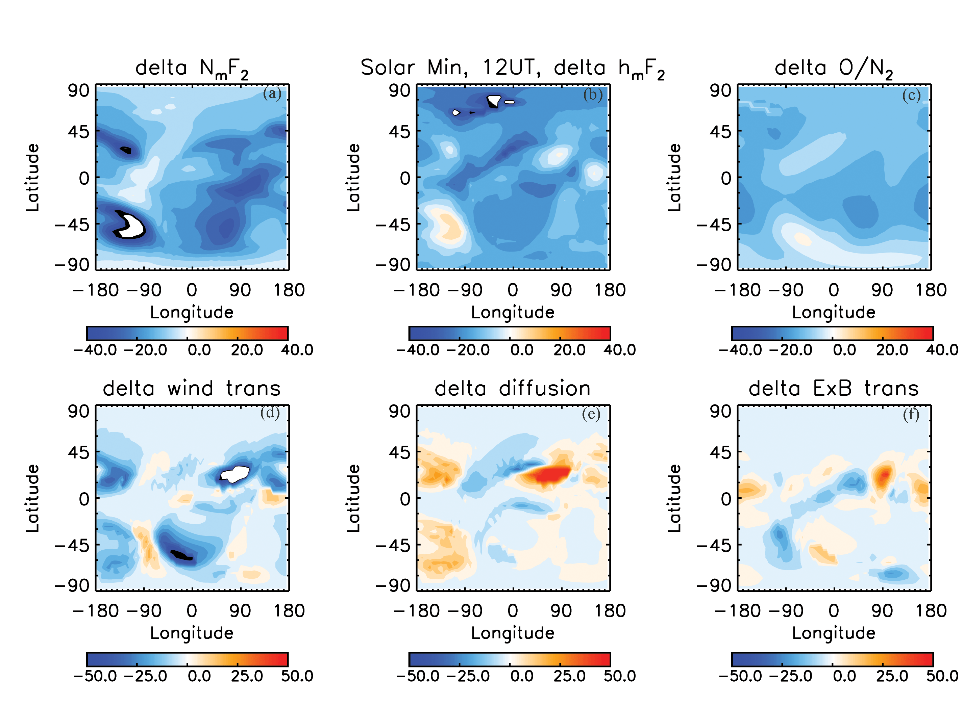
Figure 3: Changes (double CO₂ – base CO₂) of N_{m}F₂ and h_{m}F₂, changes of O/N₂ ratio, and the three plasma transport terms, i.e., transport by neutral wind, ambipolar diffusion, and $E×B$drift, at UT 12:00 under solar minimum conditions at 12:00UT, assuming geomagnetic quiet condition ($K_{p}=1$). The differences are calculated on pressure surfaces where F₂ peaks are located. Values shown in the figures: percentage difference for N_{m}F₂ and O/N₂; absolute change in km for h_{m}F₂; and absolute changes in cm⁻³s⁻¹ for the three transport terms.
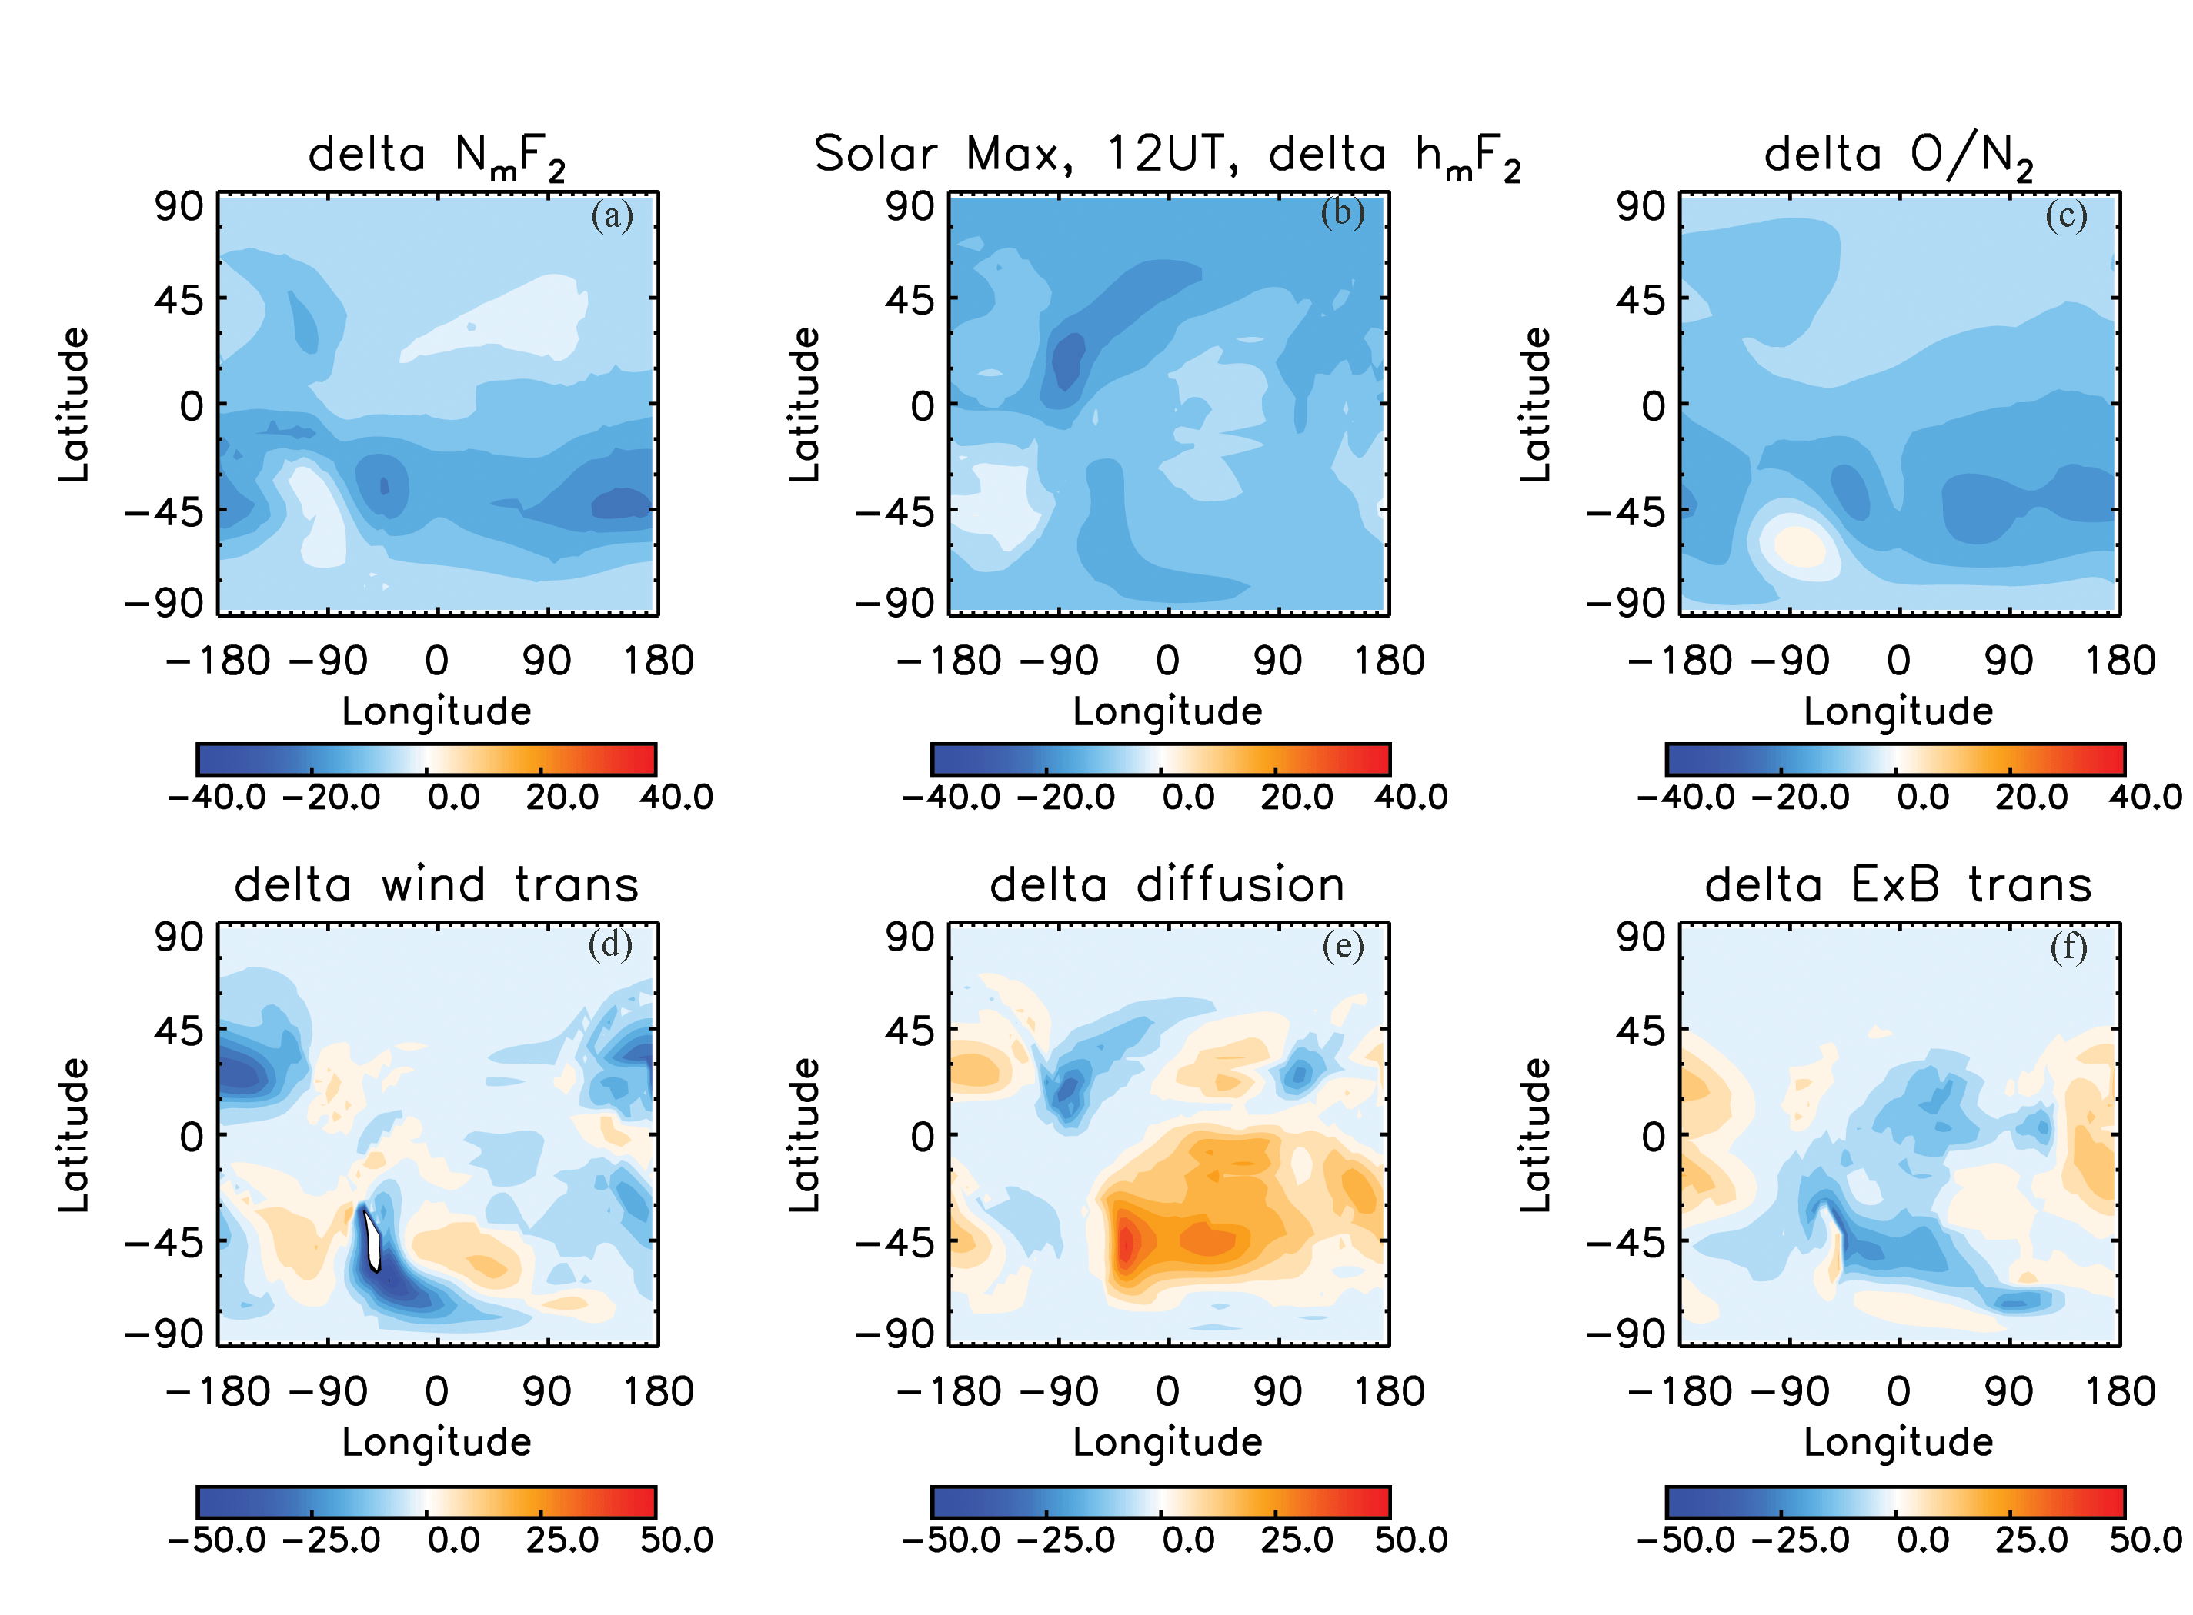
Figure 4: Changes (double CO₂ – base CO₂) of N_{m}F₂ and h_{m}F₂, changes of O/N₂ ratio, and the three plasma transport terms, i.e., transport by neutral wind, ambipolar diffusion, and $E×B$drift, at UT 12:00 under solar maximum conditions at 12:00UT, assuming geomagnetic quiet condition ($K_{p}=1$). The differences are calculated on pressure surfaces where F₂ peaks are located. Values shown in the figures: percentage difference for N_{m}F₂ and O/N₂; absolute change in km for h_{m}F₂; and absolute changes in cm⁻³s⁻¹ for the three transport terms.
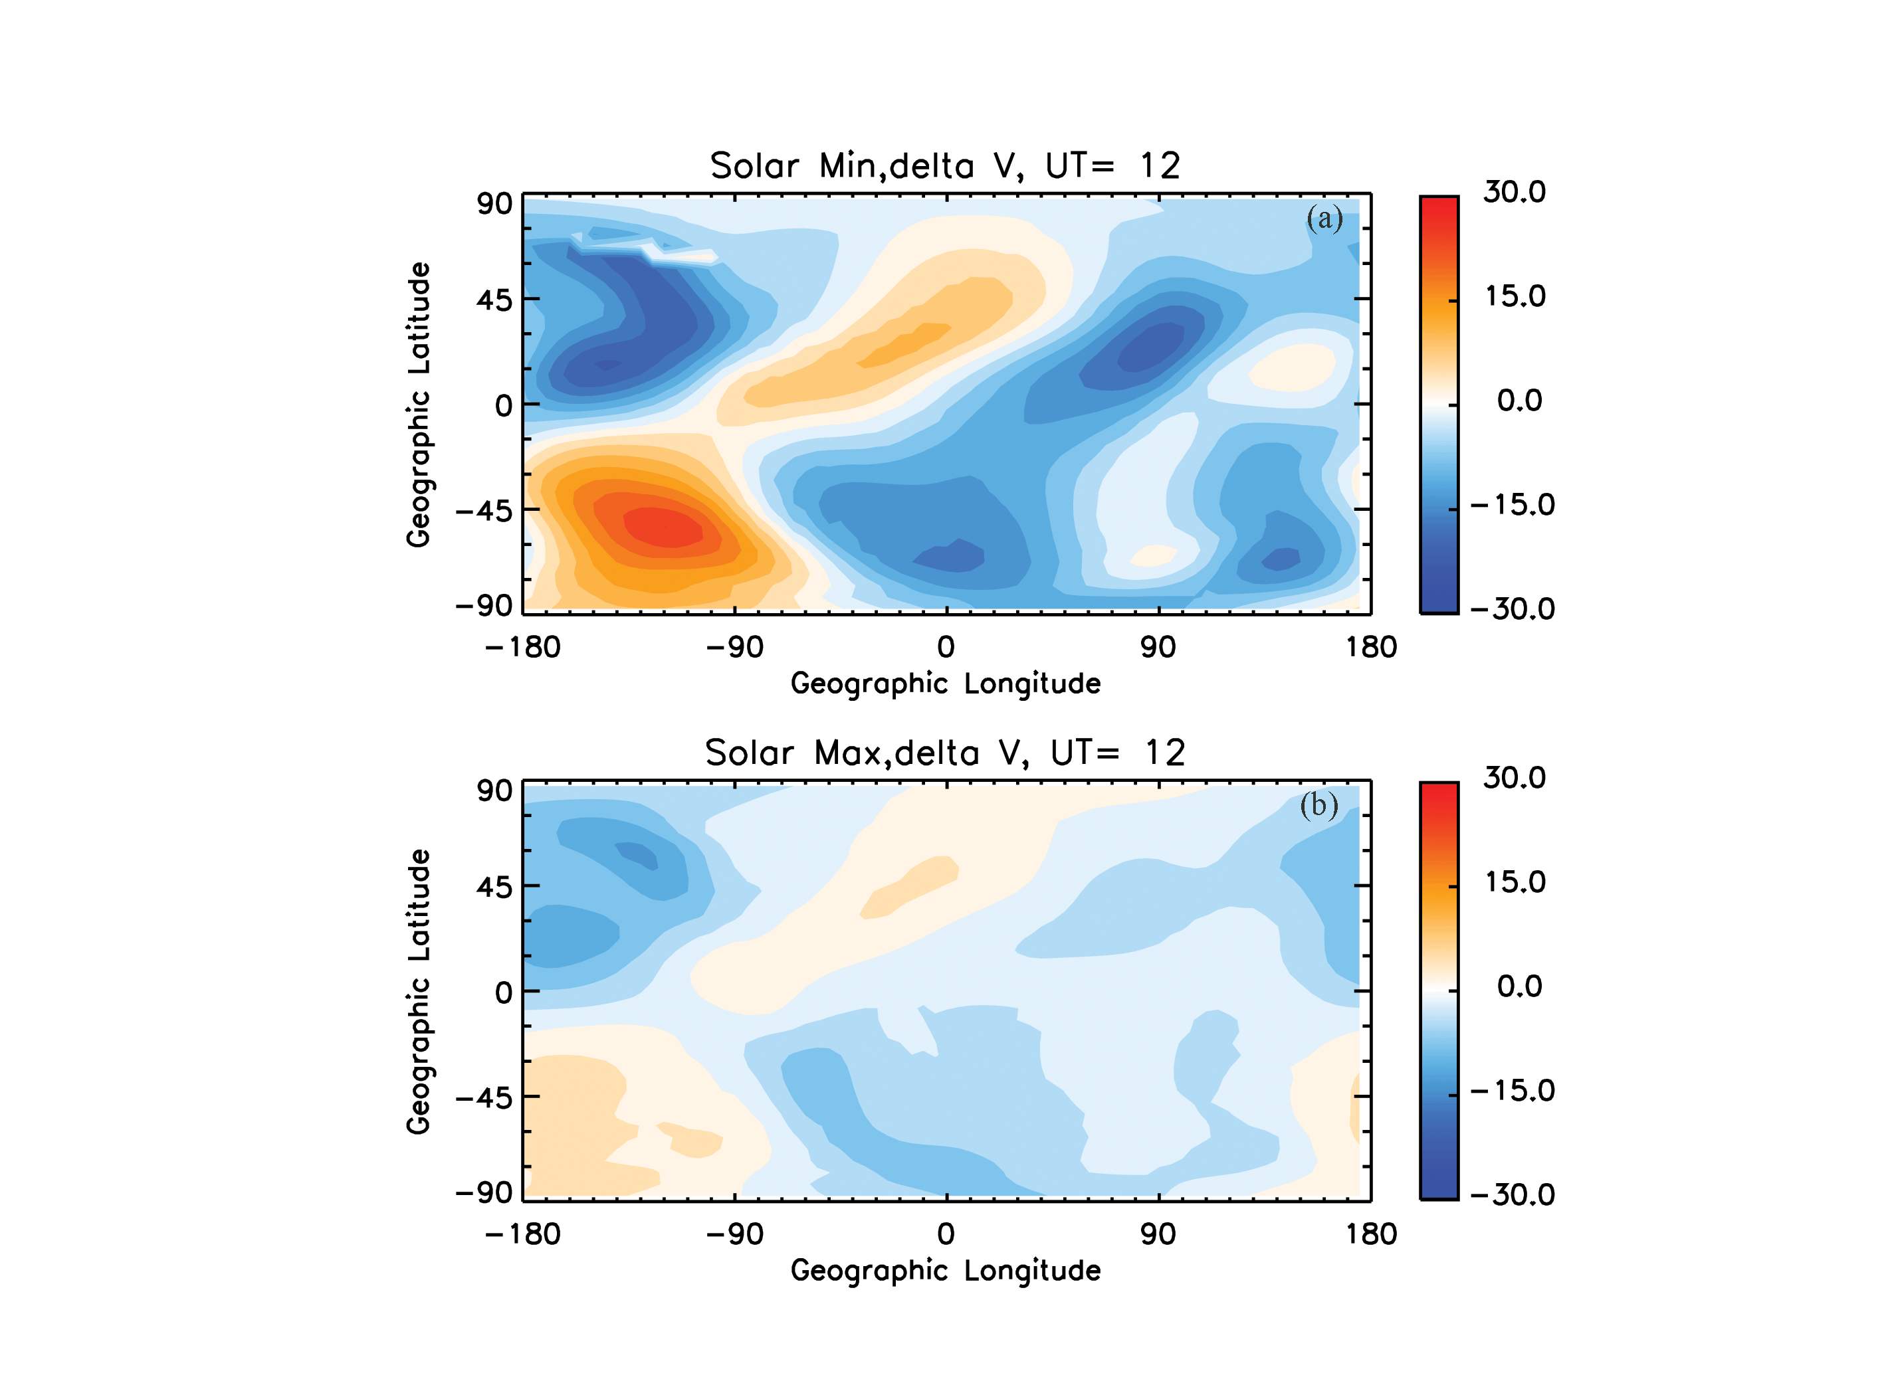
Figure 5: Changes (double CO₂ – base CO₂) of meridional wind due to cooling and contraction of the thermosphere caused by increased CO₂ concentration, under solar minimum (upper panel) and solar maximum (lower panel) conditions at 12:00UT, assuming geomagnetic quiet condition ($K_{p}=1$). Values shown in the figures are absolution changes in m/s.
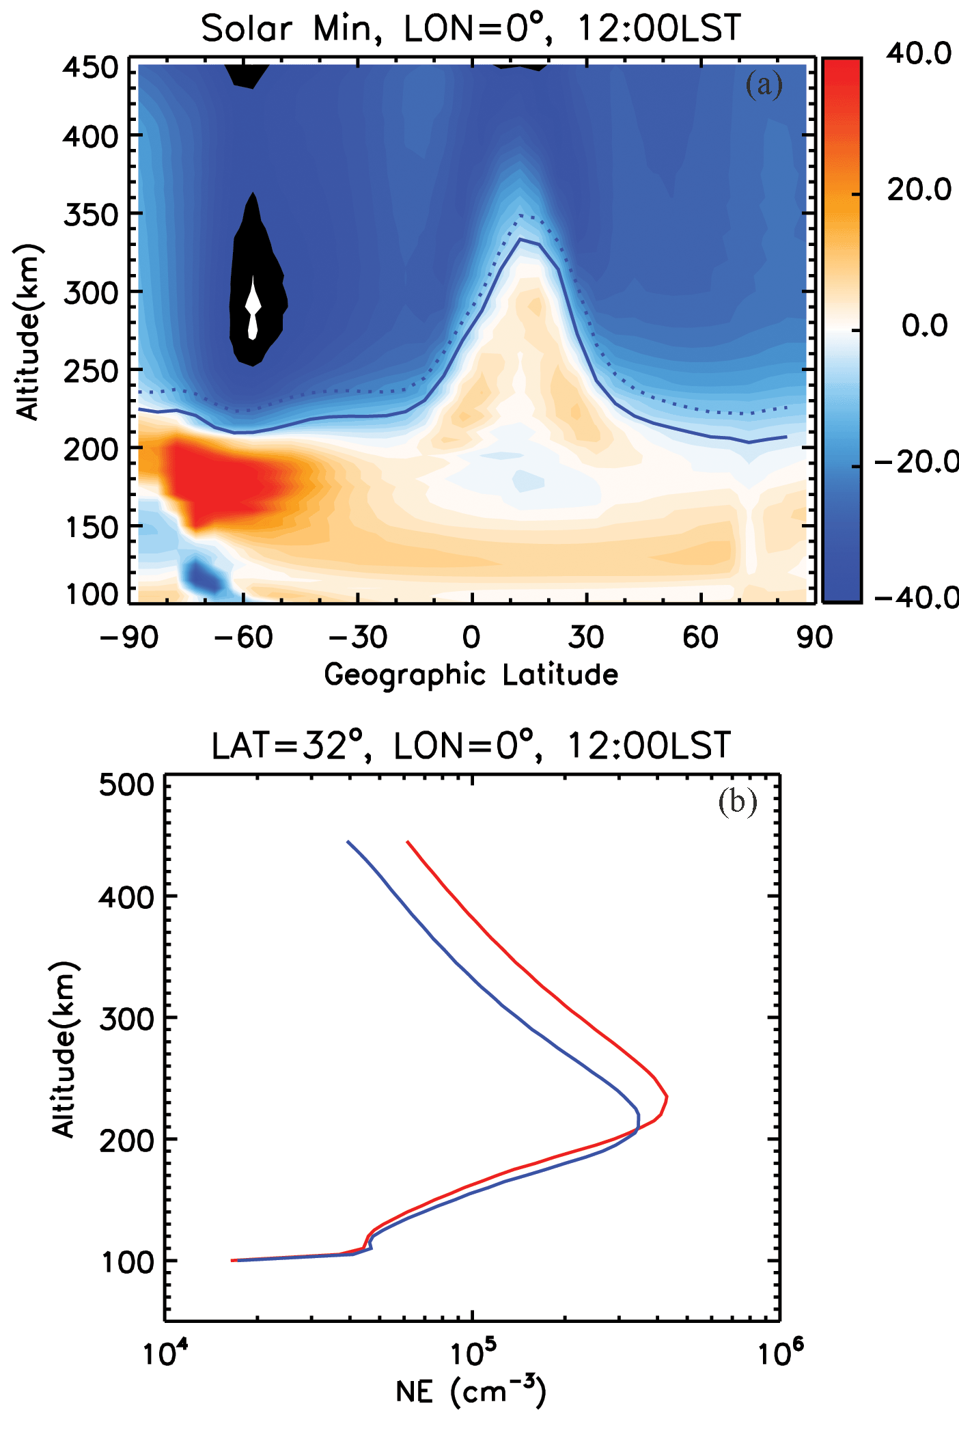

Figure 6: (a): Changes (double CO₂ – base CO₂) of electron density (percentage change) as a function of latitude (X-axis) and altitude (Y-axis) for one of longitudes of figure 1 (longitude=0º) at local noon, for solar minimum and geomagnetic quiet conditions. Dotted line: F₂ peak for the base CO₂ case; solid line: F₂ peak for the double CO₂ case. (b): electron density profiles for one of the latitudes of figure 6(a) (32º). Red: the base case; blue: the double CO₂ case.

