Model Simulations of Global Change in the Ionosphere

Liying Qian, Stanley C. Solomon, Raymond G. Roble,
National Center for Atmospheric Research, High Altitude Observatory
1850 Table Mesa Dr., Boulder, CO 80307-3000

Timothy J. Kane
The Pennsylvania State University, Depts. of Electrical Engineering and Meteorology
University Park, PA 16802

Submitted to Geophysical Research Letters
2007

Abstract. Global ionosonde data have been used to detect the effects of climate change in the ionosphere. Observations of secular trends in the E and F₁ regions indicate that electron densities have increased, and that the height of the E-region peak has decreased, during the past several decades. Detection of trends in the upper ionosphere through analysis of F₂-layer parameters has been more complex and controversial. In order to facilitate observational detection of long-term trends in the ionosphere, simulations were performed using a single-column upper atmosphere model. CO₂ concentrations for the year 2000 and for the year 2100 (using projections from the Intergovernmental Panel on Climate Change) were used to investigate changes of electron densities and the altitudes of ionospheric layers. Results show that increased CO₂ concentration increases electron density in the lower regions of the ionosphere, but decreases electron density in the upper ionosphere. The transition altitude occurs slightly below the F₂ peak altitude (h_{m}F₂). The proximity of h_{m}F₂ to the transition altitude may explain why different analyses of long-term trends in N_{m}F₂ have shown both positive and negative trends. The altitudes of the ionosphere E, F₁ and F₂ regions decrease with increased CO₂ concentration.

1. Introduction
Roble and Dickinson [1989] first suggested that there will be long-term changes of the ionospheric E- and F-region peak densities in response to cooling and contraction of the mesosphere and the thermosphere, due to changes in greenhouse gas concentrations. Rishbeth [1990] used basic theory of the ionosphere to study the ionospheric effects of the long-term cooling in the upper atmosphere proposed by Roble and Dickinson [1989]; it was concluded that the long-term cooling in the upper atmosphere would lower the E- and F₂-region peak heights but changes in the E- and F₂-region electron density should be small. Rishbeth and Roble [1992] investigated global change in the ionosphere using the NCAR Thermosphere-Ionosphere General Circulation Model (TIGCM) [Roble et al., 1988] by doubling CO₂ and CH₄ concentrations, and found that the height of the F₂-layer peak dropped on average by about 15 km but that F₂-layer electron density change was minimal. Following these theoretical and modeling studies, ground-based ionosonde data have been analyzed in attempts to detect long-term trends in the ionosphere [e.g. Bremer, 1992; Ulich and Turunen, 1997; Bremer, 1998; Upadhyay and Mahajan, 1998; Danilov and Mikhailov, 1999; Mikhailov and Marin, 2000, 2001; Clilverd et al, 2003; Danilov, 2003]. There is evidence that the altitudes of the E and F1 regions have decreased, and the E- and F1-region electron densities have increased in the past three to four decades [Bremer, 1998, 2001; Laštovička and Bremer, 2004; Laštovička et al., 2006a]. Long-term trends of F₂ parameters have been more complex and controversial with regard to methodology, results, and their interpretation [Bremer, 1998; Mikhailov and Marin, 2000, 2001; Danilov, 2001; Clilverd et al., 2003; Danilov, 2003; Laštovička, 2005; Laštovička et al., 2006a; Laštovička et al., 2006b]. Both negative and positive trends of F₂ peak electron density have been inferred; long-term changes of geomagnetic activity and greenhouse gas concentrations have been invoked as explanations.
Causes of long-term trends of the ionosphere can be natural or anthropogenic in origin [Rishbeth, 1997]. Solar irradiance and geomagnetic activity are the primary drivers forcing the ionosphere, therefore, long-term changes in solar activity and geomagnetic activity could cause long-term changes in the ionosphere. Long-term trends in the neutral atmosphere [Keating, 2000; Emmert at al., 2004a, b; Marcos et al., 2005], which have been mainly attributed to increased concentration of CO₂, can cause long-term changes in the ionosphere through production, loss, and transport of the plasma. In addition, the ionosphere, and the F₂ peak in particular, is strongly influenced by dynamics and electrodynamics [Rishbeth, 1998]. Neutral wind or electric fields can shift the F₂ peak altitude and change the peak electron density, and thus can cause complex latitudinal, longitudinal, and solar local time distributions of any long-term trends.
The purpose of this study is to explore mechanisms of long-term trends in the ionosphere, to explain the complex pattern and controversies found in observations of F₂ parameters, and to facilitate ionosonde data analysis of long-term trends. Even though secular trends in the past several decades might be influenced by natural causes of solar origin, observed trends in the upper atmosphere and ionosphere have been mainly attributed to the steady increase of greenhouse gas concentrations [Danilov, 2003; Laštovička, 2005]. Therefore, this study focuses on investigation of long-term trends in the ionosphere due to increased concentration of the greenhouse gas CO₂. The long-term trends in the E and lower F₁ region of the ionosphere may be slightly affected by the stratosphere ozone depletion since effect of the ozone depletion on lower thermospheric temperature and density has been demonstrated by model study [Akmaev et al., 2006]. However, this secondary effect is not treated here, as the ozone recovery is expected to occur before 2100. In addition, this paper addresses long-term trends of the global mean ionosphere rather than global distributions of the trends. A global mean single-column version of the NCAR Thermosphere-Ionosphere-Mesosphere Electrodynamics General Circulation Model (TIME-GCM) is used to quantify changes of the E, F₁, and F₂ regions due to increased CO₂ concentration, and physical processes in the ionosphere are invoked to explain the changes in different ionospheric regions.

2. Model Description
The model used in these studies is a self-consistent global mean model of the mesosphere, the thermosphere, and the ionosphere. Its original version is described by Roble et al. [1987]; extension to the mesosphere and additional modifications are documented in Roble [1995]. The model is a 1D representation of aeronomic processes in the NCAR TIME-GCM [Roble and Ridley, 1994], and thus can be considered as the single-column version of the TIME-GCM. Recent improvements include incorporation of a new solar EUV energy deposition scheme [Solomon and Qian, 2005], and updates to cooling rates and odd-nitrogen chemistry [Roble and Solomon, 2005; Bailey et al., 2002]. The global mean model can now be run in a time-dependent mode with varying solar activity [Qian et al., 2006], or run to steady state using constant solar forcing.
For present-day simulations, the model was run to steady state with a CO₂ concentration of 365 ppmv imposed at the lower boundary (30 km), representative of the year 2000. For a future projection, a CO₂ concentration of 730 ppmv was applied at the lower boundary, representative of the year 2100, as projected by the Intergovernmental Panel on Climate Change (IPCC) [2007] emission scenario A1B, a medium emission scenario. Different solar activity levels were employed but low geomagnetic activity conditions were assumed. Electron density profiles obtained by the different model experiments were then compared to quantify changes of ionospheric parameters in different regions. Mechanisms of these changes were explored, and solar-cycle dependence of these changes was also investigated.

3. Results

3.1 Long-term Trends in the E, F₁, and F₂ Regions
In response to cooling and contraction of the middle atmosphere and thermosphere, the entire ionosphere will similarly contract, leading to lower altitudes of the E-region and F-region density peaks h_{m}E and h_{m}F₂. Changes in the magnitudes of the peaks N_{m}E and N_{m}F₂, and changes in density throughout the ionosphere, are more subtle. Model experiments were conducted to illustrate these changes. The experiments described in this section were conducted assuming moderate levels of solar activity, using an assumed value of the 10.7 cm proxy index F_{10.7} equal to 150.
Figure 1 shows E- and F₁-region electron density profiles (panel b) and F₂ region electron density profiles (panel a) with CO₂ concentrations at year 2000 levels and the projected year 2100 levels, under solar medium conditions. The altitudes of the E and F₁ regions decrease which is consistent with the cooling and contraction of the thermosphere due to increased CO₂. The E- and F₁-region electron density increases due to increased CO₂ forcing. Increase of electron density in the E- and F₁-region electron density is controlled by compositional changes and subsequent changes in photochemical equilibrium due to the cooling and contraction of the thermosphere responding to increased CO₂. Section 3.2 will give detailed discussion of the mechanism. This pattern of decrease of altitude and increase of electron density of the ionosphere in the E and F₁ regions agrees with results from ionosonde data analyses [Bremer, 1998, 2001; Laštovička and Bremer, 2004; Laštovička et al., 2006a].
The F₂ region (figure 1a) contains both positive and negative change regions, but the peak electron density N_{m}F₂ decreases with increased CO₂ concentration. The transition altitude from positive change to negative change is near but slightly below the peak altitude h_{m}F₂. This altitude indicates a transition from where electron density is mainly controlled by photochemical equilibrium to where electron density is mainly controlled by diffusive transport, which will be explained in section 3.2. Change in forcing of photochemical equilibrium or forcing of diffusive transport can potentially cause a shift in this altitude, but this transition altitude remains near the peak altitude h_{m}F₂ [Rishbeth, 1998]. The proximity of the positive-to-negative transition to h_{m}F₂ may explain why ionosonde data analyses have resulted in a complex pattern of long-term trends in F₂ peak electron density, with both positive and negative trends detected. Recent reviews of long-term trends of F₂ peak electron density by Laštovička et al. [2006b, 2008] concluded that long-term trends of N_{m}F₂ are either negative or insignificant. This pattern of long-term trends of N_{m}F₂ is consistent with these model simulations. Panel (a) of figure 1 also shows that the altitude of the F₂ region, including the peak altitude h_{m}F₂, decreases with increased CO₂ concentration.
3.2 Mechanisms of Global Change in the Ionosphere
Model experiments conducted in section 3.1 were analyzed to elucidate the reasons for the changes shown in figure 1. Percentage changes of electron density as a function of altitude are shown in figure 2. As we mentioned earlier, the model experiments were conducted under solar medium and geomagnetic quiet conditions, with CO₂ concentrations changing from the base level of year 2000 to the projected doubling of CO₂ concentration in year 2100. The increased CO₂ concentration causes electron density increases in the lower ionosphere up to about 250 km; above that altitude, electron density decreases. To understand the causes of this transition, simplified physics of the quasi-equilibrium ionosphere are described below.
Electron density in the E region is proportional to ionization rate but inversely proportional to the ratio of the two major ions in the E region, ${\text{NO}}^{+}$and$O_{2^{+}}$. The mechanism is explained as follows. The E region is in approximate photochemical equilibrium between production of ions and loss of ions through dissociative recombination:
$$M_{2}+hν\vec{q}M_{2^{+}}+e$$

$M_{2^{+}}+e\vec{α}M+M$

where $M_{2}$represents major species in the E region, which are $O_{2}$ and $N_{2}$, $q$is the ionization rate, and $α$is the dissociative recombination rate. Since the molecular ion $N_{2^{+}}$is rapidly converted to ${\text{NO}}^{+}$and $O_{2^{+}}$through ion-atom interchange and charge exchange reactions with atomic and molecular oxygen, the major ions in the E region are ${\text{NO}}^{+}$and $O_{2^{+}}$. Assuming photochemical equilibrium:
$q=α[M_{2^{+}}][e]$
where $[M_{2^{+}}]$ and $[e]$ are ion and electron number density, respectively. Assuming charge neutrality:
$[e]={\left(\frac{q}{α}\right)}^{1/2}$
The dissociative recombination rate of ${\text{NO}}^{+}$is nearly twice that of$O_{2^{+}}$. Therefore, the effective recombination rate $α$is proportional to ${\text{NO}}^{+}$/$O_{2^{+}}$, and electron density is inversely proportional to this ratio:
$$[e]{µq}/([{\text{NO}}^{+}]/[O_{2^{+}}])$$
Figure 3 shows the corresponding altitude profile of percentage changes of the ionization rate and the ratio of ${\text{NO}}^{+}$and $O_{2^{+}}$from year 2000 to year 2100, between 100 km and 130 km. Change of the ratio of ${\text{NO}}^{+}$to $O_{2^{+}}$is negative in the E region. This is because lower temperature due to increased CO₂ concentration causes lower NO density, which in turn decreases NO⁺ density since the main source of NO⁺ is the reaction of O₂⁺ with NO. Change of the ionization rate is positive at all E-region altitudes. Cooling and contraction of the thermosphere causes less absorption of solar irradiance before it reaches the E-region altitudes, and thus can enhance ionization rate in this region. Consequently, electron density in this altitude range increases with increasing CO₂ concentration. Possible negative secular trends of ${{\text{NO}}^{+}}/{O_{2^{+}}}$in the E region have been observed [Danilov, 1997, 2001].
As the ionosphere transitions from the E region to the F region, atomic oxygen becomes the major neutral species. The F region up to the F₂ peak is also in approximate photochemical equilibrium, but different photochemical production and loss processes dominate. The production of ions is mostly due to ionization of atomic oxygen:
$$O+hν→O^{+}+e$$
Since the recombination rate of $O^{+}$is slow, loss of ions goes through two steps. The first step is for $O^{+}$to transfer to ${\text{NO}}^{+}$and$O_{2^{+}}$through the ion-atom interchange reactions:
$$\begin{aligned}O^{+}+N_{2}→{\text{NO}}^{+}+N \\ O^{+}+O_{2}→O_{2^{+}}+O\end{aligned}$$
followed by dissociative recombination of the ions:
$$\begin{aligned}{\text{NO}}^{+}+e→N+O \\ O_{2^{+}}+e→O+O\end{aligned}$$
At these altitudes, the rates of the ion-atom interchange reactions are much slower than the dissociative recombination rates. Consequently, electron density is determined by the balance between the ionization rate and the rates of the ion-atom interchange reactions. Since $N_{2}$ dominates over $O_{2}$, electron density is roughly proportional to the ratio of O and$N_{2}$:
$$[e]∝O/{N_{2}}$$
Figure 4 shows altitude profile of percentage change of O/N₂ from 2000 to 2100 scenario in this region. Change of O/N₂ is positive (on constant altitude surfaces) due to the cooling and contraction of the atmosphere, which yields an increase in electron density.
The F₂ peak is where transport of the plasma becomes comparable to chemical production and loss. Above the F₂ peak, the electron density altitude profile becomes mainly controlled by ambipolar diffusion. Consequently, electron density decreases exponentially with the plasma scale height. Since the cooling and thus contraction of the atmosphere [Roble and Dickinson, 1989] reduces the plasma scale height, electron density decreases responding to increased CO₂ concentration in this altitude range.

3.3 Solar cycle dependence of ionospheric changes
Thermospheric long-term trends show a clear solar-cycle dependence, with the secular decrease of neutral density under solar minimum conditions approximately three times of that under solar maximum conditions [Emmert et al., 2004a,b; Qian et al., 2006]. It is reasonable to expect that the ionospheric long-term trends will also depend on solar activity. This was investigated using model experiments with CO₂ concentrations for the year 2000 and the year 2100 as projected by the IPCC [2007] A1B emission scenario, under solar minimum and solar maximum conditions. Table 1 shows changes of E- and F₂-region parameters as a result of increased CO₂ concentration from year 2000 to year 2100. The solar minimum simulation was conducted with a F_{10.7} proxy index value of 70, and the solar maximum simulation used F_{10.7} equal to 200. The peak altitude of the F₂ peak h_{m}F₂ decreases by 14 km and 10 km under solar minimum and solar maximum conditions, respectively, while the peak electron density (N_{m}F₂) decreases by 9% and 4%. Therefore, trends of F₂ parameters are expected to be larger under solar minimum conditions than solar maximum condition, similar to the solar-cycle dependence of secular change in the thermosphere. Decreases of E-region peak altitude h_{m}E are 2 km under solar minimum conditions and 4 km under solar maximum conditions. Changes of E-region peak electron density N_{m}E are relatively small, with 4% and 2% increases under solar minimum and solar maximum, respectively.

4. Discussion
Model experiments with CO₂ concentration change from 2000 to the projected 2100 levels based on the IPCC [2007] emission scenario A1B indicate that long-term trends of electron density transitions from positive at lower altitudes to negative at higher altitudes; the transition altitude is near the F₂ peak. The positive and negative trends are determined by basic ionospheric physics, with positive trends in altitude ranges governed by photochemical equilibrium, and negative trends at higher altitude where diffusive transport dominates.
The E and F₁ regions are within the positive change range and thus electron density in these regions should increase with increasing CO₂ concentration. The E-region peak altitude, however, should decrease with increased CO₂ concentration. This pattern of increasing of electron density and decrease of the altitude of the lower ionosphere is consistent with results from analyses of ionosonde data attempting to measure long-term trends in the E and F₁ regions during the past several decades. The F₂ region consists of both positive and negative change regions, with the transition altitude near the F₂ peak altitude. This may explain the complex results obtained from different analyses of ionosonde observations of secular change in F₂ peak electron density, with both positive and negative trends found. Model simulation of the F₂ peak electron density predicts that it decreases with increased CO₂ concentration, in agreement with recent reviews of ionosonde trend detection. These simulations show that the F₂ peak altitude also decreases with increased CO₂ concentration.
Trends in ionospheric F₂ parameters are larger under solar minimum conditions than solar maximum conditions, similar to the solar-cycle dependence of secular trends in the thermosphere. This can be explained by examining effects of stronger cooling under solar minimum condition. Larger temperature decrease due to doubling of CO₂ under solar minimum causes larger decrease in plasma scale height, which in turn causes a fixed pressure surface to descend more compared to the case of the solar maximum condition. Since h_{m}F₂ tends to remain on a same pressure surface as temperature changes [Garriott and Rishbeth, 1963], h_{m}F₂ should have larger decrease under solar minimum condition. In addition, F2 peak is where chemical control of plasma density gives way to transport control. Plasma transport causes plasma density to decrease according to plasma scale height. Therefore, larger change in plasma scale height under solar minimum condition can result in more significant change in N_{m}F₂.
These results may give some guidance to further analyses of long-term ionospheric measurements. Changes in h_{m}E may be a significant fraction of a scale height in the E-region, but since scale heights are low at these altitudes, this may be difficult to measure on the scale of decades. Changes in N_{m}E are small but detectable [Bremer, 2001; Bremer et al., 2004]. The secular trends in N_{m}F₂ may be comparatively small compared to intrinsic variability in the F-region, but this parameter is the most unambiguous and stable measurement that can be obtained from the extensive ionosonde historical data set, and is worth tracking carefully. The accurate measurement of h_{m}F₂ may be more difficult using ionosonde measurements, but it is obtainable from incoherent scatter radar observations, and it is the most direct and significant secular change that is expected from increasing CO₂ levels.
The upper ionosphere is highly influenced by neutral atmosphere dynamics and by electrodynamics. These effects could cause significant regional features in F₂ long-term trends. For instance, long-term change of geomagnetic field could significantly influence long-term change in the ionosphere in some geographic regions. Just as simulations of climate in the troposphere and at the Earth’s surface are progressing from general averages of expected changes to regional climate change, studies of the effects in the thermosphere/ionosphere system must similarly progress. Three-dimensional modeling studies may improve our interpretation and understanding of secular trends inferred at particular geographic locations.

Acknowledgments. This research was supported by NASA grants NNX07AC55G, NNX07AC61G, and NNH05AB55I to the National Center for Atmospheric Research. NCAR is supported by the National Science Foundation.
References
Akmaev, R. A., V. I. Fomichev, X. Zhu (2006), Impact of middle-atmospheric composition changes on greenhouse cooling in the upper atmosphere, J. Atmos. Terr. Phys., 68, 1879-1889.
Bailey, S. M., C. A. Barth, and S.C. Solomon (2002), A model of nitric oxide in the lower thermosphere, J. Geophys. Res., 107, 1205, doi:10.1029/2001JA000258.
Bremer, J. (1992), Ionospheric trends in mid-latitudes as a possible indicator of the atmospheric greenhouse effect, J. Atmos. Terr. Phys., 54, 1505-1511.
Bremer, J. (1998), Trends in the ionospheric E and F regions over Europe, Ann. Geophys., 16, 986-996.
Bremer, J. (2001), Trends in the thermosphere derived from global ionosonde observations, Adv. Space Res. 28, 997-1006.
Bremer, J, L. Alfonsi, P. Bencze, J. Laštovička, A.V. Mikhailov and N. Rogers (2004), Long-term trends in the ionosphere and upper atmosphere parameters, Ann. Geophys. 47 (Supplement to nos. 2–3), pp. 1009–1029.
Clilverd, M. A., T. Ulich, and M. J. Jarvis (2003), Residual solar cycle influence on trends in ionospheric F2-layer peak height, J. Geophys. Res., 108(A12), 1450, doi:10.1029/2003JA009838.
Danilov, A. D. (1997), Long-term changes of the mesosphere and lower thermosphere temperature and composition, Adv. Space Res., 20(11), 2137.
Danilov, A. D., and A. V. Mikhailov (1999), Spatial and seasonal variations of the foF2 long-term trends, Ann. Geophys., 17, 1239-1243.
Danilov, A. D. (2001), Do ionospheric trends indicate to the greenhouse effect? Adv. Space Res., 28(7), 987-996.
Danilov, A. D. (2003), Long-term trends in foF2 independent of geomagnetic activity, Ann. Geophys. 21, pp. 1167–1176.
Emmert, J. T., J. M. Picone, J. L. Lean, and S. H. Knowles (2004a), Global change in the thermosphere: Compelling evidence of a secular decrease in density, J. Geophys. Res., 109, A02301, doi:10.1029/2003JA010176.
Emmert, J. T., J. M. Picone, J. L. Lean, and S. H. Knowles (2004b), Correction to “Global change in the thermosphere: Compelling evidence of a secular decrease in density,” J. Geophys. Res., 109, A04307, doi:10.1029/2004JA010462.
Garriott, O. K. and H. Rishbeth (1963): Effects of temperature changes on the electron density profile in the F₂ layer. Planet. Space Sci. 11, 587-590.
IPCC AR4 WG1 report (2007), Climate Change 2007: The Physical Science Basis.
Keating, G. M., R. H. Tolson, and M. S. Bradford (2000), Evidence of long-term global decline in the Earth’s thermospheric densities apparently related to anthropogenic effects, Geophys. Res. Lett., 27, 1523-1526.
Laštovička, J., and J. Bremer (2004), An overview of long-term trends in the lower ionosphere below 120 km, Surveys in Geophysics 25, pp. 69–99.
Laštovička, J. (2005), On the role of solar and geomagnetic activity in long-term trends in the atmosphere-ionosphere system, J. Atmos. Terr. Phys. 67, pp. 83–92.
Laštovička, J., R. A. Akmaev, G. Beig, J. Bremer, and J. T. Emmert (2006a), Global change in the upper atmosphere, Science, 314, pp. 1253 – 1254.
Laštovička, J., A. V. Mikhailov, T. Ulich, J. Bremer, A. G. Elias, N. Ortiz de Adler, V. Jara, R. Abarca del Rio, A. J. Foppiano, E. Ovalle, A. D. Danilov (2006b), Long-term trends in foF2: A comparison of various methods, J. Atmos. Terr. Phys. 68, pp. 1854-1870.
Laštovička, J., R. A. Akmaev, G, Beig, J. Bremer, J. T. Emmert, C. Jacobi, M. J. Jarvis, G. Nedoluha, Y. I. Portnyagin, and T. Ulich (2008), Emerging pattern of global change in the upper atmosphere and ionosphere, Ann. Geophys., in press.
Marcos, F. A., J. O. Wise, M. J. Kendra, N. J. Grossbard, and B. R. Bowman (2005), Detection of a long-term decrease in thermospheric neutral density, Geophys. Res. Lett., 32, L04103, doi:10.1029/2004GL021269.
Mikhailov, A. V., and D. Marin (2000), Geomagnetic control of the foF2 long-term trends, Ann. Geophys. 18, pp. 653–665.
Mikhailov, A. V., and D. Marin (2001), An interpretation of the foF2 and hmF2 long-term trends in the framework of the geomagnetic control concept, Ann. Geophys. 19, pp. 733–748.
Qian, L., R. G. Roble, S. C. Solomon, and T. J. Kane (2006), Calculated and observed climate change in the thermosphere, and a prediction for solar cycle 24, Geophys. Res. Lett., 33, L23705, doi:10.1029/2006GL027185.
Rishbeth, H. (1990), A greenhouse effect in the ionosphere? Planet. Space Sci. 38, 945-948.
Rishbeth, H., and R. G. Roble (1992), Cooling of the upper atmosphere by enhanced greenhouse gases: Modeling of thermospheric and ionospheric effects, Planet. Space Sci., 40, 1011-1026.
Rishbeth, H. (1997), Long-term changes in the ionosphere, Adv. Space Res. 20(11), 2149-2155.
Rishbeth, H. (1998), How the thermospheric circulation affects the ionospheric F2-layer, J. Atmos. Terr. Phys. 60, pp. 1385-1402.
Roble, R. G., E. C. Ridley, and R. E. Dickinson (1987), On the global mean structure of the thermosphere, J. Geophys. Res., 92, 8745-8758.
Roble, R. G., E. C. Ridley, A. D. Richmond, and R. E. Dickinson (1988), A coupled thermosphere/ionosphere general circulation model, Geophys. Res. Lett., 15, 1525.
Roble, R. G., and R. E. Dickinson (1989), How will changes in carbon dioxide and methane modify the mean structure of the mesosphere and thermosphere? Geophys. Res. Lett., 16, 1144-1441.
Roble, R. G. and E. C. Ridley (1994), Thermosphere-ionosphere-mesosphere-electrodynamics general circulation model (TIME-GCM): Equinox solar min simulations, 30-500 km, Geophys. Res. Lett., 21, 417.
Roble, R. G. (1995), Energetics of the mesosphere and thermosphere, The Upper Mesosphere and Lower Thermosphere: A review of Experiment and Theory, Geophysics Monograph 87.
Roble, R. G., and S. C. Solomon (2005), On modeling the upper atmosphere and ionosphere response to global change, (2005), Eos Trans. AGU, 86(18), Jt. Assem. Suppl., Abstract SA51A-01.
Solomon, S. C., and L. Qian (2005), Solar extreme-ultraviolet irradiance for general circulation models, J. Geophys. Res., 110, A10306, doi:10.1029/2005JA011160.
Ulich, T., E. Turunen (1997), Evidence for long-term cooling of the upper atmosphere in ionosonde data, Geophys. Res. Lett., 24(9), 1103-1106, 10.1029/97GL50896.
Upadhyay, H. O., K. K. Mahajan (1998), Atmospheric greenhouse effect and ionospheric trends, Geophys. Res. Lett., 25(17), 3375-3378, 10.1029/98GL02503.

Figure Captions
Figure 1. Electron number density profiles for the base case and the doubled CO₂ case, under solar medium conditions ($F_{\text{10}\text{.}7}={\overline{F}}_{\text{10}\text{.}7}=\text{150}$). Solid line: base case; dotted line: doubled CO₂ case. (a) F₂ region; (b) E and F₁ region.
Figure 2. Percentage change of electron number density from the base case to the doubled CO₂ case, under solar medium conditions ($F_{\text{10}\text{.}7}={\overline{F}}_{\text{10}\text{.}7}=\text{150}$).
Figure 3. Percentage changes from the base case to the doubled CO₂ case for the total ionization rate and the ratio of NO⁺ number density to O₂⁺ number density in the E region, under solar medium conditions ($F_{\text{10}\text{.}7}={\overline{F}}_{\text{10}\text{.}7}=\text{150}$).
Figure 4. Percentage change of O/N₂ from the base case to the doubled CO₂ case in the altitude range 120 km to 250 km, under solar medium conditions ($F_{\text{10}\text{.}7}={\overline{F}}_{\text{10}\text{.}7}=\text{150}$).

Table 1. Changes of ionospheric parameters due to change of CO₂ concentration from 2000 to the projected 2100 concentration based on the IPCC emission scenario A1B, under solar minimum and solar maximum conditions.
 | Solar Min | Solar Max
h_{m}F₂ | -14 km | -10 km
N_{m}F₂ | -9% | -4%
h_{m}E | -2 km | -4 km
N_{m}E | +4% | +2%
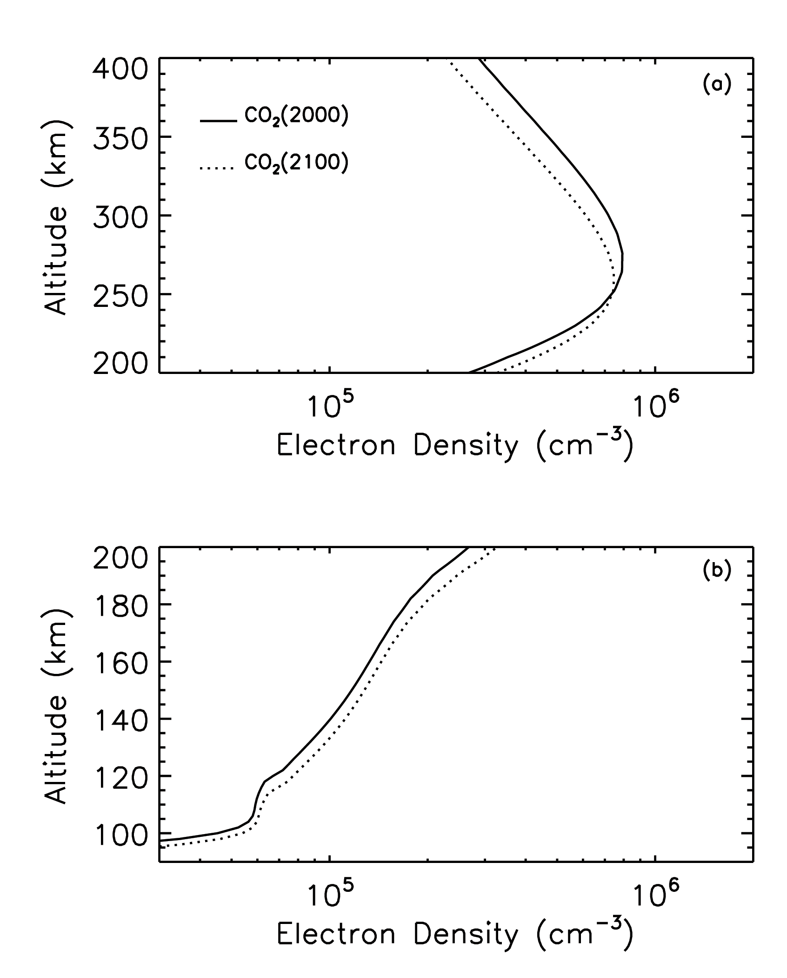
Figure 1. Electron number density profiles for the base case and the doubled CO₂ case, under solar medium conditions ($F_{\text{10}\text{.}7}={\overline{F}}_{\text{10}\text{.}7}=\text{150}$). Solid line: base case; dotted line: doubled CO₂ case. (a) F₂ region; (b) E and F₁ region.

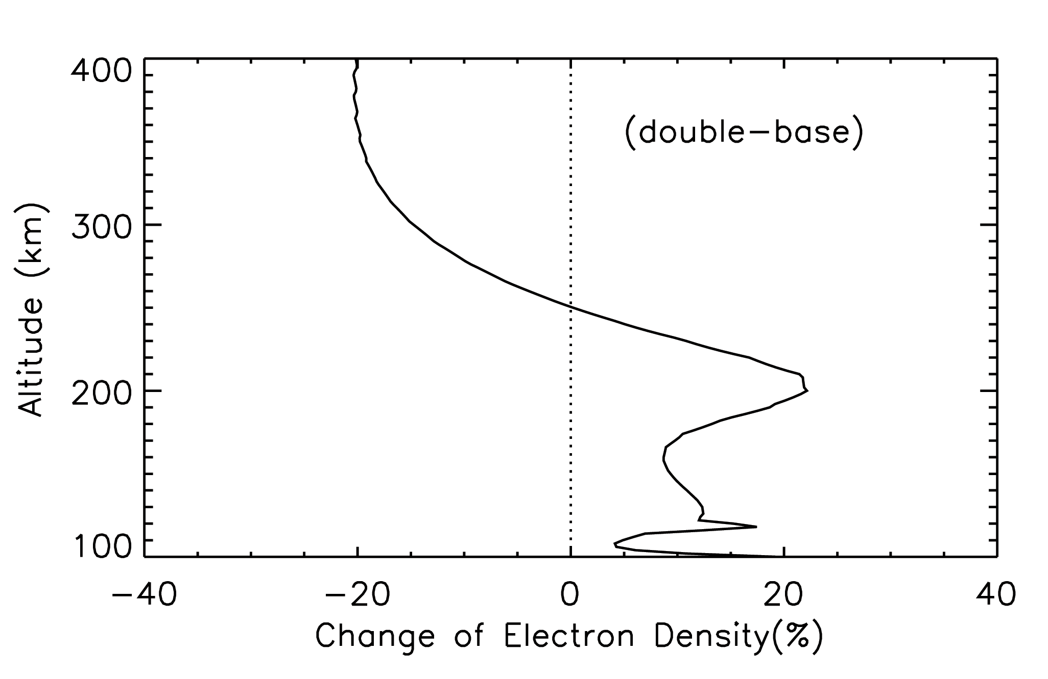

Figure 2. Percentage change of electron number density from the base case to the doubled CO₂ case, under solar medium conditions ($F_{\text{10}\text{.}7}={\overline{F}}_{\text{10}\text{.}7}=\text{150}$).

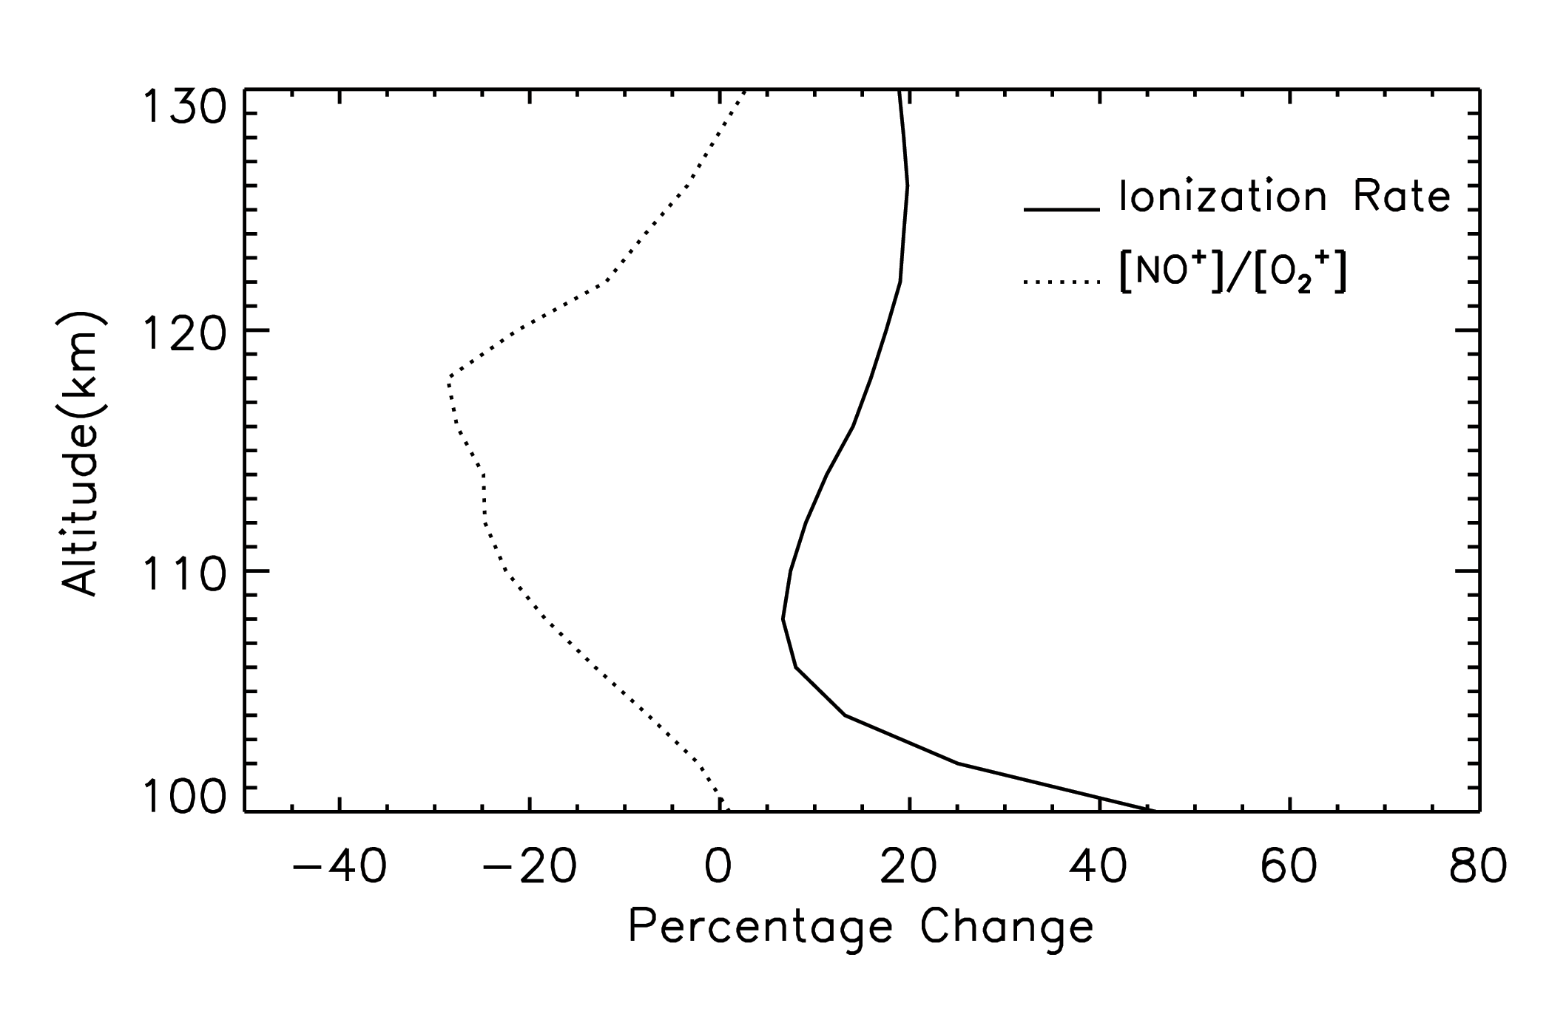

Figure 3. Percentage changes from the base case to the doubled CO₂ case for the total ionization rate and the ratio of NO⁺ number density to O₂⁺ number density in the E region, under solar medium conditions ($F_{\text{10}\text{.}7}={\overline{F}}_{\text{10}\text{.}7}=\text{150}$).

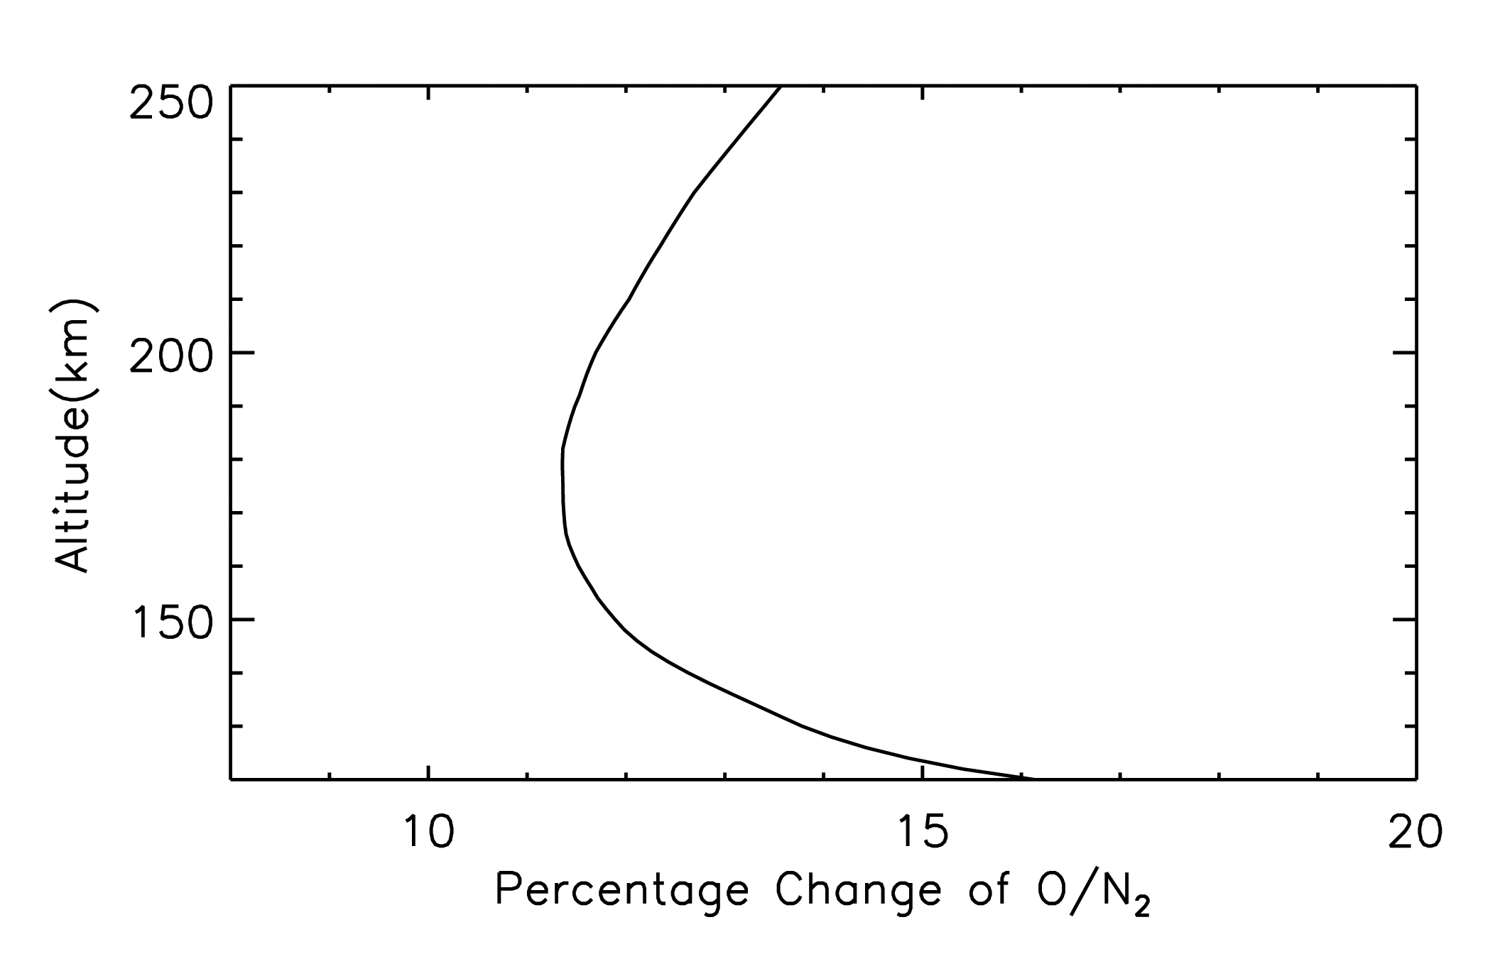

Figure 4. Percentage change of O/N₂ from the base case to the doubled CO₂ case in the altitude range 120 km to 250 km, under solar medium conditions ($F_{\text{10}\text{.}7}={\overline{F}}_{\text{10}\text{.}7}=\text{150}$).

