11 Dec:
Edits by Michael and Joei in blue with yellow;
questions in RED from MM and HR

Day-by-day modelling for a year of the ionospheric F2-layer
H. Rishbeth^{a,b} M. Mendilloª, J. Wroten^{a,}∗, R. G. Roble^{c}
ª Center for Space Physics, Boston University, 725 Commonwealth Avenue, Boston, MA 02215, U. S. A.
^{b} School of Physics and Astronomy, University of Southampton, Southampton, SO17 1BJ, U. K.
^{c} High Altitude Observatory, National Center for Atmospheric Research, Box 3000, Boulder, CO 80307, U. S. A.
rishbeth@soton.ac.uk, mendillo@bu.edu, jwroten@bu.edu, roble@hao.ucar.edu
Ref. ATP 1526_Revised by HR 3 Dec 2008

Abstract: An advanced version of the Thermosphere-Ionosphere-Mesosphere-Electrodynamics General Circulation Model (TIME-GCM) has been run for the year 2002. Its novel features include day-by-day input of solar, geomagnetic indices and of lower-boundary parameters, which include geopotential height and temperature and forcing by planetary waves and gravity waves transmitted from below. The computed day-by-day values of noon peak electron density NmF2 agree well with ionosonde data for five northern sites and two southern mid-latitude sites, and closely follow the day-by-day of the modelled concentration ratio of atomic oxygen to molecular nitrogen.

Keywords: Ionospheric modelling; General Circulation Models; Model-Data Comparisons; F-layer Morphology

1. Introduction
1.1 Background to this paper. The ionospheric F2-layer is well known to be highly variable. Most of its local-time, seasonal and solar-cycle variations are understood in principle, and are thought to be largely caused by the global circulation in the thermosphere (Rishbeth, 1998). But the day-to-day and hour-to-hour variability of the layer are not well understood. Forbes (2000), Fuller-Rowell et al. (2000) and Rishbeth and Mendillo (2001) attempted to evaluate the “solar EUV”, “geomagnetic” and “other” contributions to the day-to-day variability. The “other” component was tentatively attributed to so-called “meteorological” effects arising in the lower or middle atmosphere, but there is little firm observational evidence for this attribution. Before such ‘contribution factors’ to variability can be explored via simulations, e.g., with such processes in ON/OFF modes, the basic morphology of the ionosphere needs to be at a level of success worthy of such efforts. This is the goal of the current paper.
Having listed in sections 1.2 and 1.3 below the main features of the new CDEV7 model that we here use and detailed goals of the paper, we describe in section 2 the model and inputs, compare in section 3 the model outputs with actual F2-layer data for seven sites, and discuss in section 4 the absolute numerical calibration against data of the noon values of NmF2. We discuss in section 5 the pattern of vertical flow of the neutral air – so-called ‘upwelling and downwelling’ – and summarize the conclusions in section 6.

We here use a recently updated version of the NCAR Thermosphere-Ionosphere-Mesosphere-Electrodynamics General Circulation Model (TIME-GCM1.2) which as before extends from the upper stratosphere at 28 km (10 hPa) to the base of the exosphere at about 500 km(Ray, true?). At its lower boundary it is coupled to the daily-varying National Centers for Environmental Prediction (NCEP) climate model. In contrast, Mendillo et al. (2002) used a much earlier version of TIME-GCM, coupled at its lower boundary to a version of the Community Climate Model (CCM3). In that work, couplings from above via solar and geomagnetic activity were held constant throughout the year, except for the geographic and seasonal changes of solar zenith angle. The results were therefore limited to the first exploration of coupling from below in a model run for a full year. We discuss these limitations further in the following section.

1.2 Goals of this paper. We here use the advanced version of TIME-GCM1.2, and compare the modelled peak electron density NmF2 for every day of year 2002 with ionosonde data at seven mid-latitude sites, with all three sources of daily variability included, as compared to the approach described in Mendillo et al. (2002). We concentrate on midday data, in order to evaluate the model under near photochemical equilibrium and provide some insight into the variability caused by solar and geomagnetic forcing, as well as coupling from the lower atmosphere. We thus consider the neutral atomic oxygen/molecular nitrogen concentration ratio (O/N₂) near the F2 peak resulting from all three sources, in contrast to its forcing from below only in Mendillo et al. (2002). Our purpose, besides improving on the modelling presented in our previous paper as detailed in section 2.1, is to provide a basis for future work with different forcings imposed at the lower boundary.

Our previous paper (Mendillo et al., 2002) used TIME-GCM 1.1 with CCM3 providing the coupling from below. The model run was for a generic year of solar and geomagnetic activity, which did not change daily, but CCM3 did change daily. Therefore, we could assess seasonal trends with respect to ionosonde data that were also 'generic' – meaning we averaged several years of observations all having nearly the same solar F10.7 (140 units as used in the model). The model had Ap =4 for every day and auroral inputs set by cross polar cap potential = 45 kV and hemispheric power of 15 GW. Having sorted the ionosonde data only by F10.7, we had to take the average polar cap potential and hemispheric power for those years. We also described only the lower atmospheric variability from CCM3. We found successes and shortfalls with seasonal behaviour.
1.3 New features. The improvements over our previous work are:
(a) A real year (2002) is used, both for the ionosonde data and for model drivers from above and below.
(b) CCM3 has been completely replaced by NCEP at the lower boundary.
(c) The solar (F10.7) and geomagnetic activity (Kp) indices vary daily, and thus the parameterizations they drive for solar irradiance, the high latitude power inputs and the convection patterns vary daily.
(d) All aeronomic parameters (reaction rates and coefficients) have been updated to current values.
(e) The starting point for the thermosphere was adjusted by making the global mean match the MSIS global mean for 2002. This required changing the eddy diffusion coefficient from 90 to 45 [units], which changed the O/N₂ ratios, bringing the computed values of NmF2 close to the ionosonde measurements.
(f) Some comparisons with TIE-GCM-1.9 were made while the paper was in revision, and these resulted in a change to the number of pressure levels used in TIME-GCM1.2, adding to additional pressure levels to the topside and therefore two more scale heights, which influenced the topside boundary condition, bringing the model into better agreement with ionosonde data.
(g) We add to the results section an evaluation of the hemispheric asymmetry in summer vs. winter NmF2.
(h) With all three sources of variability included – solar, geomagnetic and mesospheric – the paper presents the first full-year modelling validation study of ionospheric seasonal patterns at widely spaced midlatitude sites. While detailed assessment of total day-to-day F2-layer variability is reserved to a later paper, some preliminary observations on that key topic are made.

2. Model simulations for the year 2002.

2.1 Model Overview. The TIME-GCM (Thermosphere-Ionosphere-Mesosphere-Electrodynamics General Circulation Model) is a self-consistent coupled model of the upper stratosphere, mesosphere, thermosphere and ionosphere, incorporating aeronomy and dynamics with electrodynamic interactions. It was developed in stages over the past 30 years as the TGCM (Dickinson et al., 1981), TIGCM (Roble et al., 1987-1988 [RAY?]) and TIE-GCM (Richmond et al., 1992), and was extended to the middle atmosphere as TIME-GCM by Roble and Ridley (1994) and Roble (2000). The version used here, known as TIME-GCM version 1.2 which extends vertically from the 10 HPa pressure level (about 30) to 500 km with spatial resolution of 5° in latitude and longitude and 2 grid points per scale height. The model time-step is 5 minutes.
**********The section below is, I think, contradictory and so Ray needs to approve or re-write it**************************************
2.2 Eddy diffusion. Eddy diffusion plays a large part in controlling the neutral gas composition – in particular the O/N₂ ratio – and it is difficult but important to compute it correctly. In earlier models eddy diffusion was specified at the lower boundary, but in TIME-GCM-1.2 it is calculated from the flux of gravity waves transmitted upward through complex wind distributions from the base of the model to the turbopause. Increasing the eddy diffusion coefficient causes more O to be transported downward and more N₂ upward, thereby decreasing the ratio of O to N₂.
Gravity wave breaking varies between summer and winter. Wave activity is stronger in winter, particularly in the southern hemisphere, and this variation in gravity wave forcing produces a seasonal variation of eddy diffusion coefficient about its global mean, the winter value of eddy diffusion coefficient being 2.5 times larger than in summer. Despite some studies that suggest a low eddy diffusion coefficient of 40 m² s⁻¹ in winter, newer ones suggest a value of 100 m² s⁻¹ (e.g., Qian et al., 2008).
RAY: Figure 6 of Qian et al. shows 40 units in January and 250 units in July---globally.
In order to make the model global mean structure of the O/N₂ ratio consistent with the global mean composition of MSIS-2000, the thermospheric neutral composition - in particular the O/O₂ ratio - has been adjusted by reducing the eddy diffusion coefficient from 90 m² s⁻¹ to 45 m² s⁻¹. This adjustment is only for the global mean: the latitudinal, longitudinal and time variations are specified by gravity wave breaking according to the scheme of Lindzen (1981) as modified by the NCAR CCM3 community model. ***Ray: Review next section too****

2.3 Forcing at the lower boundary. At its lower boundary at the 30 hPa pressure level, about 28 km height, the model is forced at 24-hour intervals with the NCEP global meteorological model. The zonal and meridional winds at the lower boundary set the planetary wave structure around the globe. On them are superimposed the diurnal and semidiurnal propagating tides derived from the Global Scale Wave Model (GSWM) of Hagan et al. (1999).

  - Solar, geomagnetic and ionospheric inputs. TIME-GCM-1.2 is driven with the daily solar F10.7 flux, 81 day average F10.7 cm flux, and geomagnetic Kp imposed every 3 hours. The solar input uses an empirical solar EUV and UV flux model of Solomon (2000), and the auroral particle input uses the high latitude ion convection model of Roble and Ridley (1987). Plasma flow through the upper boundary still presents an unsolved problem; as in our previous work, we assume an empirical flux of 10⁸ cm⁻² s⁻¹, up by day and down by night. The ionospheric parameters are the same as used by Mendillo et al. (2002), except that the model of E-layer electron density has been improved by adjusting the low wavelength EUV (<10 nm) and X-ray flux with the aid of newer satellite data.
2.5. Auroral oval model. The auroral oval used in TIME-GCM-1.2 shows both Hobart and Port Stanley well north of the equatorward edge of the auroral oval at local noon, 02 UT at Hobart and 16 UT at Stanley. This is as it should be, as Port Stanley is in the ‘Weddell Sea anomaly’, a region of complex behaviour (Bellchambers and Piggott, 1958; Burns et al., 2008).

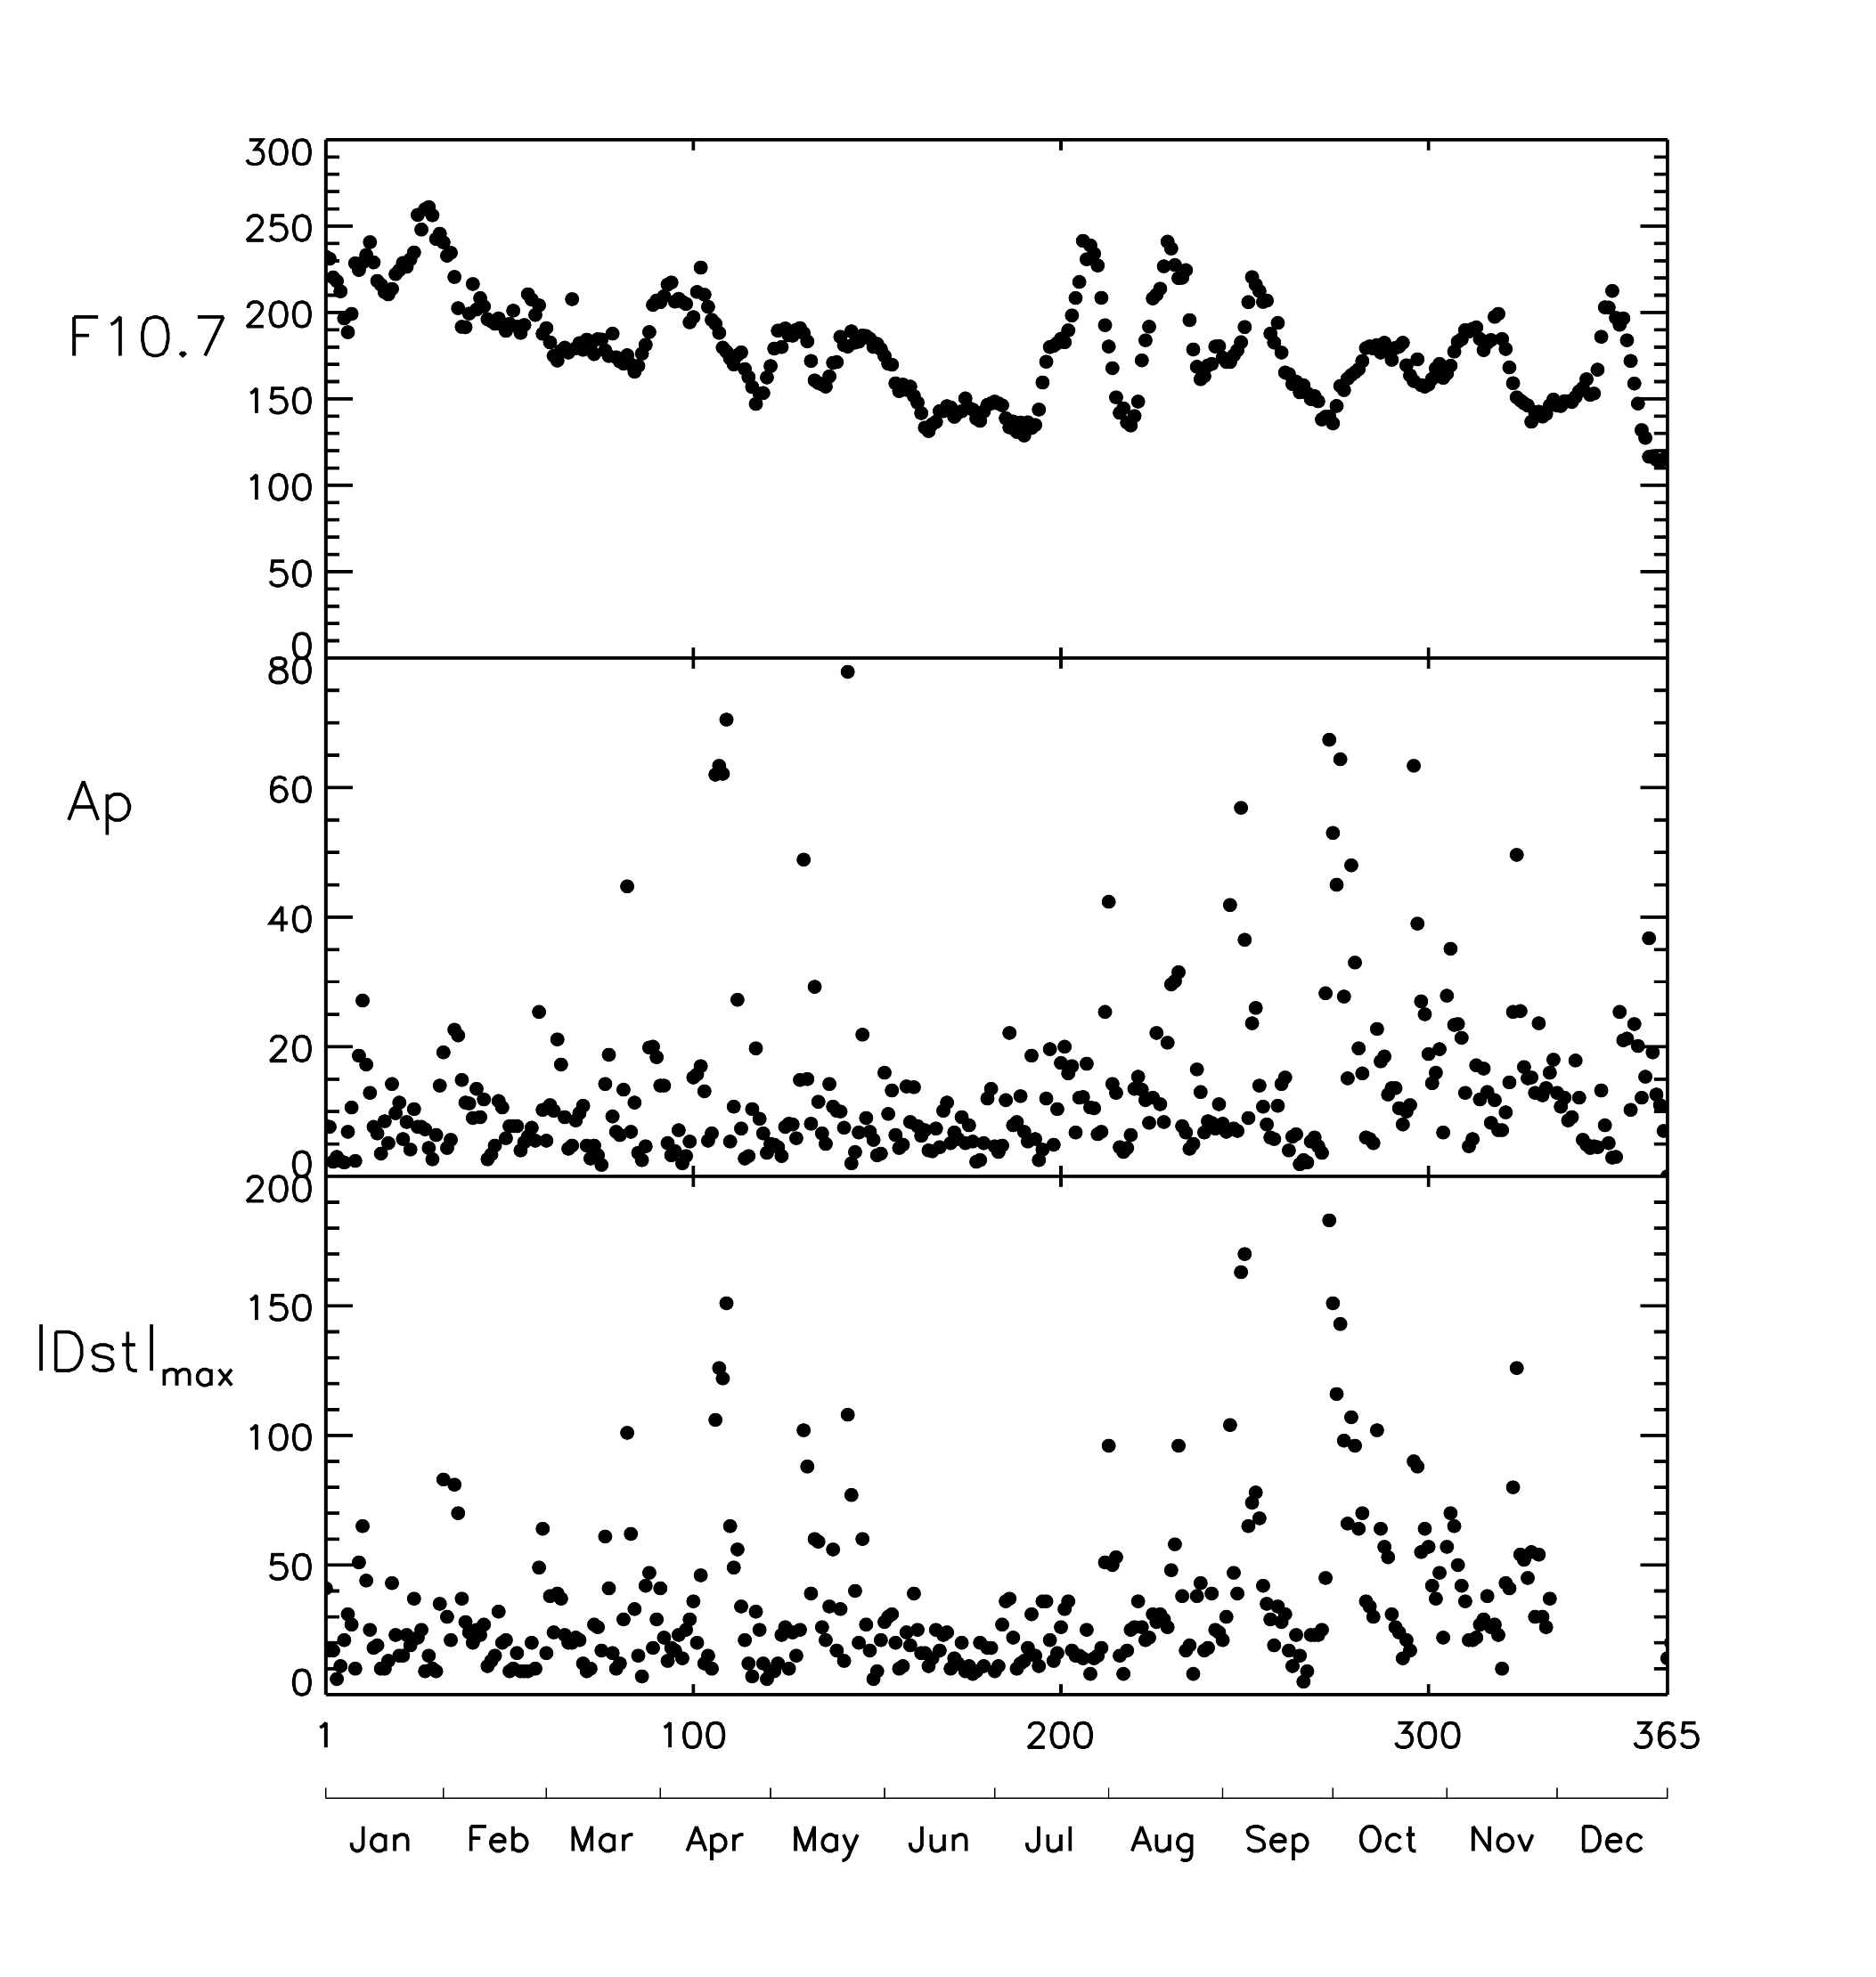

Fig. 1: Daily solar F10.7 cm flux and the geomagnetic indices Ap and |Dst|_{max} for 2002, ‘max’ denoting the numerically greatest value occurring on the UT date.

3. Results for F2-layer peak electron density

3.1 Solar and geomagnetic conditions for year 2002. The solar-geophysical parameters for the year 2002 are plotted in Fig. 1. The daily solar 10.7 cm flux (top) declined overall during the year from near solar maximum conditions at the beginning to solar medium conditions towards the end, with large 27-day variations caused by localized active regions on the Sun’s disk. The other panels show the daily values of Ap and the numerically greatest values of |Dst| occurring on each day. The geomagnetic indices are typical of solar maximum conditions with maxima in April and October.
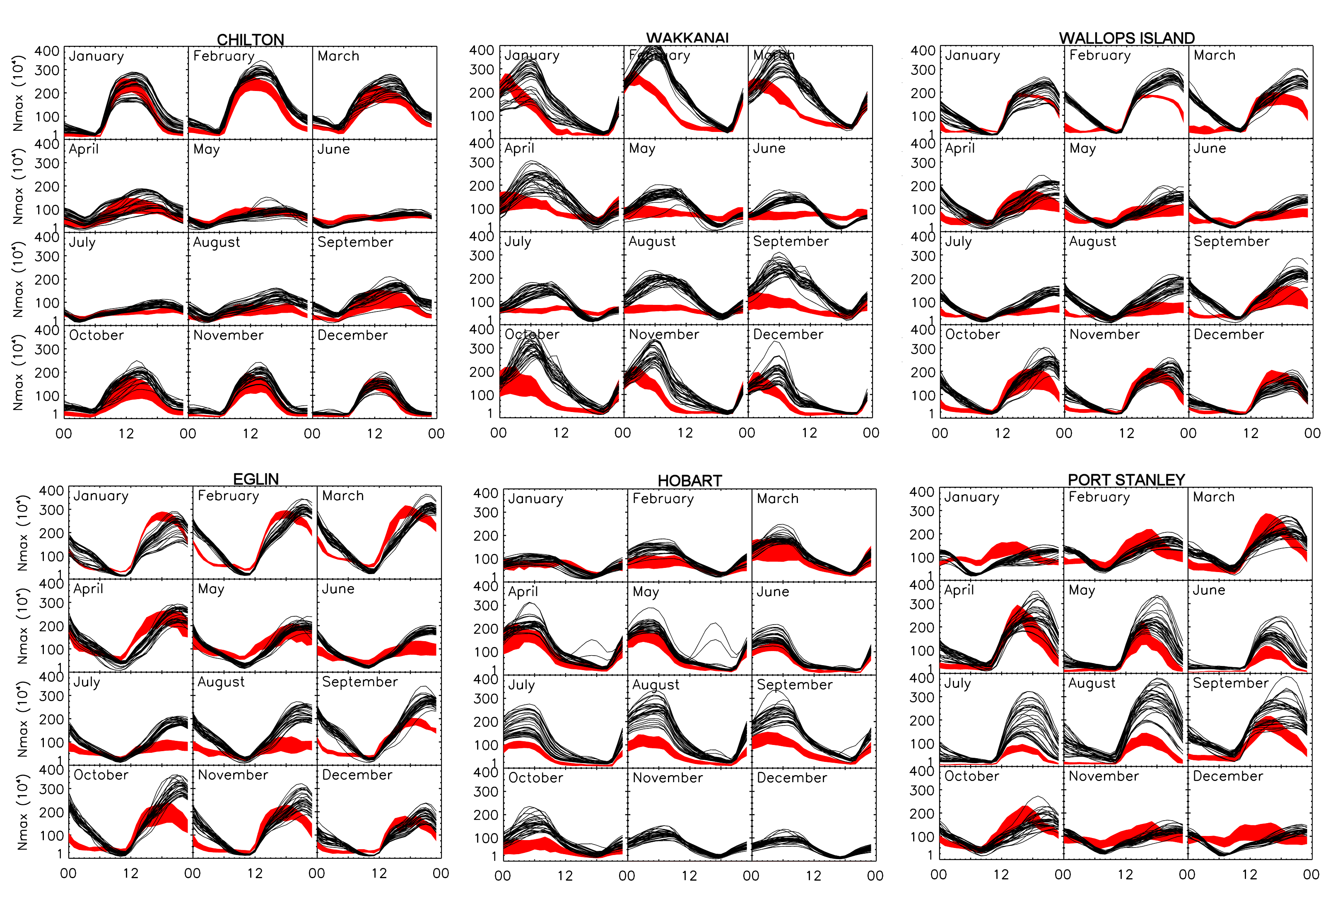
Fig. 2 NmF2 vs local time for twelve months at six sites. The black curves are the daily curves computed from the TIME-GCM-1.2 model. The red shading shows the observed monthly mean NmF2 ± 1 standard deviation. Ideally, two-thirds of the model curves should lie within the red shading.

  - How the peak electron density NmF2 varies with local time. The curves in Fig. 2
show how NmF2 varies with local time. Only six sites are shown here and in later figures, Moscow being omitted as the results are similar to those for Chilton but less complete. In Table 1 we summarize qualitatively on how well TIME-GCM-1.2 represents the shapes of these curves. In Table 2, we summarize the main features of the day-by-day variations of noon NmF2 shown in Fig. 3. In both tables the seven sites are listed in decreasing order of geographic latitude. Day numbers are quoted in the descriptions to the nearest 5 or 10 (with names of months added in places, for convenience). Labels near and far refer to the distance in longitude from the meridian of the magnetic pole in the same hemisphere, as in Rishbeth (1998). Tables 1 and 2, collectively, describe overall success of a global model when sampled at specific sites, as well as significant shortfalls during specific times and seasons. The benefit of a coupled model is that drivers of resultant patterns can be identified. For example, comparing the upper and lower panels for each station in Fig. 3 shows that the variations of O/N₂ ratio bear a strong resemblance to those of NmF2, and thus any differences that occur can be related to fundamental parameters. Finally, we do not discuss storm conditions when very low NmF2 values appear in the model on some days (e.g., at Wallops Island in September and October in Figure 2), nor nighttime increases due to auroral activity in the model (e.g., at Hobart in April and May), other than to note that significant storm activity occurred during those months (see Fig. 1).
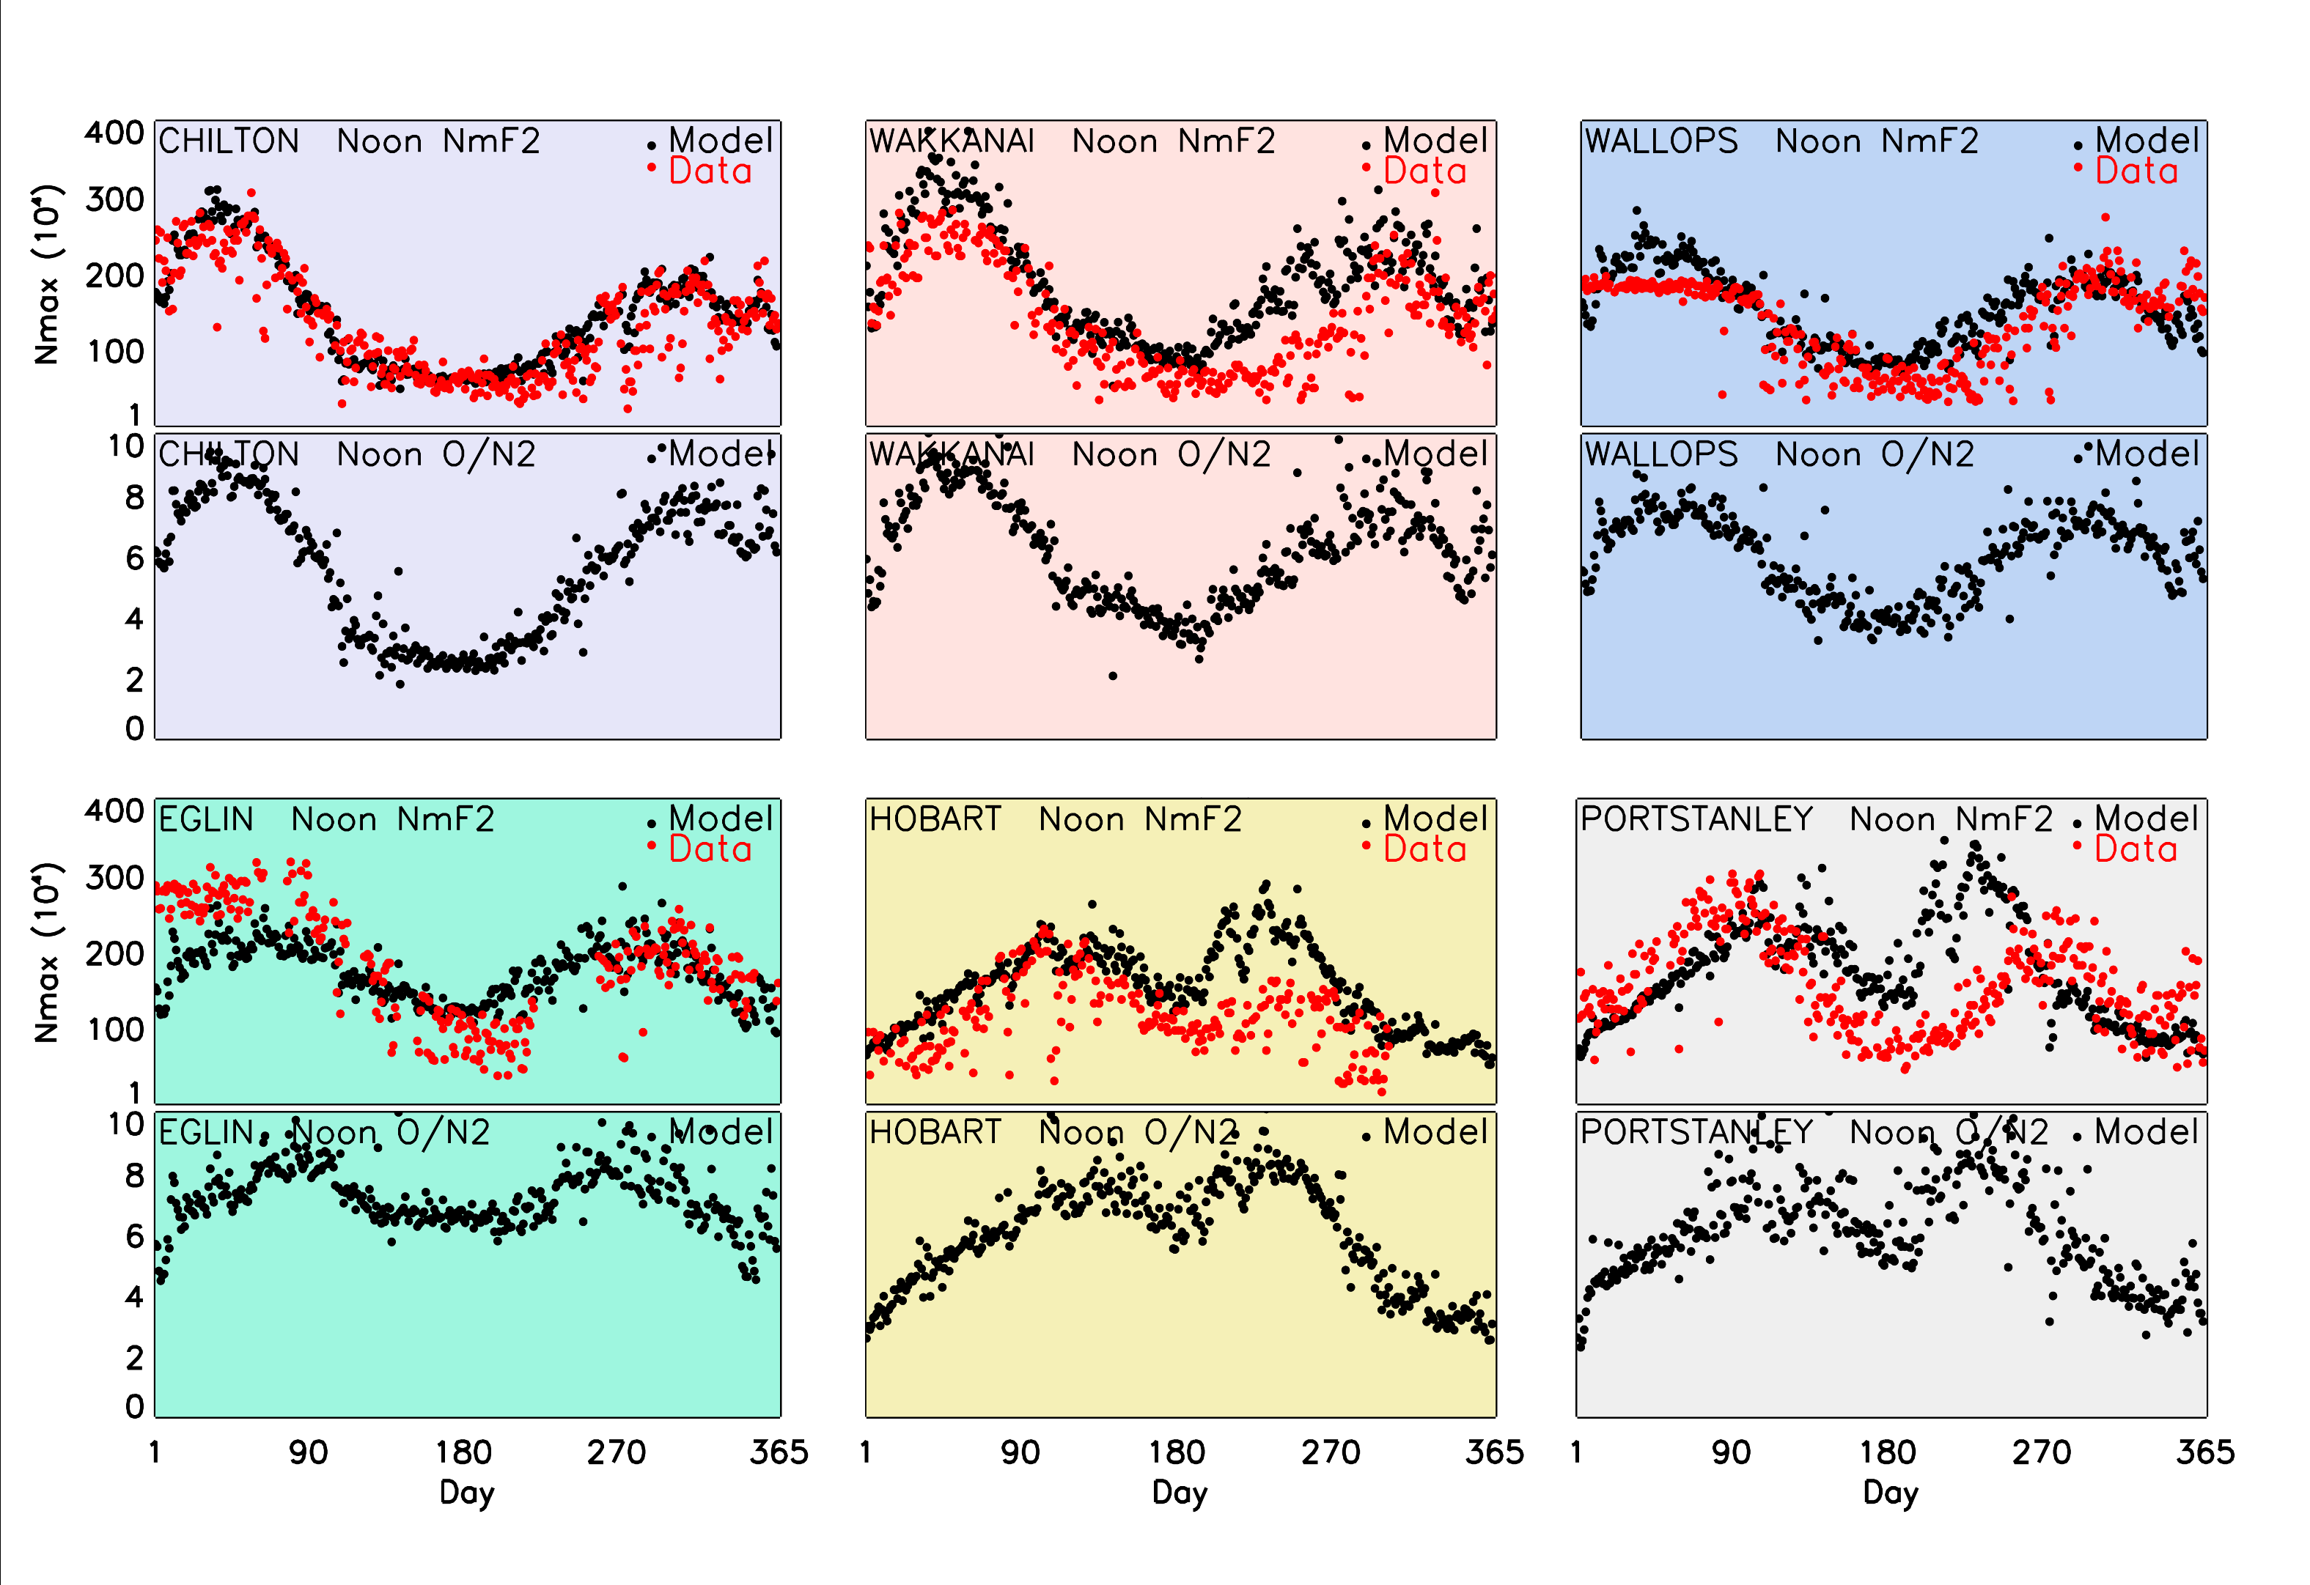
Fig. 3. Noon NmF2 on days 1-365 for six sites: ionosonde data and TIME-GCM-1.2 model output for NmF2 and noon O/N₂ ratio on the pressure level nearest the F2 peak.

3.3 Seasonal and hemispheric patterns. It has long been recognized that the annual pattern of NmF2 and the total electron content of the ionosphere do not follow the simple variations of solar zenith angle throughout the year. While the diurnal pattern for NmF2 clearly shows the strong effects of sunrise and sunset, the seasonal variation during midday hours does not follow solar zenith angle. The so-called Seasonal Anomaly discussed briefly above, and evident in Fig. 2, refers to the fact that at mid-latitudes, daytime NmF2 is larger in local winter than in local summer, in obvious contrast to what might be expected from the variation of solar zenith angle. This effect occurs in both hemispheres and is therefore helps to validate global models, though in many regions the semiannual variation is stronger.
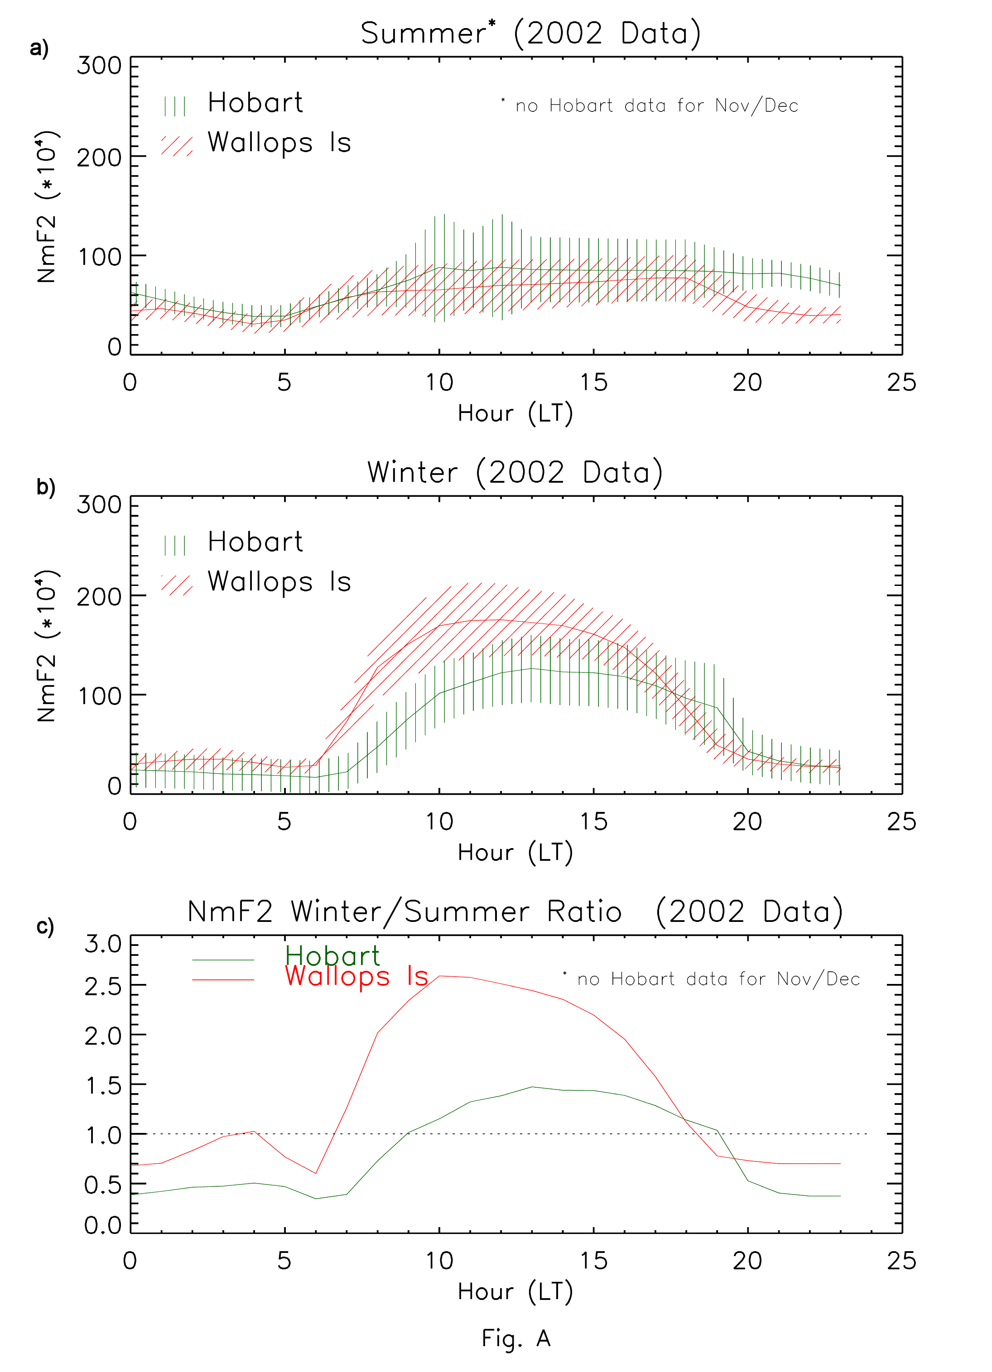
Fig. 4. Average behaviour of observed NmF2 at Wallops Island (VA) and Hobart (Tasmania) for (a) Summer and (b)Winter months, and (c) the Winter/Summer ratio. Shadings in panels (a) and (b) give standard deviations (see text).

We select for this aspect of our study the pairs Wallops Island and Hobart. These sites have comparable geographic and geomagnetic latitudes and thus are good options for examining possible hemispheric differences in seasonal behaviour. In Fig. 4 we show observations for the summer and winter months of 2002 as experienced at both sites. The months May-August are summer at Wallops Island and winter at Hobart, and the months November-February are winter at Wallops and summer at Hobart (Unfortunately, of these four months only January and February 2002 had ionosonde data at Hobart). Nevertheless, in panel (a), the average diurnal curves for summer conditions are very similar with standard deviations clearly overlapping. In panel (b) the four-month averages for winter conditions show a marked difference, the winter ionosphere being more robust in the northern hemisphere. Panel (c) shows the winter/summer ratio for both sites, with a factor of ~2 difference for daytime values.
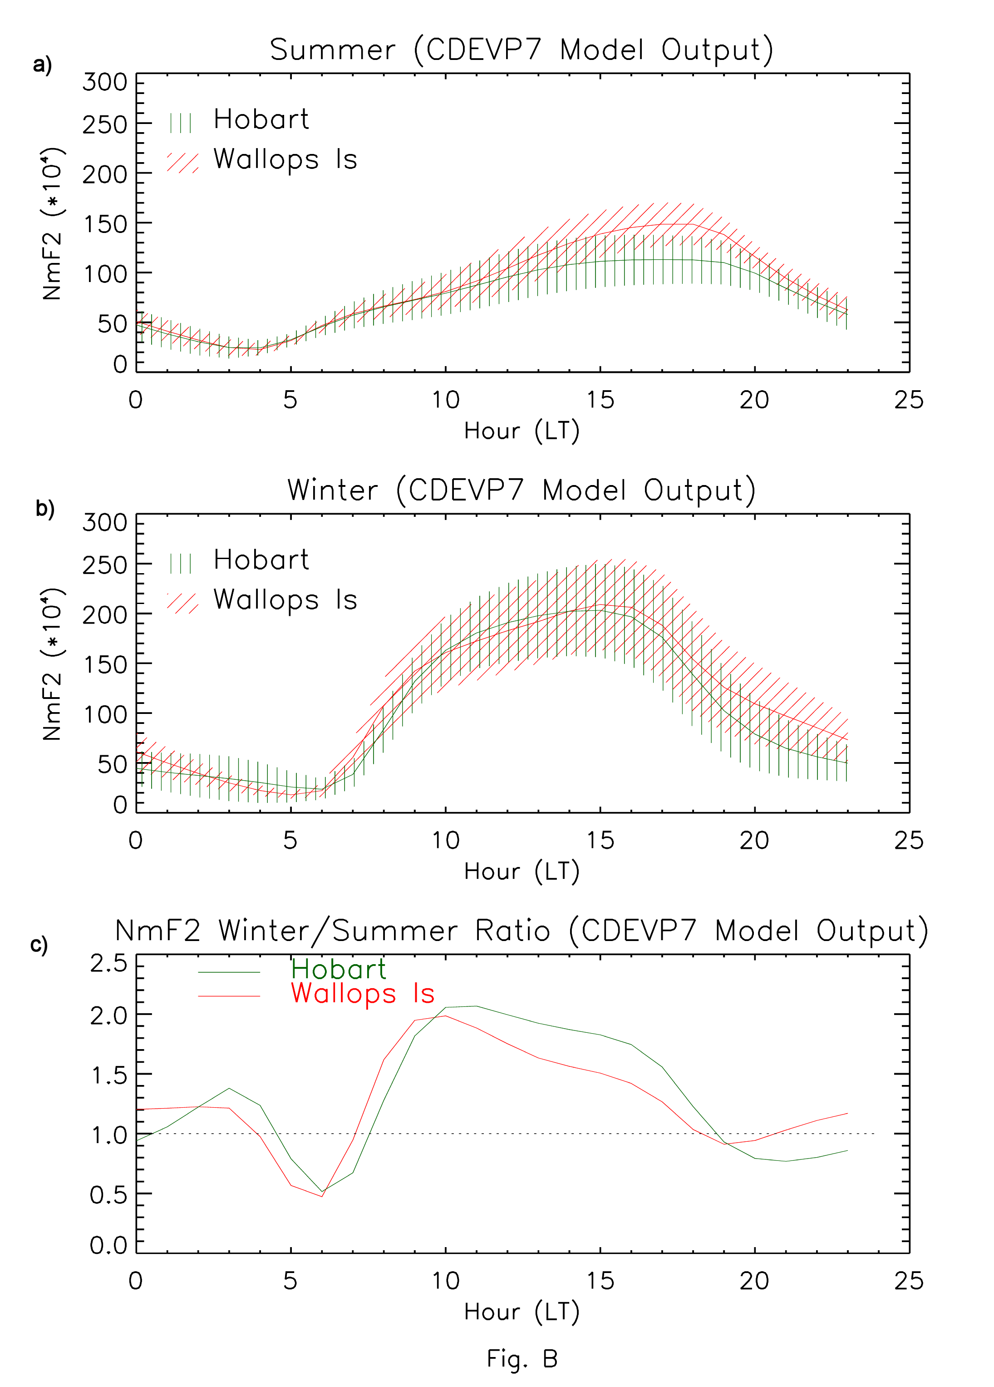
Fig. 5. Average behaviour of modelled NmF2 at Wallops Island (VA) and Hobart (Tasmania) for (a) Summer and (b)Winter months, and (c) the Winter/Summer ratio. Shadings in panels (a) and (b) give standard deviations (see text). Note that the ratio in panel (c) is similar at both sites, as modelled, but different from the observed patterns in Fig. 4(c).

For model results, we do the same analysis and include the O/N₂ ratio as an aid to interpretation. In Fig. 5, panel (a) gives the summer results, panel (b) the winter results, and panel (c) the winter/summer ratio. The mean diurnal curves for local summer are very similar except for higher values during the 15-20 LT period. For local winter, both sites are nearly identical. These attest to comparable physical processes acting in both hemispheres in the model. Fig. 6 shows that the O/N₂ ratios indeed do not differ significantly during these seasons in each hemisphere, and thus the slight differences in ratio probably arise from different thermospheric circulation patterns. More significant is that the seasonal anomaly is far stronger with data (Fig. 4(c)) than in the model (Fig. 5(c)). This type of behaviour has also been known for some time, and is sometimes described as the Annual Asymmetry, with the northern hemisphere having a more robust overall ionosphere. Yet, in Figure 5(c) this asymmetry favors the southern hemisphere. Rishbeth and Müller-Wodarg (2006) reviewed this topic in some detail and concluded that the models could not account for it. Recent model studies by Qian et al. (2008) have made progress successfully reproducing seasonal and semi-annual variations in thermospheric densities by adjusting the eddy diffusion coefficient to have a global seasonal variation.
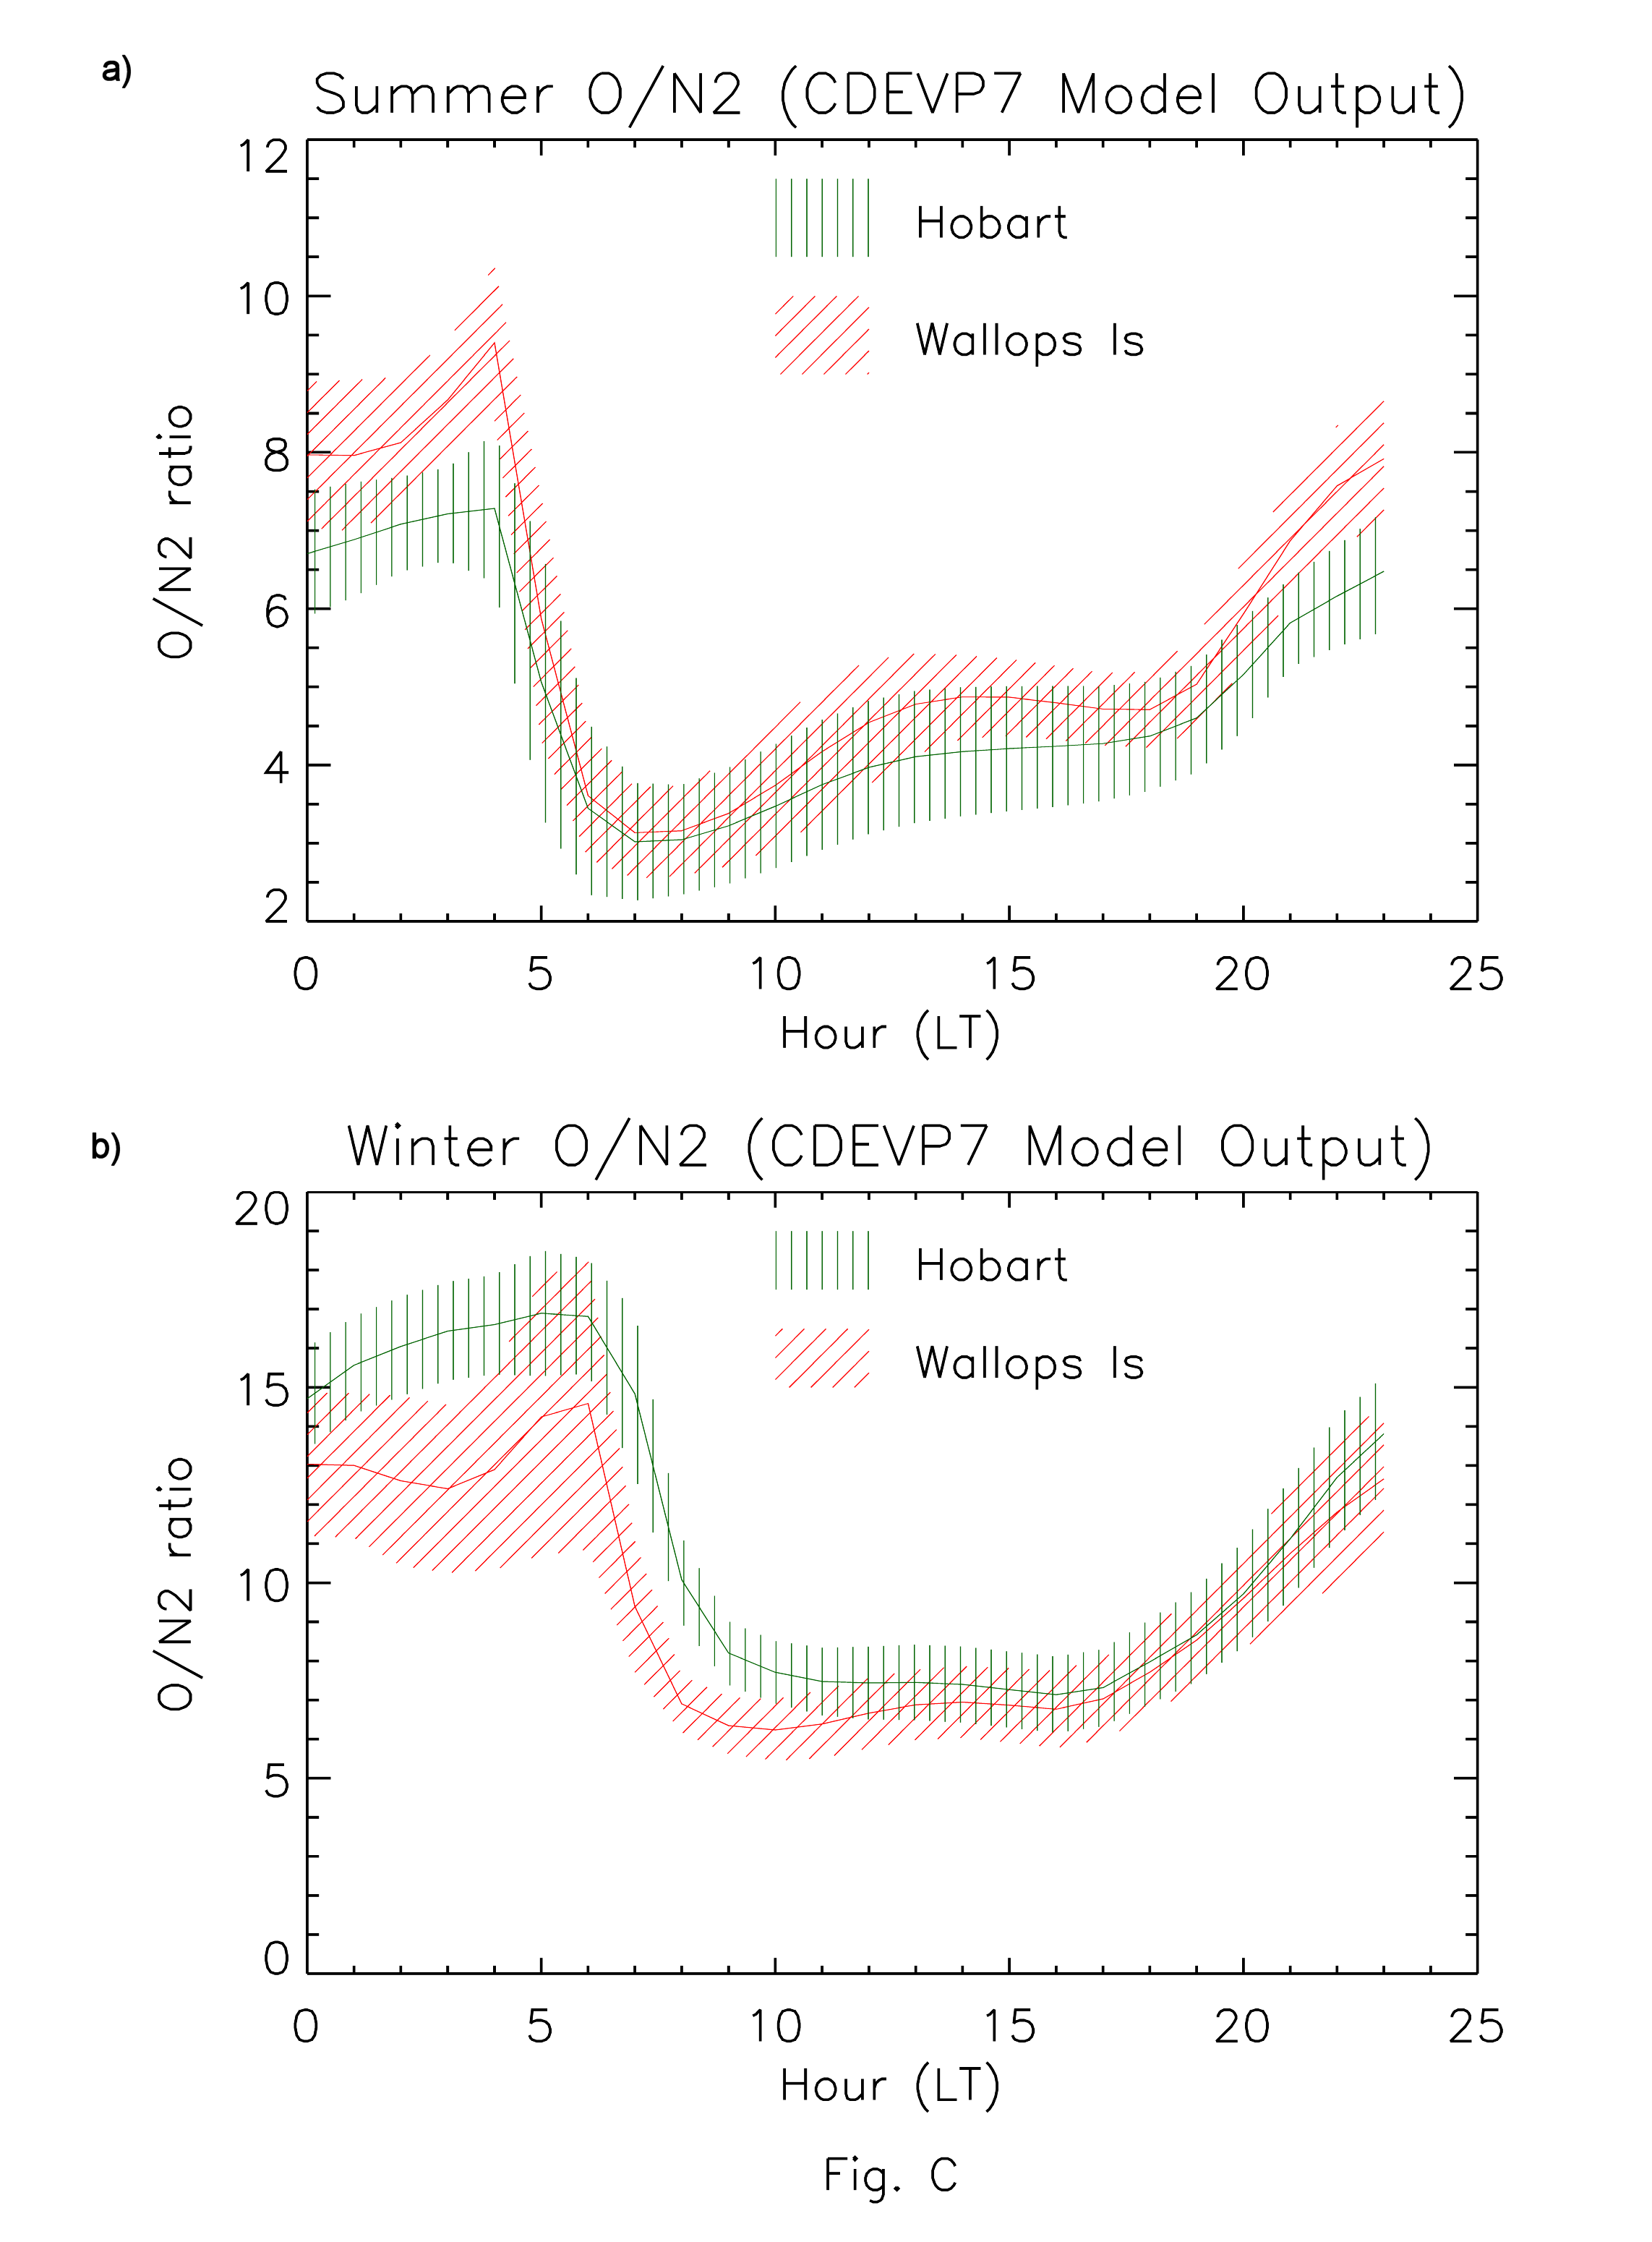
Fig. 6. Model results for the atomic oxygen to molecular nitrogen ratio at Wallops Island and Hobart from the TIME-GCM-1.2 run that produced the NmF2 patterns shown in Fig. 5.

3.4 O/N₂ concentration ratios at the noon F2 peak. Fig. 3 shows the day-by-day variation throughout the year of the O/N₂ ratio interpolated to the pressure level at the F2 peak. With a vertical resolution of 0.5 scale height, the maximum resulting error in O/N₂ ratio should be unimportant for present purposes. As in Fig. 3, the daytime patterns show that the seasonal variations of the O/N₂ ratio bear a strong resemblance to those of NmF2.

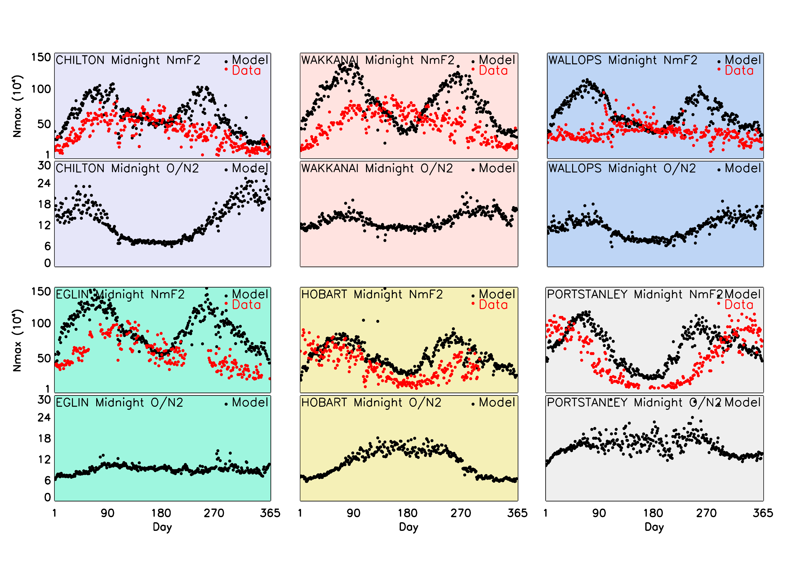3.5 Midnight F2 peak. Fig. 7 shows the night-by-night variation throughout the year of peak electron density NmF2 at local midnight, comprising any residual daytime ionization and contributions from the assumed downward flux of oxygen ions. The first thing to note is that there is a pronounced semi-annual effect in the model for all six sites, with no such observed patterns for the four northern hemisphere sites, and only partial evidence in the southern hemisphere. For Chilton, Eglin, Hobart and Port Stanley, there is no clear correspondence between NmF2 and the O/N₂ ratio in the model, and only a hint of it at Wakkanai and Wallops Island. This is in marked contrast to daytime conditions in the model (Fig. 3). Clearly, the lingering effects of photochemistry are not the drivers of nighttime behaviour; dynamical processes are more important. For absolute magnitudes, the two sites in the southern hemisphere offer the best agreement, and these only due to the weak semi-annual pattern. At present we have no general explanation of the behaviour at midnight, and we have yet to study the data at local times either side of midnight.
Fig. 7 Midnight NmF2 on days 1-365 at six sites: ionosonde data and TIME-GCM-1.2 model, and noon O/N₂ ratio on the pressure level nearest the F2 peak.

4. Calibration of the TIME-GCM-1.2 ionospheric model at noon.

Table 4 shows the model/data ratios of noon NmF2 expressed as natural (base e) logarithms. Plus signs imply that model values exceed the ionosonde values. Omitting Moscow because of four missing months, the average for the remaining four northern sites is 0.xx which corresponds to a factor of 1.xx, and for the two southern sites it is xxxx which corresponds to a factor of 1.xx. This means that model values of NmF2 are on average yy% high, which appears [remarkably accurate], so the model may be regarded as ‘well calibrated’ in the northern hemisphere. But many individual values in the table exceed 0.3 which corresponds to a factor of 1.35, i.e., model values are 35% high. There are larger factors in local winter at southern sites where the model gives wrong month-by-month shapes throughout the winter.

5. Discussion.

5.1 General. The conclusion from section 3 is that at noon the 1.2 version of the TIME-GCM model represents very well the ‘1-365’ day-by-day variation of peak electron density NmF2 at five northern mid-latitude sites, except for a few individual station-months, e.g., February and March at Wakkanai and Wallops Island. In the southern hemisphere, the months July-September over-estimatenotably magnitudes in during the daytime, an effects also seen at a few of the northern stations.. At midnight the model, with an assumed flux of O⁺ ions from above, the overall patterns in the southern hemisphere are quite good. Except for strong peaks of NmF2 during the equinoxes that occur at Wakkanai and Wallops Island (and to a lesser extent at Eglin), which are not seen in the data, the model give acceptable representations of the nighttime F2-layer.

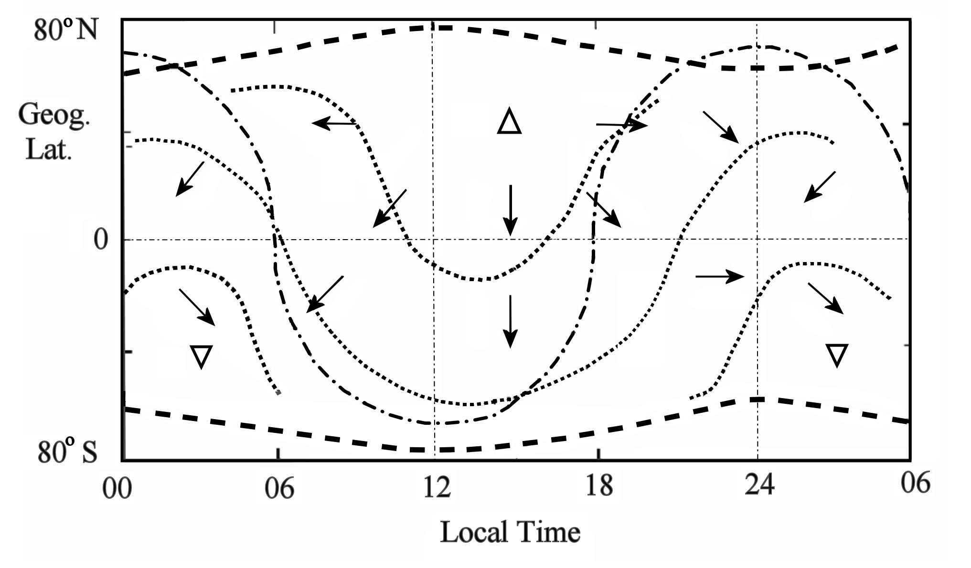
Fig. 8 Sketch of the thermospheric circulation, after Rishbeth (1998). The figure represents average conditions in June at around 300 km at no particular longitude. The bold dashed lines at the top and bottom represent the auroral ovals, the dash-dot curve represents the sunrise/sunset terminator, thin dotted lines represent typical isobars, and arrows represent wind directions (but not magnitudes). The upward pointing triangle at 14 LT shows the position of maximum temperature and pressure; the downward pointing triangle at 03 LT shows the position of minimum temperature and pressure. Note that the six hours 00-06 LT are repeated on the right-hand side.

HENRY: With new results for the seasons, e.g., Figures 3, 4 and particularly 5, this discussion (the full 5.2 section) needs up-dates. Now, the winters are comparable and the summers are nearly so----and thus the seasonal anomaly is virtually the same in both hemispheres---but not in the data where it is local winter that is high.
  - Vertical flow of the neutral air. Fig. 8 illustrates the general pattern of upwelling and downwelling of the neutral air, envisaged by Duncan (1969) and computed by Rishbeth and Müller-Wodarg (1999), with a downwelling zone at moderately high winter latitudes but equatorward of the winter auroral oval, Though we have not investigated vertical velocities in this paper, this pattern is consistent with the idea that the O/N₂ ratio is influenced by vertical velocity. The high winter NmF2 at the northernmost sites imply that they lie within the downwelling zone, while the modest winter NmF2 at the southern sites, Hobart and Port Stanley (Fig. 3), imply that the downwelling zone usually lies to their south, though day-to-day changes at these sites suggest that the zone sometimes moves far enough north to include them. The winter NmF2 at Kerguelen in the South Indian Ocean at 49°S, 70°E (Zou et al., 2000) show that Kerguelen is also within the downwelling zone. Furthermore, perusal of three solar cycles of midwinter (June) data from Faraday, in the Antarctic peninsula at 65°S, 64°W, shows that monthly mean NmF2 lies in the range 2-8 x 10⁵ cm⁻³ at noon, higher than might be expected with the noonday sun virtually on the horizon, which suggests that the downwelling zone may even extend far enough south to include Faraday. Another model, CTIPM (Zou et al., 2000), portrays fairly well the month-to-month variations of NmF2 at Hobart, Port Stanley and Kerguelen, implying that it uses a satisfactory model of the southern auroral oval.
5.2. Day-to-day variability. While the focus of this paper is the correct representation of diurnal, seasonal and hemispheric behaviour of the F2-layer peak electron density, the set of comparisons given in Figure 2 (Fig. or figure?) contain messages about variability patterns. In each panel, the shading gives the observed monthly mean NmF2 ±σ (the standard deviation of the mean) for each hour. For an ideal distribution about the mean,2/3rd of the observed diurnal curves would fall within the shading. The curves shown, however, are from the model, and thus one can get a preliminary feel about the ability to simulate day-to-day fluctuations using TIME-GCM-1.2. For example, …….

6. Conclusion.

The TIME-GCM-1.2 coupled model reproduces midday NmF2 well throughout year 2002 at seven mid-latitude sites. The variations of O/N₂ ratio near the F2 peak follow a similar pattern, strongly supporting the idea that NmF2 is linked to the chemical composition of the ambient neutral air. At midnight the model is more successful in the southern hemisphere, with the model predicting strong equinoctial peaks in the northern hemisphere that are not seen in the data..
Section 4 discussed the absolute values of NmF2, month by month and site by site, arriving at an overall ‘calibration factor’ of 1.xx. This implies that the model values exceed observed values on average by xx%, a quite accurate performance. The atomic/molecular concentration ratio is affected by eddy diffusion, which we have adjusted according to the best available information, and by the pattern of vertical motions (‘upwelling’ and ‘downwelling’) of the neutral air. This implies that getting these processes right is necessary for good F2 layer modelling. It is encouraging that the model reproduces the seasonal and semiannual variations of NmF2 quite successfully. We expect to use the improved modelling achieved via this validation study as the basis for future work in which different forcings at the upper and lower boundaries will be imposed.
Rishbeth and Mendillo (2001) found that recorded values of NmF2 at several ionospheric sites show considerable day-to-day variability that occurs in differing episodes at different sites. They surmised that this component of variability stems from the variable forcing by dynamic processes, generated in the lower atmosphere and propagated to the ionosphere as mutually interacting planetary waves, tides and gravity waves. A future study using TIME-GCM-1.2 will be conducted to explore the contributions of coupling from below using NCEP, together with solar and geomagnetic input, and then with the TIME-GCM-1.3 with the European………..
Other topics for future discussion are the problems posed by (1) the day-to-day variability of the height of the F2-peak electron density, (2) the differences of the peak between the March and September equinoxes, (3) the seasonal variation of thermospheric temperature, with maxima shortly after the equinoxes, (4) the semiannual variation of F2 peak height hmF2 which is closely related to (3), and (5) the continuing necessity for an assumed downward flux at night. Up to now, TIME-GCM and other coupled models have failed to resolve these well-established questions, and we have yet to see critical discussion of all five. We believe our day-to-day modelling of data for an actual year (2002) is a significant advance. Thermospheric modelling is not complete, but it has come a long way!

Acknowledgments

We are most grateful to Ben Foster for his assistance with the TIME-GCM calculations and for providing model output for comparison with ionosonde data, and to Alan Burns for the use of his model of the auroral ovals. We thank the World Data Centres A and C1 for Solar-Terrestrial Physics at Boulder, Colorado, and Chilton, UK, for supplying data. At Boston University, support for this study was provided by a grant from the Aeronomy Program of the US National Science Foundation (NSF). The NCAR modelling is supported by grants from the NSF.

References
Bellchambers, W. H., Piggott, W. R., 1958. Ionospheric measurements made at Halley Bay. Nature 182, 1596-1597.
Burns, A. G., Z. Zeng, W. Wang, J. Lei, S.C. Solomon, A. D. Richmond, T. L. Killeen,
and Y.-H. Kuo, The behaviour of the F2 peak ionosphere over the South Pacific at dusk during quiet summer conditions from COSMIC data, J. Geophys. Res. (submitted), 2008.
Dickinson, R. E., Ridley, E.C., Roble, R. G., 1981. A three-dimensional general circulation model of the thermosphere. Journal of Geophysical Research 86, 1499-1512.
Duncan, R. A., 1959. F-region seasonal and magnetic storm behaviour. Journal of Atmospheric and Terrestrial Physics 31, 59-70.
Forbes, J. M., Palo, S. E., Zhang, X, 2000, Variability of the ionosphere. Journal of Atmospheric and Solar-Terrestrial Physics 62 685-693.
Fuller-Rowell, T. J., Codrescu, M., Wilkinson, P., 2000. Quantitative modelling of the ionospheric response to geomagnetic activity. Annales Geophysicae 18, 766-781.
Hagan, M. E., Burrage, M. D., Forbes, J. M., Hackney, J., Randel, W. J., Zhang, X., 1999. GSWM-98: Results from migrating solar tides, Journal of Geophysical Research 104(A4), 6813-6828.
Hedin, A. E., 1987. The MSIS-86 thermospheric model. Journal of Geophysical Research 92, 4649-4662.
Lindzen, …., 1981?
Liu, H.-L., Roble, R. G., 2002. A study of a self-generated stratospheric sudden warming and its mesospheric/lower thermospheric impacts using coupled TIME-GCM/CCM3, Journal of Geophysical Research 107(D23), 4695, doi:10.1029/2001JD001533.

Mendillo, M., Rishbeth, H., Roble. R. G., Wroten, J., 2002. Modelling F2-layer seasonal trends and day-to-day variability driven by coupling with the lower atmosphere. Journal of Atmospheric and Solar-Terrestrial Physics 64, 1911-1931.
Richmond, A. D., Ridley E.C., Roble, R.G., 1992. A thermosphere/ionosphere general circulation model with coupled electrodynamics. Geophysical Research Letters 19, 601-604.
Qian et al., 2008. J G R 113,
Rishbeth, H., 1998, How the thermospheric circulation affects the ionospheric F2-layer. Journal of Atmospheric and Solar-Terrestrial Physics 60, 1385-1402.

Rishbeth, H., 2007. Thermospheric targets, EOS/Transactions of the AGU 88, 189 & 193.
Rishbeth, H., Mendillo, M., 2001. Patterns of ionospheric variability. Journal of Atmospheric and Solar-Terrestrial Physics 63, 1661-1680.
Rishbeth, H., Müller-Wodarg, I.C.F., 1999. Vertical circulation and thermospheric composition: a modelling study. Annales Geophysicae 17, 794-805.
Roble, R. G., 1996. The NCAR ermosphere-Ionosphere-Mesosphere-Electrodynamics General Circulation Model (TIME-GCM). In: Schunk, R. W. (Ed.), STEP Handbook of Ionospheric Models. Utah State University, pp. 281-288.
Roble, R.G., 2000. On the feasibility of developing a global atmospheric model extending from the ground to the exosphere. Geophysical Monograph, Vol. 123, American Geophysical Union, Washington DC, pp. 53-67.
Roble, R. G., and E.C. Ridley, 1987. An auroral model for the NCAR thermosphere general circulation model (TGCM). Annales Geophysicae 5A, 369-382.
Roble, R. G., and E.C. Ridley, 1994. A thermosphere–ionosphere–mesosphere–electrodynamics general circulation model (TIME-GCM): equinox solar cycle minimum simulations (30–500 km). Geophysical Research Letters 21, 417-420.
Roble, R.G., Dickinson, R. E., Ridley, E. C, 1987. On the global mean structure of the thermosphere. Journal of Geophysical Research 92, 8745-8758.
Roble, R. G., E.C. Ridley, A.D. Richmond and R.E. Dickinson, 1998. A coupled thermosphere/ionosphere general circulation model. Geophysical Research Letters 15, 1325-1328.
{{Zeng, Z. et al., 2008. [Annual anomaly] JGR A113 A07305/2007JA012897}}
Zou, L., Rishbeth, H., Müller-Wodarg, I. C. F., Aylward, A. D. Millward, G. H., Fuller-Rowell, T. J., Idenden, D. W., Moffett, R. J., 2000. Annual and semiannual variations in the ionospheric F2-layer. I: a modelling study. Annales Geophysicae 18, 927-944.
Table 1 Comments on shapes of daytime variations of NmF2 vs local time (Fig. 2).
Labels near and far refer to longitude distance from the magnetic pole.
Moscow 56°N 37°E Model shapes are very good on the whole, but omit the forenoon peaks (08-10 LT) in spring, especially April, and tend to fall off too quickly at dusk in Mar-Sept.

Chilton 52°N 2°W Very much as for Moscow, but with forenoon peaks more marked during Jan-Apr.

Wakkanai 45°N 142°W Model shapes match the data badly, particularly in the winter half of the
year (Jan-Mar, Sept-Dec), when data values fall off much faster in the afternoon than do the model values.

Wallops Is 39°N 77°W In many months the shapes match well, but the forenoon peaks tend to
occur later in the model than in the data.

Eglin 30°N 87°W Daytime peaks in the model occur 2-4 hours too late in every month.

Hobart 43°S 147°E Model shapes match the data quite well, though with bad mismatches in actual values. Model values fall too quickly after sunset, especially in summer (Jan-Mar).

P Stanley 52°S 58°W The daytime peaks mostly occur 2-4 hours too late, though in southern winter the model/data mismatch is too great for meaningful comparison.

Table 2 Comparisons of model with data for noon NmF2 (Fig. 3).
Labels near and far refer to longitude distance from the magnetic pole.
Moscow 56°N near No data June or Oct-Dec (days 150-180, 270-365). Data have sharp peak around day 30 (Feb) not shown by model. Model values are ~25% too low on most days 70-140 (Mar-May).
Chilton 52°N near Data peak around day 30-35 (Jan-Feb) and have nearly flat minimum
days 150-230 (June-Aug). Model is very good in January and March-September, apart from a few days, but fails to show the very high NmF2 on days 20-50 (February). On days 290-350 (Oct-Dec), model values ~10% too high most days, but show big reductions on days 275-280 (storm Kp 7) and some other disturbed days.
Wakkanai 45°N far Data values peak at days 30-35 (Feb) and 300-330 (Nov). Model values are good much of year, but are ~20% too high at the Feb peak and days 200-300 (July-Sept).
Wallops Is. 39°N near Data values are surprisingly flat Jan to early Apr (days 1-100), but
model shows sharp Feb peak around days 30-35. Model fits data well rest of year, but is 15-20% high days 310-350 (Nov-Dec).
Eglin 30°N near No data days 225-260 (Aug-Sept). Fairly good fit overall, but model is ~25% low on days 70-135 (Mar-May) and ~15% too high on days 280-330 (Oct-Nov).
Hobart 43°S near No data days 305-365 (Nov-Dec). Model values are good on days 1-110 (Jan-Apr) and 270- 300 (Oct), but are much too high throughout winter days 120-270 (May-Sept). The model shows peaks around days 130 and 200-230, of which the data show little trace, There are many individual days, especially early in the year, with very low data values.
P Stanley 52°S far Data show a basic semiannual variation, peaking in autumn at days 90-100 (April) and in spring (days 260-310 (Sept-Oct). In the model, the autumn peak at days120-150 is too late and the spring peak at days 210-230 is much too early, and merged with a spurious winter peak not in data. Model values ~30% too high in summer days 1-100 & 276-365.
Table 3 Comparisons of model and data for midnight NmF2 (Fig. 7 –should be 6?).
Labels near and far refer to longitude distance from the magnetic pole.

Moscow 56°N near No data June or Oct-Dec (days 150-180, 270-365. Data show flat peak in summer (days 80-210), tailing off towards day 270 (late Sept). Model values are too low and flat throughout this period.
Chilton 52°N near Data show flat peak in early summer (days 70-190) tailing off towards
day 270 (late Sept). Model values are too low throughout this period, with flat minimum days 110-230 (Apr-Aug).
Wakkanai 45°N far Data show a summer plateau, days 100-280 (Apr-Oct). Model values are much too low and flat in winter, days 100-230 (Apr-Aug) with very marked spring/autumn peaks, less marked in the data.
Wallops Is. 39°N near Data are rather flat throughout year, slightly raised at days 110-230 (Apr-Aug) with many individual values well above the others. Model values flat during summer with marked Feb-Mar and Oct peaks.
Eglin 30°N near Data rise sharply days 1-90, peak in early summer at days 120-150 (May), slowly decline during days 150-310 (June-Oct), stay flat till year end. Model variation very similar to Wakkanai.
Hobart 43°S near No data days 305-365 (Nov-Dec). Data show nearly flat winter minimum (days 140-220), model values are too high; but on summer-autumn days 1-100, model values much below data values.
P Stanley 52°S far Data peak in late summer (days 10-30) and in early summer (days 310-340), sloping down in autumn to flat minimum in winter (days 150-200) and sloping up in spring. Model varies completely in antiphase with data, with very low values in summer (days 1-60, 300-365), peaks in autumn and spring, trough in winter.

TABLE 4 NOT REVISED YET-jlw

Table 4. Month-by-month calibrations between model and data.
Each entry gives the monthly average of the daily ratios, expressed as the natural log of noon NmF2 (model)/NmF2 (data).

2002 |  | Chilton | Wallops I | Wakkanai | Eglin |  | Mean
Jan |  | -0.01 | 0.36 | 0.05 | -0.34 |  | 0.01
Feb |  | 0.23 | 0.49 | 0.24 | -0.01 |  | 0.24
Mar |  | 0.01 | 0.30 | 0.11 | -0.11 |  | 0.08
Apr |  | -0.20 | -0.04 | -0.09 | -0.06 |  | -0.10
May |  | -0.28 | 0.09 | 0.05 | -0.20 |  | -0.09
June |  | -0.06 | 0.08 | 0.15 | 0.07 |  | 0.06
July |  | 0.04 | 0.33 | 0.32 | 0.37 |  | 0.26
Aug |  | 0.12 | 0.42 | 0.54 | 0.34 |  | 0.35
Sept |  | 0.07 | 0.35 | 0.66 | 0.18 |  | 0.32
Oct |  | 0.33 | 0.26 | 0.52 | 0.32 |  | 0.36
Nov |  | 0.34 | 0.26 | 0.28 | 0.25 |  | 0.28
Dec |  | 0.21 | 0.30 | 0.33 | 0.24 |  | 0.27
Mean |  | 0.06 | 0.27 | 0.26 | 0.09 |  | 0.17

MICHAEL-CHECK! I think JASTP colour is free on-line but extortionate in print edition!
Figure Captions
Fig. 1. Daily values of solar F10.7 cm flux and the geomagnetic indices Ap and
|Dst|_{max} for 2002, ‘max’ denoting the numerically greatest value occurring on the UT date.

Fig. 2. NmF2 vs local time for twelve months at six sites. The black curves are the
daily curves computed from the TIME-GCM-1.2 model. The red shading shows the observed monthly mean NmF2 ± 1 standard deviation. Ideally, two-thirds of the model curves
should lie within the red shading.

Fig. 3. Noon NmF2 on days 1-365 for six sites: ionosonde data and TIME-GCM-1.2 model results, with the noon O/N₂ ratio on the pressure level nearest the F2 peak.

Fig. 4. Fig. 4. Average behaviour of observed NmF2 at Wallops Island (VA) and Hobart (Tasmania) for (a) Summer and (b)Winter months, and (c) the Winter/Summer ratio. Shadings in panels (a) and (b) give standard deviations (see text).

Fig. 5. Fig. 5. Average behaviour of modelled NmF2 at Wallops Island (VA) and Hobart (Tasmania) for (a) Summer and (b)Winter months, and (c) the Winter/Summer ratio. Shadings in panels (a) and (b) give standard deviations (see text). Note that the ratio in panel (c) is similar at both sites, as modelled, but different from the observed patterns in Fig. 4(c).

Fig. 6. Fig. 6. Model results for the atomic oxygen to molecular nitrogen ratio at Wallops Island and Hobart from the TIME-GCM-1.2 run that produced the NmF2 patterns shown in Fig. 5.

Fig. 7. Midnight NmF2 on days 1-365 at six sites: ionosonde data and TIME-GCM-1.2 model results, with the noon O/N₂ ratio on the pressure level nearest the F2 peak.

Fig. 8. Sketch of the thermospheric circulation, after Rishbeth (1998). The figure represents average conditions in June at around 300 km at no particular longitude. The bold dashed lines at the top and bottom represent the auroral ovals, the dash-dot curve represents the sunrise/sunset terminator, thin dotted lines represent typical isobars, and arrows represent wind directions (but not magnitudes). The upward pointing triangle at 14 LT shows the position of maximum temperature and pressure; the downward pointing triangle at 03 LT shows the position of minimum temperature and pressure. Note that the six hours 00-06 LT are repeated on the right-hand side.

 Corresponding Author. Center for Space Physics, Boston University, 725 Commonwealth Avenue, Boston, MA 02215, U. S. A. Tel:+00 1 617 353 2631; fax: +00-1-617-353-6463; E-mail address: jwroten@bu.edu

