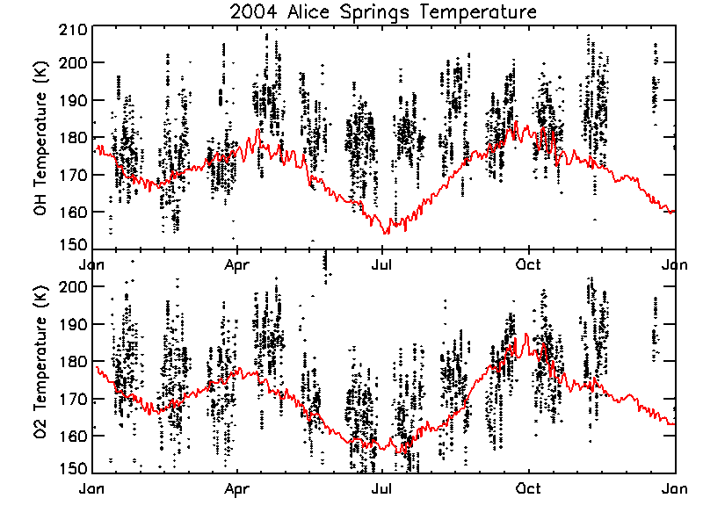
Figure 1. Daily data from 13-16 UT each night at Alice Springs in 2004. Midnight modeled temperatures overplotted in red.
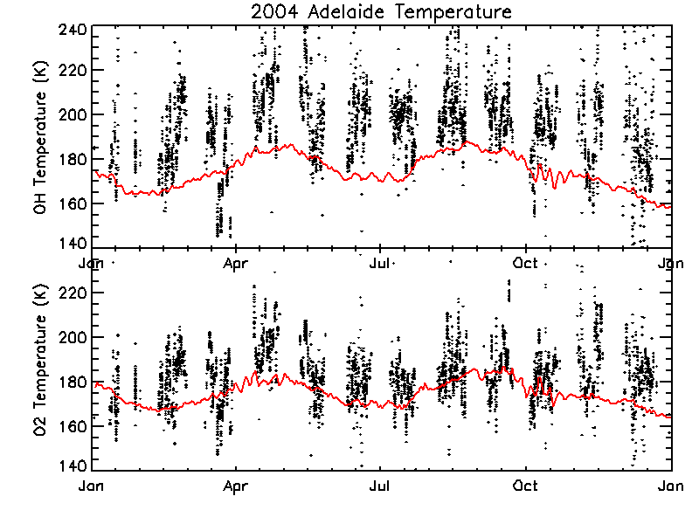
Figure 2. Daily data from 13-16 UT each night at Adelaide in 2004. Midnight modeled temperatures overplotted in red.

