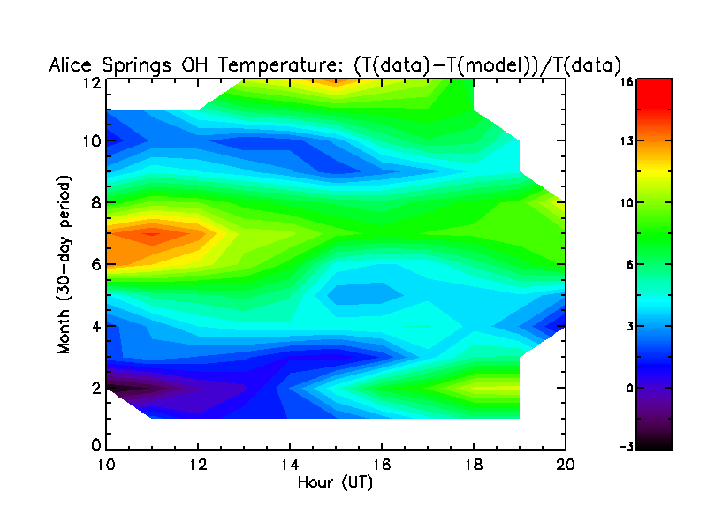
Figure 1. Data and model comparison for 2004. Data has been binned in 30-day increments, corresponding to months 1-12 on the y axis. Colors show percentage of data deviation from model.
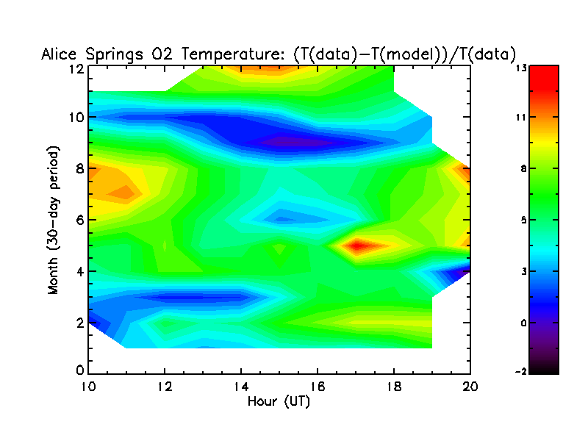
Figure 2
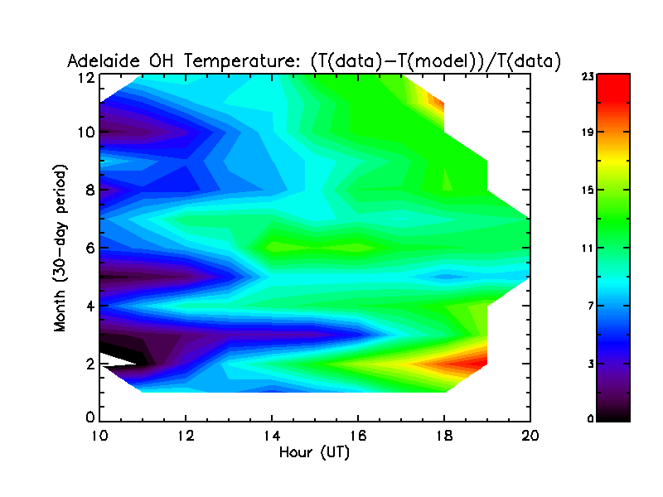
Figure 3
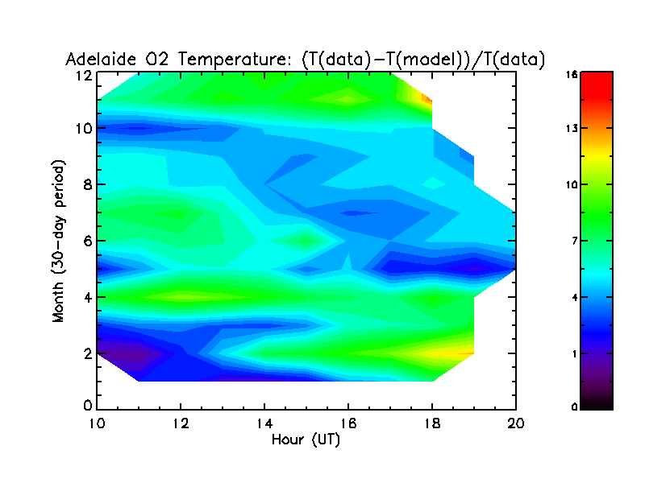
Figure 4

