Data/Model comparison

Mean nightly values of temperature and intensity (black dots in each plot), overplotted with the mean nightly model values (red line). Nightly mean standard deviation in temperature and intensity are shown as filled blue curve at the bottom of each panel (I’ve called it “variance” here), overplotted with model nightly mean standard deviation (dashed blue line).

A note about the intensity data: I’ve reduced the model OH intensity by a factor of 1.5 to better match the data. The O2 model intensity has also been reduced by a factor of 10 in the plots below; I assume this discrepancy is due to the difference between the 0-1 (data) and 0-0 (model) intensity.

Alice Springs
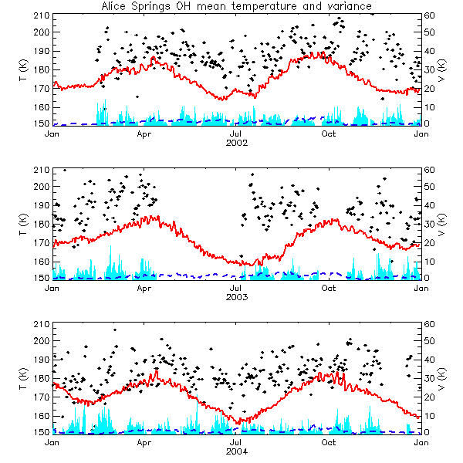
Figure 1
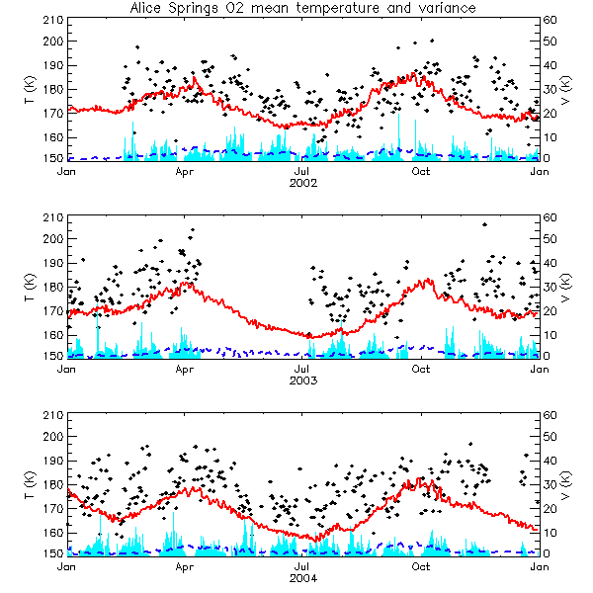
Figure 2
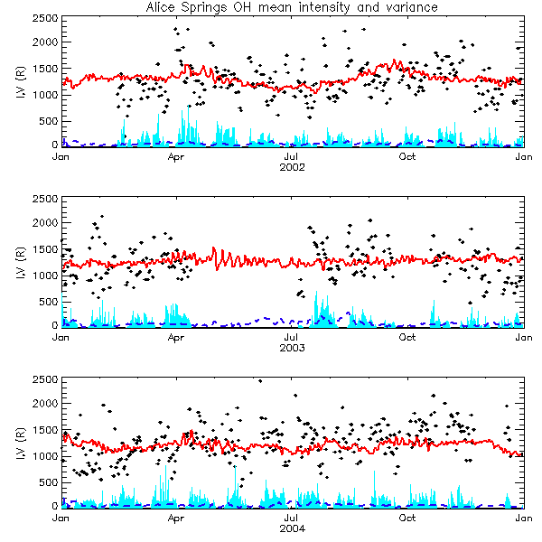
Figure 3
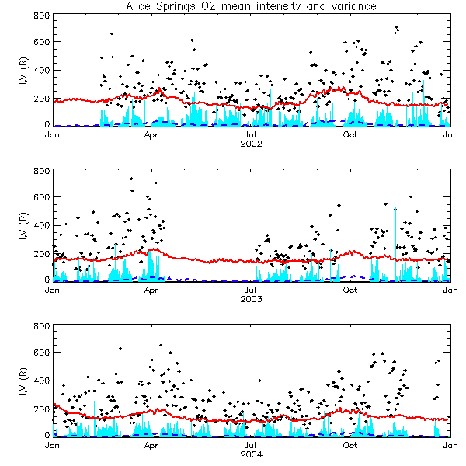
Figure 4

Adelaide
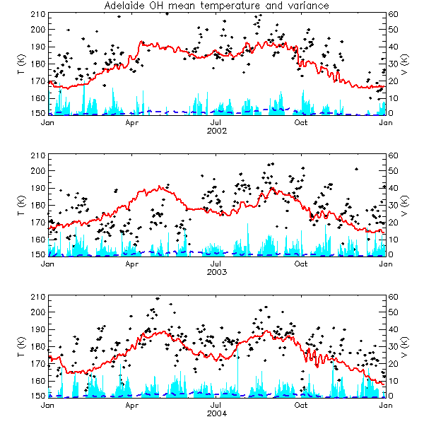
Figure 5
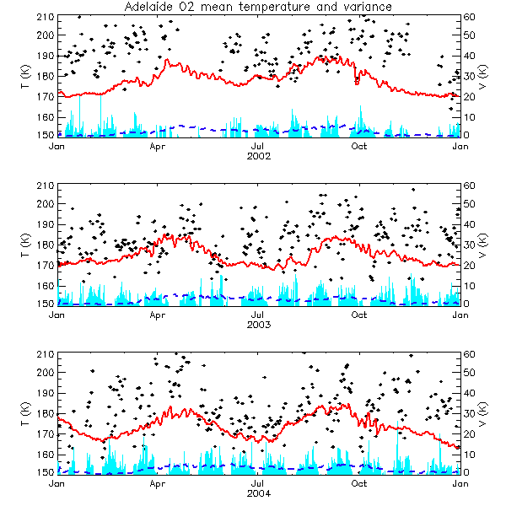
Figure 6
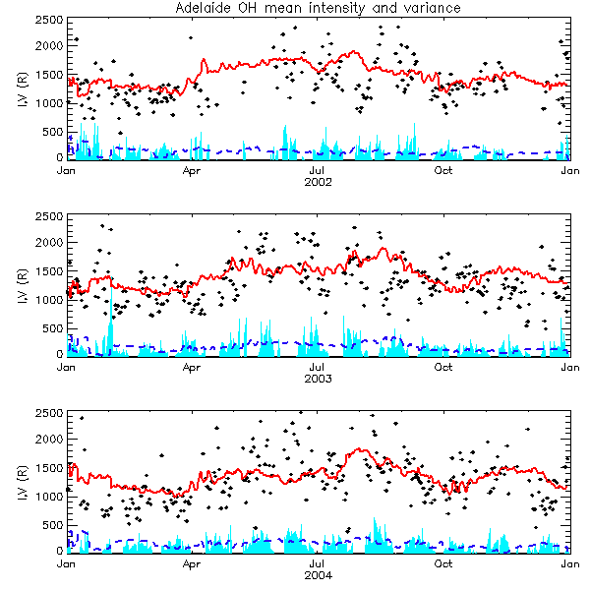
Figure 7
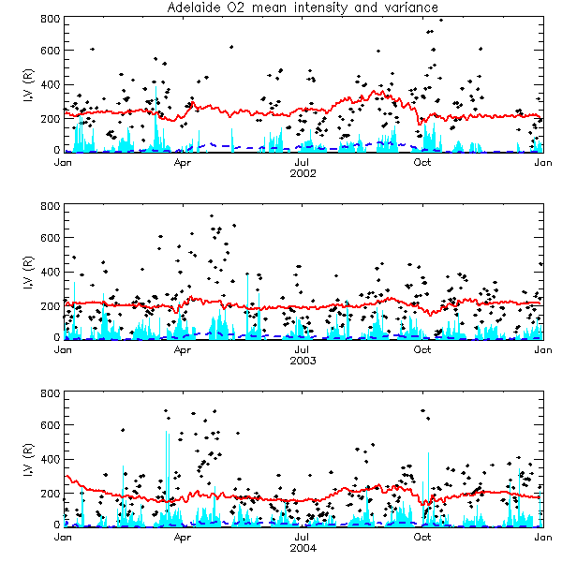
Figure 8

